**Chapter 3 In class exercise – Solution**

1.      Inventory has increased from $18,776 to $21,908. This is  ____________ of cash;

 Long term debt has increased from $9,800 to $11,500. This is ____________ of cash.   
A. use; use  
B. use; source  
C. source; source  
D. source; use

**Answer: B**

2. The Blue Bonnet's 2008 balance sheet showed net fixed assets of $2.2 million, and the 2009 balance sheet showed net fixed assets of $2.6 million. The company's income statement showed a depreciation expense of $1,000,000. What was the amount of the net capital spending for 2009? （$1,400,000）

**Answer:**

**Net capital spending (or cash flow from investment) = -(changes in NFA + depreciation) = -(2,600,000-2,200,000 + 1,000,000) = -1,400,000. This is capital spending of $1,400,000**

**3.** A firm has $500 in inventory, $1,860 in fixed assets, $190 in accounts receivables, $210 in accounts payable, and $70 in cash. What is the amount of the current assets?  (760)

Answer:

CA = cash + inventory + accounts receivable = 70+500+190 = 760

**4.** A firm has net working capital of $640. Total liability is $5,860. Total assets are $6,230, and fixed assets are $3,910. What is the amount of long term debt?  (4180)

Answer:

Long term debt + CL = Total liability = TL, TL=5860, but CL is unknown.

We can get CL from the following equation:

Net working capital = NWC = CA-CL==> CL = CA-NWC, NWC=640, but CA is unknown. We can get CA from the following equation:

TA = CA + FA, TA=6230, FA = 3910, so CA=6230-3910 = 2320

So, plug it In the CL equation, to get CL, and then plug into Long term debt equation to get Long term debt.

Note: CA is current asset, FA is fixed asset, CL Is current liability, TA is total asset.

**5.** Which one of the following is a use of cash?   
A. decrease in accounts receivable  
**B.** decrease in accounts payable   
C. increase in common stock  
D. decrease in inventory

**6.** A firm generated net income of $878. The depreciation expense was $40 and dividends were paid in the amount of $25. Accounts payables decreased by $13, accounts receivables increased by $20, inventory decreased by $14, and net fixed assets decreased by $8. There was no interest expense. What was the net cash flow from operating activity? (899)

**Answer:**

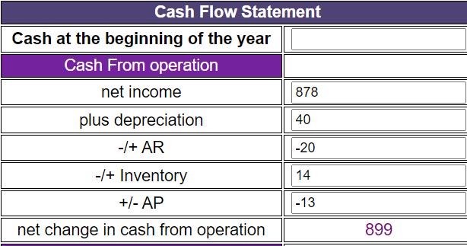

7. Teddy’s Pillows has beginning net fixed assets of $480 and ending net fixed assets of $530. Assets valued at $300 were sold during the year. Depreciation was $40. What is the amount of capital spending? (90)

**Answer:**

**Net capital spending (or cash flow from investment) = -(changes in NFA + depreciation) = -(530-480+40) = -90. This is capital spending of $90.**

**$300 is the market value, not book value. So irrelevant.**

8. The total assets are $900, the fixed assets are $600, long-term debt is $500, and short-term debt is $200. What is the amount of net working capital? (100)

**Answer:**

NWC = CA-CL, CL=200, but CA is unknown.

CA + FA = TA, so CA = TA-FA = 900-600=300,

So NWC = 300-200=100

9. At the beginning of the year, a firm has current assets of $380 and current liabilities of $210. At the end of the year, the current assets are $410 and the current liabilities are $250. What is the change in net working capital?

**Answer:**

NWC = CA-CL,

So NWC beginning of the year = 380-210=170

So NWC end of the year = 410-250=160.

So changes in NWC =10

10 . Art’s Boutique has sales of $640,000 and costs of $480,000. Interest expense is $40,000 and depreciation is $60,000. The tax rate is 34%. What is the net income?

(39,600)

Answer:

