**Chapter 5 In Class Exercise**

1. Compute compound interest on $100 invested at 6% for three years with annual compounding.

Calculate the interest earned in the next three years.

1st year interest _____________________ Principal ______________________

2nd year interest _____________________ Principal ______________________

3rd year interest _____________________ Principal ______________________

Total interest ________________________ Final Principal ___________________

Math Calculation – future value calculation

*FVN* = *PV* (1 + *r*)*n*

Plug in:

PV =

r=

n=

So FVN=

Excel function

Using fv function in Excel ------ fv

future value =abs(fv(rate, nper, pmt, pv))

So calculate future value using excel.

1. Present value

Definition:

Example: What will be the present value of $500 to be received 10 years from today if the discount rate is 6%?

1. Time line:
2. Math equation to calculate present value

***PV = FVn* {1/(1 *+ r*)*n*}**

Plug in FV =

r=

n=

PV=

1. Excel function - pv

Using pv function in excel; present value = abs(pv(rate, nper, pmt, fv))

So present value =

1. Number of years

Definition:

Example: How does it take to double your investment of $500 @ the rate of 6%?

1. Math equation to calculate number of years

***N = ln(FV/PV)/ ln(1+r)***

Plug in FV =

r=

PV=

N=

1. Excel function - nper

Using nper function in excel; number of years = nper(rate, pmt, pv, -fv))

So nper =

1. Interest rate

Definition:

Example: What is rate for you to double your investment of $500 in ten years?

1. Math equation to calculate rate

***rate = (FV/PV)1/n - 1***

Plug in FV =

n=

PV=

rate=

1. Excel function - rate

Using rate function in excel; rate = rate(nper, pmt, pv, -fv))

So rate=

1. Ordinary annuity: A serial equal dollar payment.

Future value of annuity

Example: What will be the *FV* of a 5-year, $500 annuity compounded at 6%?

1. Time line:
2. Math equation (not required)

*FVn = PMT* {(1 + *r*)*n –* 1/*r*}

1. Excel function – fv (still calculate fv, given annuity)

fv = abs(fv(rate, nper, 0, pv))

So calculate fv=

1. Present value of ordinary annuity

You are going to receive $500 annually @ 6% for five years. How much is your present value?

1. Time line
2. Math equation (not required)

*PV* of Annuity = *PMT* {[1 – (1 + *r*)–1]}/*r*

1. Excel function – pv (still calculate pv, given annuity)

pv = abs(pv(rate, nper, pmt, fv))

So calculate pv=

1. Ordinary Annuity calculation

To receive $2818.50 five years later at 6%, how much you should save annually?

1. Time line
2. Excel function – pmt

Pmt = abs(pmt(rate, nper, 0, fv)

So calculate pmt =

1. Annuity due
2. Difference between annuity due and ordinary annuity

If we assume that $500 invested every year at 6% to be annuity due, the future value will increase due to compounding for one additional year.

1. Time line
2. *Math – not required*

*FV*5 (annuity due) = *PMT* {[(1 + *r*)*n* – 1]/*r*} (1 + *r*)

1. Excel function – fv (still calculate fv, given annuity due)

fv = abs(fv(rate, nper, 0, fv, **1** ))

1. Summary: For annuity due, the payment is at the beginning period. Ordinary annuity’s payment is by the end of the period. Add 1 at the end of the function is for annuity due. That is all.
2. Find out interest rate charged.

Example: 12% APR credit card rate. So 12% is the actual interest rate you are paying?

1. APR: do not consider time value of money.

Definition:

Using the prior example, APR =

1. EAR: Consider time value of money. This is the actual interest rate.

Definition:

Calculation:

* 1. Math EAR = (1+APR/n)^n-1

Plug in: Apr=

N=

EAR=

* 1. EXCEL: EAR = effect(nominal, n) or = effect(apr, n)

SO EAR=

1. If your investment earns 10% a year, with quarterly compounding for 10 years, what should we use for “*r*” and “*N*”?

APR=

EAR=

1. Uneven cash flow

Annuity has even cash flow.

With uneven cash flow, you can use NPV function to calculate net present value.

Example:

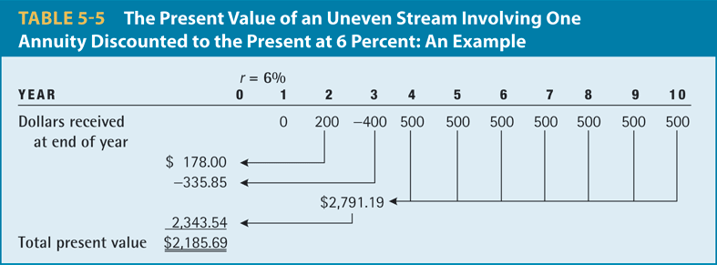

NPV = npv(rate, cash flow in year 1, CF in year 2, …, CF in last year)