**Chapter 5 In Class Exercise – Solution**

1. Compute compound interest on $100 invested at 6% for three years with annual compounding.

Calculate the interest earned in the next three years.

1st year interest _____6____________ Principal _____**100+6=106**

2nd year interest _**106*6%-6.36**__ Principal __**106+6.36=112.36_____**

3rd year interest __**112.36*6% = 6.74**____ Principal _**112.36+6.74=119.10_**

Total interest ___**119.10-100=19.10**________ Final Principal **______119.10_____**

Excel function

Using fv function in Excel ------ fv

**future value =abs(fv(rate, nper, pmt, pv))**

So calculate future value using excel:

**Answer: Three years later, the total amount = abs(fv(rate, nper, pmt, pv)) = abs(fv(6%, 3, 0, 100)) = 119.10**

1. Present value

Definition:

Example: What will be the present value of $500 to be received 10 years from today if the discount rate is 6%?

1. Time line:

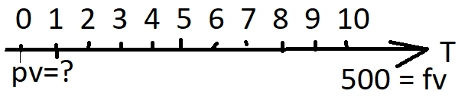

1. Math equation to calculate present value

***PV = FV/* {(1 *+ r*)*n*} = 500/(1+6%)^10 =279.20**

1. Excel function - pv

Using pv function in excel; present value = abs(pv(rate, nper, pmt, fv))

**So present value = abs(pv(6%, 10, 0, 500)) = 279.20**

1. Number of years

Definition:

Example: How does it take to double your investment of $500 @ the rate of 6%?

1. Math equation to calculate number of years

***N = ln(FV/PV)/ ln(1+r)= ln(1000/500)/ln(1+6%) = 11.90 years***

1. Excel function - nper

Using nper function in excel; number of years = nper(rate, pmt, pv, -fv))

So **nper = nper(6%, 0, 500, -1000) = 11.90**

1. Interest rate

Definition:

Example: What is rate for you to double your investment of $500 in ten years?

1. Math equation to calculate rate

***rate = (FV/PV)1/n – 1 = (1000/500)^(1/10)-1 = 7.18%***

1. Excel function - rate

Using rate function in excel; rate = rate(nper, pmt, pv, -fv))

**So rate= rate(10, 0, 500, -1000) = 7.18%**

1. Ordinary annuity: A serial equal dollar payment.

Future value of annuity

Example: What will be the *FV* of a 5-year, $500 annuity compounded at 6%?

1. Time line:

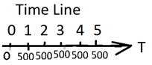

1. Math equation (not required)



**So FV = 500*(((1+6%)^5-1)/6%) =2818.55**

1. Excel function – fv (still calculate fv, given annuity)

fv = abs(fv(rate, nper, pmt, pv))

**So calculate fv= abs(fv(6%, 5, 500, 0)) = 2818.55**

1. Present value of ordinary annuity

You are going to receive $500 annually @ 6% for five years. How much is your present value?

1. Time line



1. Math equation (not required)

*PV* of Annuity =



**PV = 500*(1-(1+6%)^(-5))/6% = 2106.18**

1. Excel function – pv (still calculate pv, given annuity)

pv = abs(pv(rate, nper, pmt, fv))

**So calculate pv= abs(pv(6%, 5, 500, 0)) = 2106.18**

1. Ordinary Annuity calculation

To receive $2818.50 five years later at 6%, how much you should save annually?

1. Time line

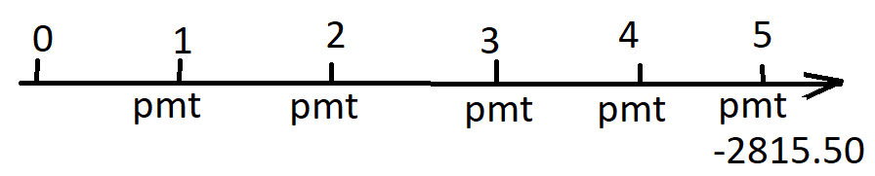

1. Excel function – pmt

Pmt = abs(pmt(rate, nper, pv, -fv)

**So calculate pmt = abs(pmt(6%, 5, 0, 2815.50)) = 499.45**

1. Annuity due
2. Difference between annuity due and ordinary annuity

**Type =0 or omitted for ordinary annuity, and type=1 for annuity due.**

If we assume that $500 invested every year at 6% to be annuity due, the future value will increase due to compounding for one additional year.

1. Time line of annuity due

Time line of ordinary annuity

1. Math equation (not required)

**PV = 500*(1-(1+6%)^(-5))/6% *(1+6%) = 2232.55**

1. Excel function – pv (still calculate pv, given annuity)

pv = abs(pv(rate, nper, pmt, fv, type))

**So calculate pv= abs(pv(6%, 5, 500, 0, 1)) = 2232.55**

1. Summary: For annuity due, the payment is at the beginning period. Ordinary annuity’s payment is by the end of the period. Add 1 at the end of the function is for annuity due. That is all.
2. Find out interest rate charged.

Example: 12% APR credit card rate. So 12% is the actual interest rate you are paying?

1. APR: do not consider time value of money.

Definition: Annual percentage rate, or quoted rate

Using the prior example, **APR = 12%**

1. EAR: Consider time value of money. This is the actual interest rate.

Definition: Effective annual rate, or real rate

Calculation:

* 1. Math **EAR = (1+APR/n)^n-1 = (1+12%/12)^12-1 = 12.68%**

* 1. EXCEL: EAR = effect(nominal, n) or = effect(apr, n)

SO **EAR= effect(12%, 12) = 12.68%**

1. If your investment earns 10% a year, with quarterly compounding for 10 years, what should we use for “*r*” and “*N*”?

APR=10%

**EAR= effect(10%, 4) =10.38%**

1. Uneven cash flow

Annuity has even cash flow.

With uneven cash flow, you can use NPV function to calculate net present value.

Example:

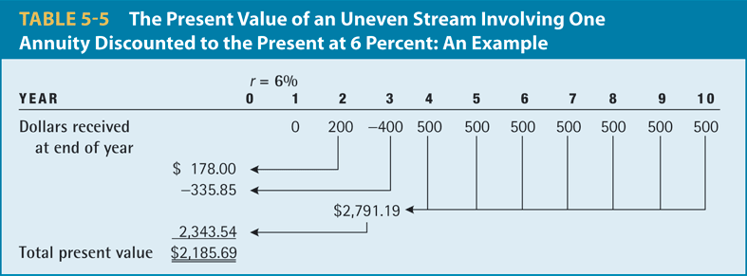

NPV = npv(rate, cash flow in year 1, CF in year 2, …, CF in last year)

**NPV = npv(6%, 0, 200, -400, 500, 500, 500, 500, 500, 500, 500) = 2185.69**

**Or use math equations as follows.**

**NPV = 0/(1+6%) + 200/(1+6%)^2 + (-400)/(1+6%)^3+ 500/(1+6%)^4 + 500/(1+6%)^5+ 500/(1+6%)^6 + 500/(1+6%)^7 + 500/(1+6%)^8 + 500/(1+6%)^9 + 500/(1+6%)^10 = 2185.69**