**Chapter 6 Study Guide Part II**

Portfolio, Systematic Risks, Stock Returns, CAPM:

1. Why holding portfolio is safer than holding individual stock?
2. Now use our class sample with GOOG, AAPL, WMT, Exxon, Ford, and GE, create an equally weighted portfolio. Calculate the portfolio’s average return and standard deviation. Calculate risk/return ratio.
3. Compare your portfolio’s risk return ratio with that of each stock. What do you find?
4. Now calculate the correlation coefficient of (GOOG, APPL), (GOOG, WMT), (GOOG, EXXON), (GOOG, FORD), (GOOG, GE), assuming 50%/50% holding. What do you find?

Note (not required):

Rof portfolio with two stocks = W1*R1+ W2* R2

σ2of portfolio with two stocks = W12 σ 12+ W22σ 22+2* W1W2*ρ12* σ 1* σ 2.

1. Apple’s launching of IPhone 5C and 5S will affect the stock price of GOOG? WMT? EXXON? FORD? GE? Why? Check it out on Google finance.
2. What the difference between systematic risk and unsystematic risk?
3. How to measure systematic risk?

1. How to measure total risk?
2. How to understand the following graph?

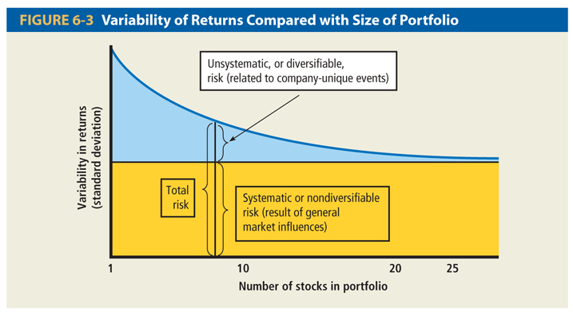

1. How to measure expected return?
2. Find Beta of GOOG, AAPL, WMT, GE, Ford, Exxon and calculate their expected return using CAPM.
3. How to understand the following graph?

