Boom! What Next for This Yo-Yo of a Stock Market?

Feeling lucky? Be careful because most scenarios on the charts suggest stocks are not the place to be.
·
MICHAEL KAHN
August 24, 2015
It’s rare to see the market as a whole break the way it did over the past week. We often see such vertical plunges in individual stocks when bad earnings or legal news is released. Then it typically takes a good deal of time for them to heal. That suggests stocks are not the place to be right now.
Volatility is the new order so individual investors should keep calm and not try to get fancy in the current rough and tumble. Professionals with computing power rivaling NASA are already trying to do that.
The time to sell, of course, was almost any time earlier this year because this month stocks have already entered “correction territory” being 10% down from the highs. Favorites such as Netflix (ticker: NFLX ) dipped into “bear market” territory early Monday morning with a 20% threshold.
Of course, these metrics are meaningless in terms of telling us what to do now. They live completely in the past. So how do we cope?
The answer is preparation. And for that I like to step back away from traditional indicators. Setting downside price targets in this environment is folly.
The CBOE volatility index (VIX ) leapt above 50 Monday morning to levels not seen since the last major correction in 2011. That is a fairly good indication that there is enough fear in the market to suggest some sort of recovery here. Indeed, the Dow Jones Industrial Average moved from down more than 1000 points to down “only” 150 points by lunch time in New York. In 1987, there was no such intraday rebound on Black Monday.
But I have also seen many pundits trotting out the idea that this is a chance to buy great companies at great prices. They also said the same thing a week ago when Disney (DIS) was trading at $106, a 14% discount from the beginning of the month. The stock hit $90 Monday morning before rebounding.
However, saying that the market will bounce now is still trying to time the bottom in a very volatile environment. Let’s lay out a few scenarios for what could happen and what it could mean.
If the market is able to pull itself back up, I would not expect anything more than a test of the major breakdowns that occurred last week (see Chart 1). Clearly, that would tell us that doing nothing during the current volatility was the best idea. And at that point, we should get more clues as to the market’s health and ability to continue to recover. The best case would be the negation of the breakdowns and that would signal the market has overcome yet another obstacle. The worst case would be failure at that resistance and the second chance to get step away from the emerging bear market.

Chart 1
Short-Term S&P 500
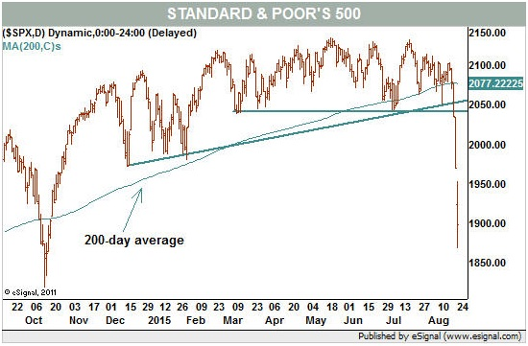
If the market does not bounce but just sits where it is then it will probably be a good idea to trim weak stocks from the portfolio. The odds that the market is truly broken would be high and the path of least resistance would be down. Just take a look at the long-term trendline (see Chart 2).

Chart 2
Long-Term S&P 500
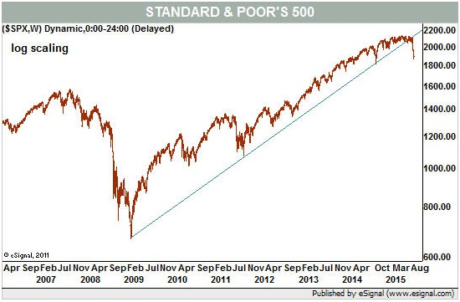
J.C. Parets, market technician and editor of the AllStarCharts.com blog, said of the chart, “no matter how you draw it up (the trendlines), there’s no reason to be long the market.”
And if prices continue lower in earnest then I would agree it would be time to look for stocks that you would love to own based on whatever analysis you choose. Joshua Brown, CEO of Ritholtz Wealth Management, offered an interesting strategy to press the market to give up some serious bargains.
Quoting: “I pick five or six of the best stocks in America that I’ve missed out on – the ones that have always bothered me. Everyone has their names. A contemporary list might include Netflix, Amazon ( AMZN ), Facebook ( FB ), Disney, Celgene ( CELG ), Starbucks ( SBUX ), Chipotle CMG), Goldman Sachs ( GS ), etc. Now I go to my quotes screen to see where they’re currently trading and I come up with utterly absurd prices at which I would buy them…Facebook: Buy at $65.” (The stock actually traded Monday afternoon as high as $87.13).
It was amazing how close many of his examples got to those prices as the market opened. But his point was to set “good until canceled” orders and go do something else. No adjusting, no worrying. And no problem if they never get filled because it would mean the market recovered.
All of these scenarios are still fluid and it may take several more days to find the correct one. The point is that long-term investors have no need to panic. But that does not mean all is well.
With traditional safe havens of gold and the U.S. dollar down Monday – and the dollar down huge – something is different in the market. Investors should probably make orderly changes as the market makes things a bit less murky. Unfortunately, most of the scenarios suggest that stocks are not going to be the place to be for quite some time.

