Chapter 6 Study Guide
- What is Holding Period Return?
Example:
You bought 1 share of HPD for $19.70 in May 2008 and sold it for $32.32 in May 2009. The company paid divided of 8 cents every quarter during the last two years.
How much is holding period return?

- Expected return and expected cash flow
  - Definition
  - Example
State of the economy | Probability of the states | Cash flow from the investment | % Return (Cash Flow/Inv. Cost)
Economic Recession | 20% | $1,000 | 10% ($1,000/$10,000)
Moderate Economic Growth | 30% | 1,200 | 12% ($1,200/$10,000)
Strong Economic Growth | 50% | 1,400 | 14% ($1,400/$10,000)
How much is expected cash flow? Expected return?

- What is risk?

How to measure risk?

Why diversification can reduce risk?

Example:
Treasury Bill
100% 3%
Stock
10% 0%
20% 5%
40% 15%
20% 25%
10% 30%

Why Treasury Bill is less risky than stock?

Calculate expected return and standard deviation of both.

- Portfolio:
Why holding portfolio is safer than holding individual stock?

What the difference between systematic risk and unsystematic risk?

How to measure systematic risk?

How to measure total risk?

Steps
- Calculate monthly return of each company.
Holding period return = Return = P2/P1 – 1 = (P2-P1)/P1

- Calculate the risk of each stock
Total risk of stock = Standard deviation
The syntax for the Standard Deviation function is: standard deviation = STDEV ( Number1, Number2, ... Number…)

- Set up portfolio. Here the portfolio has one share of WMT, AAPL, GE, and EXXON, respectively.

- Calculate portfolio’s risk. Significantly lower than the risk of individual stock?

- Why risk of portfolio is lower?

- Calculate correlation

Syntax - CORREL(array1,array2); Array1 is a cell range of values; Array2 is a second cell range of values.

- A optimal portfolio should have stocks negatively correlated. Why?

- What are systematic risk and unsystematic risk? Why an optimal portfolio has systematic risk only?

- How to measure systematic risk?
Systematic risk is measured by Beta. What is Beta?

- What CAPM? How to measure Beta?
Beta = slope ( S&P500 return, stock return)

Date | wmt | aapl | ge | exxon | nbg_penny | span_penny | sp500 | portfolio
1/2/2014 | 74.1 | 500.75 | 25.29 | 95.11 | 4.49 | 21.63 | 1774.2 | 695.25
12/2/2013 | 78.69 | 561.02 | 28.03 | 101.2 | 5.6 | 20.84 | 1848.4 | 768.94
11/1/2013 | 80.54 | 556.07 | 26.45 | 93.48 | 6.27 | 19.72 | 1805.8 | 756.54
10/1/2013 | 76.31 | 519.67 | 25.93 | 89.01 | 5.85 | 18.71 | 1756.5 | 710.92
9/3/2013 | 73.53 | 473.98 | 23.7 | 85.46 | 4.05 | 21.35 | 1681.6 | 656.67
8/1/2013 | 72.56 | 484.39 | 22.78 | 86.57 | 4.01 | 20.93 | 1633 | 666.3
7/1/2013 | 77.02 | 446.95 | 23.99 | 92.48 | 3.55 | 20.71 | 1685.7 | 640.44
6/3/2013 | 73.61 | 391.64 | 22.83 | 89.12 | 3.45 | 20.14 | 1606.3 | 577.2
5/1/2013 | 73.96 | 444.19 | 22.77 | 89.24 | 7.22 | 19.12 | 1630.7 | 630.16
6/1/2004 | 43.51 | 15.73 | 23.35 | 35.94 | 197.09 | 7.44 | 1140.8 | 118.53
5/3/2004 | 46.18 | 13.57 | 22.29 | 35 | 202.59 | 6.63 | 1120.7 | 117.04
4/1/2004 | 47.12 | 12.46 | 21.45 | 34.22 | 196.23 | 6.9 | 1107.3 | 115.25
3/1/2004 | 49.35 | 13.07 | 21.86 | 33.44 | 177.06 | 7.66 | 1126.2 | 117.72
2/2/2004 | 49.13 | 11.56 | 23.3 | 33.91 | 186.16 | 7.43 | 1144.9 | 117.9
1/2/2004 | 44.42 | 10.91 | 23.94 | 32.6 | 180.31 | 7.19 | 1131.1 | 111.87
12/26/2003 | 43.76 | 10.33 | 22.06 | 32.77 | 173.81 | 6.99 | 1111.9 | 108.92

How to understand the following graph?
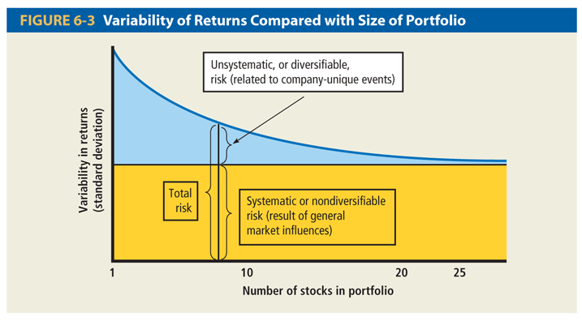

How to measure expected return?

Examples:
Go to www.google.com/finance
To calculate monthly return of 2012. Find Beta of google and calculate expected return of GOOGLE using CAPM.

How to understand the following graph?

