How to Master Analyzing the Balance Sheet

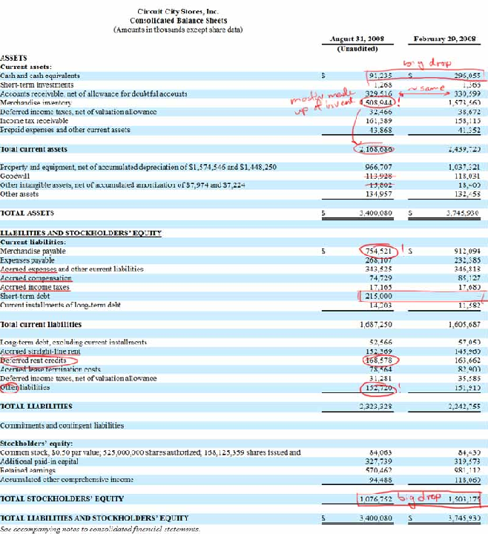

Cash
Any company with lots of cash is a reassurance to investors that the company should be able to survive during downturns as well as expand during booms.
Divide the cash by the number of shares outstanding to see how much of the stock price is made of cash. On Feb 29, 2008, Circuit City had $1.76 in cash per share but by August 31, 2008, that number dropped to $0.54 and has probably dropped further since then.
If the cash per share is greater than the share price, it could be a potential net net.

Accounts Receivables
As I covered in the Statement of Cash Flows, accounts receivables is an indication of whether the company is able to collect its payments. If accounts receivables decrease from the previous years (you have to compare by going back a few years), the company has been able to collect its money.
If this is continually increasing, the company is either willing to sell to anyone or the company may have become lenient in its payment policies to customers which could lead to an inflation of earnings causing nasty surprises later on.
Compare the increase in accounts receivable with increase in sales. e.g. If accounts receivables has increased 120% while sales only increased 90%, the company is not collecting bills.
I’ve only displayed a quarterly statement for Circuit City but if we look back at the previous statements, Circuit City has been unsuccessful in reducing this line. Although the sum of $330mil is a good reduction from $447mil in Nov 2007, the overall story shows that Circuit City has an unimpressive payment collection system.

Inventory
One of the most important aspects of the balance sheet. Ben Graham has written that inventory should be marked down to 50% of its valuation when calculating a liquidating value. This is true especially when it comes to electronics. With a product life cycle lasting only a few months, old inventory will continually have to be discounted.
Inventory should also be compared with cost of goods. This inventory indicator is a reliable sign of whether a manufacturer or retail company will stumble if the difference is substantial. In terms of inventory growth, Circuit City hasn’t done too bad of a job but their inventory level is far too high for a business of their size.
It’s also a good idea to compare the inventory turnover with competitors. While Best Buy has been able to turn over its inventory 6.9x times a year for the past 5 years, Circuit City has only managed an average of 5.5x in the past 5 years.
A further discussion of inventory will be required in another post as we look at how companies calculate and state the value of inventory.

One Time Items
Deferred income taxes and income tax receivables should not be considered as part of business assets. They add no value to the operations of the business. Hopefully these numbers are kept low and not included too often. Circuit City needs all the cash it can get. It shouldn’t be overpaying taxes and waiting to receive it without interest from the government.

PP&E and Goodwill
PP&E is an illiquid asset and is mostly taken into consideration when the company is liquidating.
If the company owns land, additional research would be to find todays market value of the land.
As most readers know, goodwill is best ignored. No tangible value exists and impairment charges usually always appear from a goodwill that is too high.
Although Circuit City “may” have a brand, I believe there is no tangible value because there is nothing stopping a consumer from crossing the road to Best Buy if they have better prices.

Liabilities
Liabilities is much like the assets section. There are payments that have to be made and if this number increases, the company has not been paying their bills.
Circuit City’s problem is that they are overladen with debt and no cash. They need to pay suppliers in excess of $750 mil, expenses in the amount of $270 mil and $343 mil for accrued expenses and other liabilities as well as a short term debt of $215 mil due shortly. With only $91 mil in cash and the rest tied up in inventory, no wonder the suppliers demanded cash up front for delivery of items.
Also, watch out for companies like Circuit City that have accrued so many expenses. These are obligations that must be paid which will hit earnings hard.
Circuit City has also been deferring its rent credits. Companies often abuse deferred charges by pushing expenses into the future so that they can inflate earnings even when things are not going so great.
Circuit City’s “other” liabilities add up to over $150 mil so its always important to check the footnotes as well as the possibility of off balance sheet liabilities.

Quality of assets
Quality of assets is something you should always be asking yourself whenever going through a balance sheet. Circuit City’s assets are made up of mostly inventory, property and equipment. However, we know that electronics cant hold their value for more than a few months and Circuit City does not own their stores (land). So all the stated property and equipment is probably associated to shelves, tables and other shop fitting items. Nothing that can fetch full value.
Quality of assets for Circuit City? BAD

Summing Up
- Cash helps companies survive and grow.
- Watch the trend in Accounts Receivables. Be careful of companies unable to collect money.
- Take the value of inventory stated on the balance sheet with a grain of salt. Different accounting methods (FIFO, LIFO) produce different ending values even though the products are the same.
- One time items in assets should not appear often such as sale of assets.
- PP&E is illiquid and should be considered mostly in asset plays or liquidation. Ignore goodwill.
- All debt isn’t bad. Just when you can’t afford it.
- Assets should be high quality (cash is best)

How to Master Analyzing the Income Statement

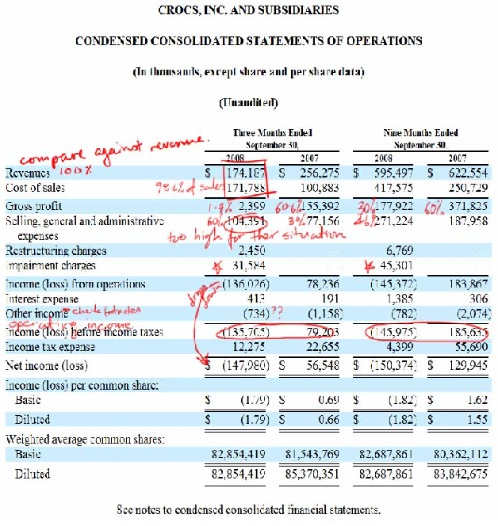

Cost of Goods Sold
When analyzing the income statement, we should always try to compare each line with Revenues as a percentage. As numbers go from 6 figures (millions in revenue) to 9 figures (billions in revenue), it’s easy to lose track of the numbers. Below is a screenshot of how I have my spreadsheet set up.
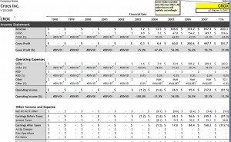
Straight away we see that Crocs COGS (Cost of Goods Sold) is 98.6% of revenues in its latest quarter. Also keep an eye out for how COGS increases in relation to sales over many quarters. If COGS increases faster than sales, that is a red flag which must be looked into.

Margins
If we then move to the gross profit line we have to consider many things regarding margins. Gross margins tell you a lot about a firm’s competitive position. If a company can increase its gross margins, the company is doing two things;
- cutting production costs or
- raising prices
Both are good signs and margins that can trend up is always a good thing and will lead to an increase in future earnings.
Unfortunately, for Crocs, compared to a year ago, their margins have jumped off a cliff from an impressive 60% to 1.4% in 3 months ended September 30. This deterioration could mean that raw and production costs are rising, as evidenced by the increase in COGS compared to 2007.
If production costs increase, the company has to proportionally increase their prices, but do people really want to spend an extra $5 for an already expensive fad shoe? On the other hand, if a rise in production cost is not the cause, then the company must be cutting prices in order to maintain market share and gain some revenues.
Brad at TMWTFS has stated clearly that a company should never compete on price. Those that do, have no competitive advantage.
Operating margins and net margins also provide vital information about the capabilities of the company. Gross margins could be superb but if operating margins are low, any drop in gross margins could have a material effect on the overall profit of the company. Huge drop in gross margins lead to a loss in operations and subsequently, net margins.
An important note about margins is that we must identify the company strategy before immediately jumping to conclusions. Crocs is an example of a typical company banking on high returns with low inventory turnover to make a profit. Costco, Wal-Mart and other super retailers have small margins yet their inventory turnover is extremely high. The volume of products sold is where the profits come from. So think strategy before dismissing a company completely.

Selling, General and Administrative Expenses
For a company doing so poorly, SG&A for Crocs is far too high. High SG&A for any company is a serious problem. This line is also where companies expense the limos, private jets, boats etc used by executives. For a company doing so poorly, as a shareholder you would expect the CEO to take economy.
Companies should try to keep SG&A to a certain percentage of revenues. This prevents future problems caused by hiring sprees and huge bonuses. Costco has been able to keep their SG&A between 8.5-10% for the past 10 years. A clear indication of the quality of management.

Other Income, Income tax, EPS, Shares Outstanding
Footnotes should always be reference to determine exactly what Other Income is. This is evermore true if the number is high.
Income tax and Earnings Per Share (EPS) is straightforward and doesn’t require additional comments.
Shares outstanding should be monitored as well. Always use the diluted number as it includes stock options. Crocs has been buying back its shares from the previous year in an attempt to increase shareholder value but that is a minor point compared to what has been discussed above.

Summary
- View numbers as percentages and compare over several quarters and years
- COGS should never be higher than sales
- Margins reflect competitive position and company strategy
- SG&A and Impairment Charges determines the company’s management quality

How to Master Analyzing the Cash Flow Statement

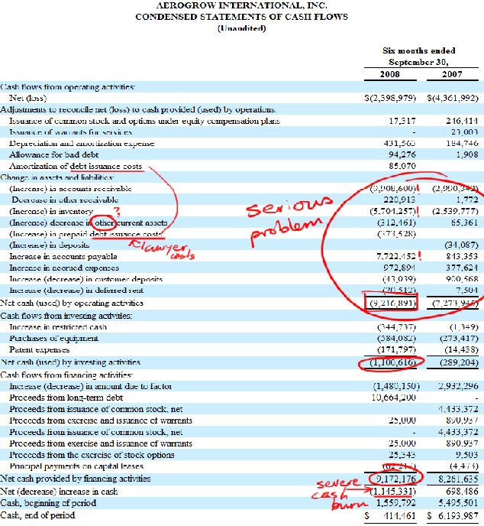

Intro to Cash and the Statement of Cash Flows
The Statement of Cash Flows details all cash inflow and outflows and boils it down to how much cash the company has generated in a given period. Income statement and balance sheets include the future incoming and outgoing cash recorded as credit.
Cash is king and is the blood of a business – it has to flow evenly. Holding plenty of cash is never a bad thing but there are exceptions to this as well. On the other hand, too much outflow in one area is the equivalent of getting shot and seeing blood pour out from the hole. The basic and key idea is that cash is what a company needs to be healthy and generate earnings.
Cash flow is calculated by adding and subtracting certain items to the net income. These adjustments must be made because non-cash items may be included into the net income even though it does not represent any cash in the bank.
e.g. You sell an item with a condition that the buyer can use it for 30 days, and if they like it, they pay for it. Otherwise they return it during the 30 day period without paying anything. In this case, accounts receivables will go up which makes it seem like the assets have increased, but in cash terms, you did not receive a single cent. Thus the importance of seeing how this number is stated in the statements.

The AeroGrow Statement of Cash Flows

Accounts Receivable
If accounts receivable decreases from the previous years (you have to compare by going back a few years), this means that more cash has entered the company from customers paying off their credit accounts. If accounts receivable increases, this means that the company has sold more products that money received.
In AeroGrow’s latest filing 10-Q filing (see above), we see that the cash related to accounts receivable decreased by $9.9 million compared to a decrease of $3 million a year ago. In other words, AERO sold $9.9 million worth of goods without being paid, compared to $3 million the prior year. They are both bad numbers, but the latest increase is a whopping 330%!
This is a huge warning sign that management is desperately, in a maniacal way, trying to get their products onto any available shelf. Far too aggressive.

Inventory
Same for inventory, which they burned $5.7 million on. Rather than managing it, they’ve multiplied it like cockroaches. They currently have $8.5 million in finished goods which I assume is supposed to meet the demand they were expecting, except they have announced an expected slow down.
It would have been better to keep it as raw materials and streamline assembly processes in order to meet demand. Raw materials could be sold at commodity prices if it came down to it, but finished goods collecting dust will only fetch 50% at best in a fire sale.
Good indicator that management is unrealistic with performance and does not perform proper market research.
(If raw materials increase but finished goods decrease, it means the company has a problem with efficiency, processes and ultimately meeting demand.)

Accounts Payable
The third big warning sign is accounts payable. Since this is a positive number, the cash hasn’t left yet, so it’s been added back to net income because it is stated as a liability in the Balance Sheet.
This means that AERO has delayed the payment but will have to pay this huge amount in another period. An increase of $7.7 million in payables will surely require the company to look for further credit or dilute shareholders in order to pay it down.

Cash From Operations
For a company to be healthy, the cash from operating activities should be positive, but the quality of the cash is just as important.
The net income at the top of the Cash Flow Statement should preferably be a high positive number and the adjustment differences should not be huge. If this is the case, the majority of cash from net income should drop to the Cash from Operations line.
We see AeroGrow went from a net income of $(2.4 million) to Cash Used in Operations of $(9.2 million) in 6 months. This is $2 million more than the previous year and considering the size of the company, this is a first degree burn.
You can also see the company spending to purchase new equipment and receiving $9 million from financing with over $10 million in debt from $0 one year ago. Not the quality we want to see. Unsuspecting investors may only see the Cash at Beginning of Period of $1.6 million and Cash at End of Period of $0.4 million and think they used up $1.2 million. But we can see the true number is $9.2 million.
Not to mention a $8 million market cap with $10 million in debt and more coming.. you do the math.

Conclusion
The latest news from AERO touts its first every profitable quarter masked behind a mess of cash outflows. We’ve just seen why it’s more important to view cash than earnings.
I don’t mean to pick on AeroGrow, and the company will hate me for writing this, but before getting into the details of ROE, ROA, margins, solvency, turnover etc, taking a quick glance at the statements will reveal the company for what it is and save you from deep trouble.

