Welcome to the Crisis Economy, Where Tumult Reigns

Be it geopolitical tension, terror threats or faltering markets, there always seems to be something testing growth

By
STEPHEN FIDLER
Jan. 18, 2016 5:08 p.m. ET
Myriad sources of anxiety are roiling global financial markets and political capitals: a weakening Chinese economy; collapsing oil prices; escalating tension in the Middle East that has spawned a refugee crisis in Europe; the possibility of financial dislocation as U.S. monetary policy tightens.
As politicians, bankers and business leaders gather in Davos this week for the annual gathering of the World Economic Forum, they face not a single upheaval—the eurozone crisis of 2010, say, or Russia’s 2014 intervention in Ukraine—but numerous political and economic hotspots, many of which have the potential to undermine already-anemic growth.
The earthquake that began with the 2008 financial crisis in the U.S. and that later rumbled through Europe has finally shaken China, in turn crippling countries and companies from Africa to South America that prospered feeding Chinese demand. As a result, the early weeks of 2016 have been marked by paroxysms in financial, energy and commodity markets.
“What the three crises have in common is the end of the global credit expansion,” saidMarc Chandler, global head of currency strategy at Brown Brothers Harriman in New York.
Meanwhile, geopolitical uncertainty abounds. Conflict in the Middle East—made worse by an increasingly overt proxy war between Saudi Arabia and Iran—has sent waves of refugees into Europe and fanned fears of terrorism in the West. Movements opposed to political and economic integration have gained ground across much of Europe. Nuclear tests in North Korea and territorial disputes over the South China Sea underscore how Asia is not immune from turmoil.
If there is a single theme here, it is the struggle of political leaders to cope.
President Barack Obama’s caution in wielding American power—critics might call it timidity—has created vacuums that others have sought to fill. Chinese leaders have stumbled in their attempts to quell financial turmoil. German Chancellor Angela Merkeland other European leaders have floundered as millions of refugees have poured into Europe. Russian President Vladimir Putin’s adventure in Ukraine remains unresolved even as he takes further risks by sending Russian armed forces into the Syrian maelstrom.
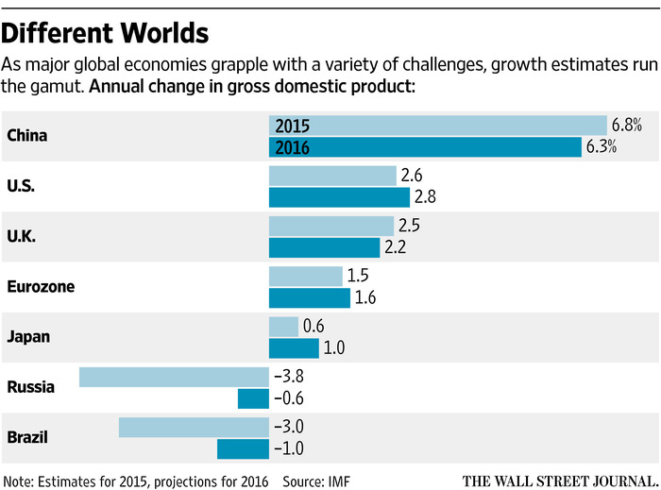ENLARGE
Sir Lawrence Freedman, emeritus professor of war studies at King’s College London, says Western capitals must bear some of the blame for the deepening disorder in the Middle East, even if they have scant powers now to fix the mess.
“You could argue that we are culpable in the things we did in the past, but we’re not the ones posing the risks at the moment,” he said. “Western policy choices are not as consequential, and therefore we may be at the mercy of pretty bad choices made by others.”
The faltering of the Chinese economic expansion is also complicating the geopolitical outlook.
China is falling victim to the global cycle, but it is also undergoing a challenging structural transformation from an economy based heavily on investment and manufacturing toward one more skewed toward domestic consumption and services.
The Chinese authorities face a dilemma: They could move to prime the pump to keep growth on track, as they have before. But that would risk further swelling the country’s economic and financial imbalances, in particular the heavy debts of Chinese companies and state-owned enterprises. The second path could spell “possible further trouble down the road,” said International Monetary Fund chief economist Maury Obstfeld. The credibility of Chinese policy makers is on the line, with critical consequences for the rest of the world.
The spillovers from China have been much larger than expected by many forecasters, including those at the IMF. One telling measure of the shift is the fortune of the Baltic Dry Index—the main indicator tracking rates for ships carrying industrial commodities—that at the start of the year slumped to the lowest level since it was created in 1985. That reflects weak demand but also of the oversupply of ships built on the back of excessive optimism about the global economy.
Other signals are betraying weak global demand. If falling oil and commodity prices were a reflection only of excess supply, stock markets would usually rally on optimism that cheaper raw materials would spur growth. Instead, world-wide share prices have been sinking, a strong suggestion that investors see a demand problem.
There’s another possible trigger for economic dislocation: the strong U.S. dollar. Trillions of debt denominated in the U.S. currency has been issued by foreign borrowers, governments but also private companies and banks in emerging economies, raising the prospect of debt defaults.
One place where these troubles could come together is Russia, which is also beset by Western sanctions over its intervention in Ukraine. Since Mr. Putin came to power in 1999, Moscow has shown scant success in shifting its economy away from dependence on oil and gas production. Now, with the price of oil flirting with $30 a barrel, Russia faces a second year of economic contraction and possible financial crisis as companies and banks scramble for scarce dollars to pay debts.
Mr. Putin’s popularity has so far been little affected by the economic setbacks, helped by the control his administration exerts over Russian media. How he will react to further turmoil—through more nationalist saber-rattling or by trying to reinsert Russia into the global economic mainstream—is unclear. Some strategists, such as Sir Lawrence, believe Moscow has already overextended itself in Ukraine and Syria and will find it difficult to sustain its military efforts there.
The travails of raw-materials producers extend to Latin America. Brazil, the largest economy in the region, is also due for a second year of profound economic contraction and further political turmoil over allegations of corruption at the state-owned oil company Petrobras. Two major credit-rating firms have downgraded Brazilian debt to junk.
In the Middle East, the world’s largest oil producer, Saudi Arabia, has reacted to the oil-price fall by cutting budget spending. Even Iran, which may benefit economically from the lifting of sanctions related to its nuclear program, may not enjoy much of a windfall because of the oil slump.
Whatever their economic fortunes, Riyadh and Tehran will be central to any solution to the conflict in Syria. Their deteriorating relations have raised questions about a settlement in Syria in the near term, the prospects for which briefly rallied late last year. That suggests the humanitarian disaster that has spilled into neighboring Turkey, Lebanon and Jordan, and is pushing tens of thousands of refugees weekly into Europe, could be prolonged.
Amid the waves of asylum seekers, European governments have looked hapless. Ms. Merkel’s sure political touch seems to have fallen foul of her humanitarian instincts in first opening—and then seeking to close—the door to migrants. Borderless travel, one of the achievements of European integration, is now under threat as some governments seek to block the entry of migrants and others try to deter the kind of terrorist outrage that shook Paris on Nov. 13.
The capacity of European governments to muddle through another crisis shouldn’t be underestimated, but it may be that the high point of European integration is in the rearview mirror. Not least, a U.K. referendum over whether to stay in the European Union, likely to be held this year, could have broad ramifications for the future of the bloc, as well as the U.K.’s place in the world.
With a sluggish economic recovery in the eurozone and tensions over migration, frustration among voters over the perceived failure of incumbent politicians has bolstered self-styled alternatives, of the left and the right, in continental Europe. The phenomenon is wider: Anger among some voters against the political “establishment” helped left-winger Jeremy Corbyn to become leader of the British Labour Party and, on the other side of the political spectrum, has buoyed the presidential campaign of billionaire Donald Trump.
Not all of these developments will have long-term consequences. But even if some sources of unpredictability subside, the economic and geopolitical outlook appears more unsettled this year than it has in decades.

