Chapter 6 Study Guide
- Stock market is risky? What is risk? Among AAPL, CSX, which stock is the more risky one? Demonstrate it, based on the market performance of the two stocks in the prior year.

- Can you do better via diversification? For example, you can allocate half of your fund to AAPL and the rest to CSX. Now let’s demonstrate that it is less risky.

- Imagine that you have a fully diversified portfolio, meaning you have invested in every stock in the market. Now let’s figure out the risk of the stocks, such as AAPL and CSX.
Steps
- Calculate monthly return of each company.
Holding period return = Return = P2/P1 – 1 = (P2-P1)/P1

- Calculate the risk of each stock
Total risk of stock = Standard deviation
The syntax for the Standard Deviation function is: standard deviation = STDEV ( Number1, Number2, ... Number…)

- Set up portfolio. Here the portfolio has one share of AAPL and CSX, respectively.

- Calculate portfolio’s risk. Significantly lower than the risk of individual stock?

- Why risk of portfolio is lower?

- Calculate correlation (AAPL and CSX, CSX and AMAZON, AAPL and AMAZON, AAPL and Gold, CSX and gold, and Amazon and gold)

Syntax - CORREL(array1,array2); Array1 is a cell range of values; Array2 is a second cell range of values.

- A optimal portfolio should have stocks negatively correlated. Why?

- What are systematic risk and unsystematic risk? Why an optimal portfolio has systematic risk only?

- How to measure systematic risk?
Systematic risk is measured by Beta. What is Beta?

- What CAPM? How to measure Beta?
Beta = slope ( S&P500 return, stock return)

How to understand the following graph?
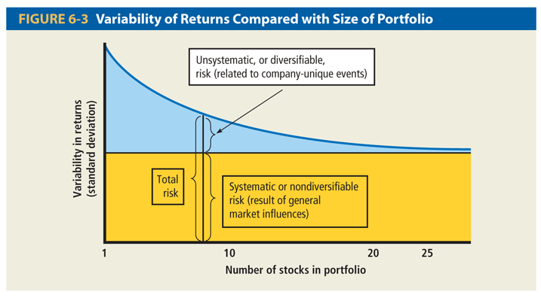

How to understand the following graph?

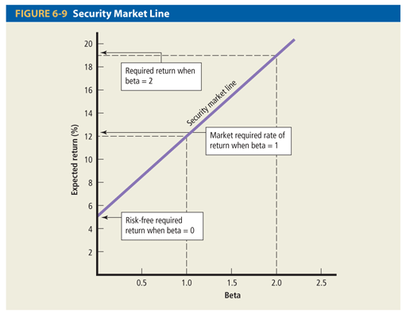

- What is Holding Period Return?
Example:
You bought 1 share of HPD for $19.70 in May 2008 and sold it for $32.32 in May 2009. The company paid divided of 8 cents every quarter during the last two years.
How much is holding period return?

