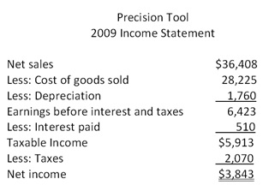
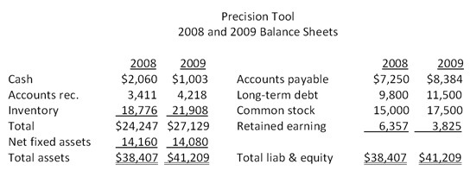

1. What was change in cash flow in investment for 2009? (Hint: compare for net fixed asset and adjust for depreciation).
A. $80
B. -$1,680
C. -$1,840
D. $1,700

2. What is the net change in cash flow in operation in 2009? (hint: start with NI, depreciation and adjust for other current assets and liability)
A. 3,822
B. 2,798
C. 3,575
D. 3,269

3. What is the net change in cash flow in financing in 2009? (Hint: calculate cash flow changes in debt and equity and then add them up – calculate dividend first)
A. -$3,008
B. $1,720
C. -$2,175
D. -$1,668

4. Inventory has increased from $18,776 to $21,908. This is ____________ of cash;
Long term debt has increased from $9,800 to $11,500. This is ____________ of cash.
A. use; use
B. use; source
C. source; source
D. source; use

Cash Flow Statement Answer |  | calculation for changes
Cash at the beginning of the year | 2060
Cash from operation
net income | 3843
plus depreciation | 1760
-/+ AR | -807 | 807
-/+ Inventory | -3132 | 3132
+/- AP | 1134 | 1134
net change in cash from operation | 2798
Cash from investment
-/+ (NFA+depreciation) | -1680 | 1680
net change in cash from investment | -1680
Cash from finaning
+/- long term debt | 1700 | 1700
+/- common stock | 2500 | 2500
- dividend | -6375 | 6375
net change in cash from investment | -2175
Total net change of cash | -1057
Cash at the end of the year | 1003

(The excel file of the above cash flow statement is here)
More exercises of chapter 3
1. The Blue Bonnet's 2008 balance sheet showed net fixed assets of $2.2 million, and the 2009 balance sheet showed net fixed assets of $2.6 million. The company's income statement showed a depreciation expense of $1,000,000. What was the amount of the net capital spending for 2009? （$1,400,000）
2. A firm has $500 in inventory, $1,860 in fixed assets, $190 in accounts receivables, $210 in accounts payable, and $70 in cash. What is the amount of the current assets? (760)
3. A firm has net working capital of $640. Total liability is $5,860. Total assets are $6,230, and fixed assets are $3,910. What is the amount of long term debt? (4180)
4. Which one of the following is a use of cash?
A. decrease in accounts receivable
B. decrease in accounts payable
C. increase in common stock
D. decrease in inventory
5. A firm generated net income of $878. The depreciation expense was $40 and dividends were paid in the amount of $25. Accounts payables decreased by $13, accounts receivables increased by $20, inventory decreased by $14, and net fixed assets decreased by $8. There was no interest expense. What was the net cash flow from operating activity? (899)
6. Teddy’s Pillows has beginning net fixed assets of $480 and ending net fixed assets of $530. Assets valued at $300 were sold during the year. Depreciation was $40. What is the amount of capital spending? (90)

7. The total assets are $900, the fixed assets are $600, long-term debt is $500, and short-term debt is $200. What is the amount of net working capital?
(100)
8. At the beginning of the year, a firm has current assets of $380 and current liabilities of $210. At the end of the year, the current assets are $410 and the current liabilities are $250. What is the change in net working capital?

9. . Art’s Boutique has sales of $640,000 and costs of $480,000. Interest expense is $40,000 and depreciation is $60,000. The tax rate is 34%. What is the net income?
(39,600)

