12:33 pm ET
Jun 9, 2014

What Apple’s Stock Split Means for You
- By STEVEN RUSSOLILLO

No, your screens aren’t lying to you. Shares of Apple Inc.AAPL +4.12% now trade under $100, a development that hasn’t happened in years.
Apple’s unorthodox 7-for-1 stock split, announced at the end of April, has finally arrived. The stock started trading on a split-adjusted basis Monday morning, and recently rose 1% to $93.14.
In a stock split, a company increases the number of shares outstanding while lowering the price accordingly. Splits don’t change anything fundamentally about a company or its valuation, but they tend to make a company’s stock more attractive to mom-and-pop investors. Apple shares rallied 23% from late April, when the company announced the split in conjunction with a strong quarterly report, through Friday.
A poll conducted by our colleagues at MarketWatch found 50% of respondents said they would buy Apple shares after the split. Some 31% said they already owned the stock and 19% said they wouldn’t buy it. The survey received more than 20,000 responses.
Here are five things you need to know about Apple’s stock split.
WHO DOES THE STOCK SPLIT IMPACT? Investors who owned Apple shares as of June 2 qualify for the stock split, meaning they get six additional shares for every share held. So if an investor held one Apple share, that person would now hold a total of seven shares. Apple also previously paid a dividend of $3.29, which now translates into a new quarterly dividend of $0.47 per share.
WHY IS APPLE DOING THIS? The iPhone and iPad maker says it is trying to attract a wider audience. “We’re taking this action to make Apple stock more accessible to a larger number of investors,” Apple CEO Tim Cook said in April. But the comment also marked an about-face from two years earlier. At Apple’s shareholder meeting in February 2012, Mr. Cook said he didn’t see the point of splitting his company’s stock, noting such a move does “nothing” for shareholders.
WILL APPLE GET ADDED TO THE DOW? It’s unclear at the moment, although a smaller stock price certainly makes Apple a more attractive candidate to get added to blue-chip Dow. Apple, the biggest U.S. company by market capitalization, has never been part of the historic 30-stock index, a factor that many observers attributed to its high stock price. The Dow is a price-weighted measure, meaning the bigger the stock price, the larger the sway for a particular component. That is different from indexes such as the S&P 500, which are weighted by market caps (each company’s stock price multiplied by shares outstanding).
WILL APPLE KEEP RALLYING? Since the financial crisis, companies that have split their stocks have struggled in the short term and outperformed the broad market over a longer time horizon. Since 2010, 57 companies in the S&P 500 have split their shares. Those stocks have averaged a 0.2% gain the day they started trading on a split-adjusted basis, according to New York research firm Strategas Research Partners. A month later, they have risen just 0.5%. But longer term, the average gains are more pronounced. Since 2010, these stocks have averaged a 5.4% increase three months after a split and a 28% surge one year later, Strategas says.
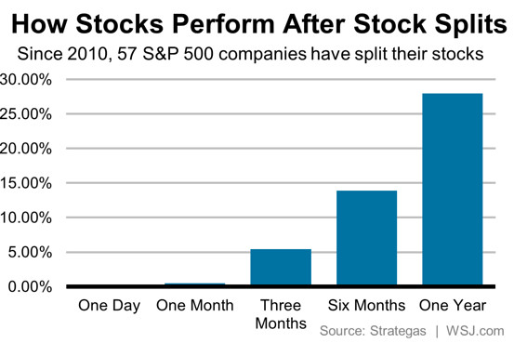
WHAT IF APPLE NEVER SPLIT ITS STOCK? Apple has now split its stock four times throughout its history. It previously conducted 2-for-1 splits on three separate occasions: February 2005, June 2000 and June 1987. According to some back-of-the-envelop math by S&P’s Howard Silverblatt, if Apple never split its stock, you’d have eight shares for each original one prior to the most recent split. So Friday’s $645.57 closing level would translate to $5164.56 unadjusted for splits.

