25 August 2016

Is There a Bond Market Bubble?

By Ron Rimkus, CFA

What is a financial bubble?
A financial bubble occurs when the market price of a security or a group of securities increases well beyond the point where the long-term benefits of ownership fail to compensate the investor for the costs — market price, trading costs, liquidity, etc. — and risks of ownership.
Which brings us to the bond market.
If the results of a recent CFA Institute Financial NewsBrief poll are any indication, at least some of the global fixed-income market is in bubble territory. So if respondents agree with the above definition, then 87% of the 815 participants believe that owning at least some types of fixed income no longer makes sense.
Yet clearly many investors do own these bonds. What explains this dissonance?
The global policy response since the financial crisis of 2008 has been massive and unrelenting. While the US Federal Reserve has (at least for now) ceased its quantitative easing (QE) operations, it has struggled to return interest rates back to normal levels or reduce its balance sheet back to its former size. Japan has maintained QE at approximately 15% of its GDP for some time, and recently hinted that it may escalate it in the near future. In March of this year, the European Central Bank (ECB) increased its QE program from €60 billion to €80 billion in bond purchases per month.
All of this bond buying by central banks has been intentional, of course. By providing a bid under bonds, they have lifted bond prices and reduced interest rates. In many cases, like in Europe and Japan, this has created negative interest rates. The ECB now “charges” a negative interest rate of 0.4% for banks that borrow from the ECB. Of course, this means that the ECB is actually paying banks to borrow money.
In July, Germany became the second G7 nation to issue a 10-year bond with a negative yield. In fact, according to a recent report by Bloomberg, more than 80% of German government bonds have negative yields. In Japan, 20-year bonds are now below zero. This is making it hard on global bond fund managers where Japanese bonds typically comprise 20%–35% of the global bond indices. (How would you like guaranteed losses on one-third of your holdings?)
Globally, over $13 trillion of the global bond market is now negative. “It’s surreal,” says Gregory Peters of Prudential Fixed Income.
Of course, this backward, underwater, upside-down world is just fine with some people. Certain investors suggest that negative yields are a “Sign of Prosperity.” And some bond managers have even figured out clever ways to make money in this market. For instance, PIMCO is buying negative yielding Japanese bonds and using swaps to lock in exchange rates, effectively quadrupling the yield on long-only US bonds of similar duration. So, they are buying negative yielding bonds, but using savvy finance skills to transform it into positive yield.
And that’s really the game, isn’t it? Low and negative rates are forcing legions of investors to seek higher yield, and in doing so, they are taking on more and more risk. Maybe it’s because they know that the central banks will maintain these policies despite potentially adverse consequences in the long term.
So, what do CFA Institute Financial NewsBrief respondents make of the fixed-income market today? As noted, 87% of respondents see the bond market in bubble territory in some way. In other words, they believe that bonds today fail to compensate investors for the costs and risks of ownership.

Are any of the following global fixed-income markets in bubble territory?
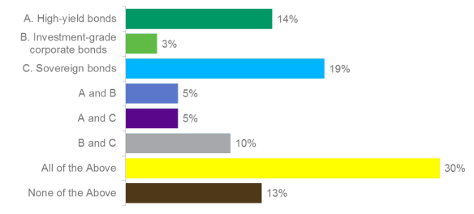

The largest segment of respondents (30%) believe all bonds are in bubble territory. Another 24% see a bubble in sovereign bonds and at least one other class of fixed income, while 14% of poll participants think that only high-yield bonds are over-inflated. When combined with other classes of bonds, 54% of respondents view high-yield bonds as in bubble territory. And roughly 13% don’t see a fixed-income bubble anywhere. Perhaps this cohort should have attended the Financial Analyst Seminar in Chicago where Edward Altman suggested that “the benign credit cycle is in ‘extra innings‘” — an ominous sign of a coming default cycle.
Most investors recognize the vast power that central banks wield but, by and large, disagree with the wisdom of their policies. In order for the world to return to market pricing of bonds, there has to be a catalyst. The power of the central banks must be more than offset by something else. There has to be a fundamental wave — either positive or negative — to counteract it, or a political wave to change it.
Until then, investors will remain adrift on an ocean of negative yields.
Editor’s note: An earlier version of this article did not specify that 815 respondents participated in the poll and stated that “only 14% of poll participants think high-yield bonds are over-inflated.” That was incorrect. It now reads ” . . . while 14% of poll participants think that only high-yield bonds are over-inflated.” Also, an earlier version did not specify that Germany was the second G7 nation to issue negative 10-year bonds. It did so in July.

