Opinion: Why Greenspan is wrong about bubbles in bonds
Published: Aug 4, 2017 3:32 a.m. ET

By

CAROLINEBAUM
Getty Images
Former Chairman of the Federal Reserve Alan Greenspan sees bubbles.
Alan Greenspan, the former Federal Reserve chairman who presided over the creation of two asset bubbles and exited before the second one could burst, is back with a new book and a new warning about — you guessed it — a bubble in bond prices.
Whether Greenspan’s timing proves as precise as his departure from the Fed in 2006, after which all hell broke loose, remains to be seen. But the double-bubblemeister took to the airwaves to warn of “a stagflation not seen since the 1970s” that will undercut asset prices.
Bond prices, not stock prices, are the Maestro’s main concern. When inflation rears its head, the bubble in bond prices will burst, he said. Rising interest rates will short-circuit the stock market’s seemingly boundless enthusiasm.
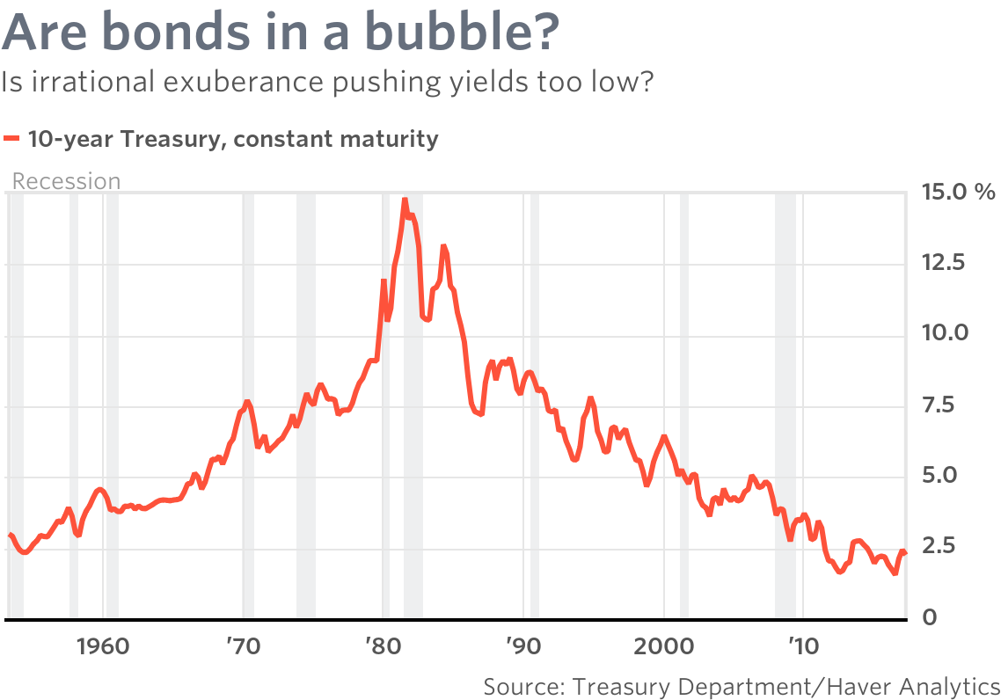
Alan Greenspan argues that current low yields on bonds is the result of irrational exuberance by investors. The former Fed chairman said higher yields are inevitable and he predicted a stagflation not seen since the 1970s.
With all due respect to Maestro Greenspan, Mr. Market has a different take. There is not a soupçon of concern about inflation to be found anywhere in the bond market. Nominal and real rates are historically low, as are inflation expectations. Ten-year inflation expectations have been well below the Fed’s 2% target for almost three years, excluding a brief period earlier in 2017 when they breached that level.
Greenspan’s views contrast with those expressed by many current Fed officials, including Chairwoman Janet Yellen, who are concerned about the persistence of low inflation even as the economy operates at what is perceived to be full employment.
On Tuesday, the Bureau of Economic Analysis reported that the personal consumption expenditures price index rose 1.4% in June from a year ago, the fourth consecutive monthly drop in the annual rate. This constitutes a conundrum for the Fed, defying as it does its Phillips Curve model, premised on an inverse relationship between the unemployment rate and inflation.
The Phillips Curve hasn’t been operational for a long time. And when it was, the relationship — initially between unemployment and wages in the U.K. — was only valid in the short run. The absence of any long-term trade-off was described by economists Milton Friedman and Edmund Phelps in the late 1960s. The coexistence of high unemployment and high inflation in the 1970s provided real-world validation of their research.
If Greenspan is looking for history to repeat itself in the form of 1970’s-style stagflation, he may be disappointed. There are some similarities to that era — a productivity slump was common to both periods — but even more differences, not all of which are positive for the outlook. Still, the parallels aren’t convincing.
On the positive side, central bankers have come a long way in terms of their credibility by bringing inflation down and keeping it down. (”The Great Moderation” is more than an empty slogan.) Investors believe that the central bank won’t let inflation diverge too much from its target, despite pressure from some academic economists to raise the target to 4%.
On the negative side, the labor force was expanding rapidly in the 1970s as women sought work outside the home. Today, with the baby boomers retiring — the oldest boomers turned 65 in 2011 — annual labor-force growth has slowed to a crawl of 0.6% compared with a post-war average of 1.5%.
This is important because productivity and labor-force growth circumscribe how fast an economy can grow without creating inflationary pressure. That moving target has been revised so many times that one is forced to conclude that the labor market isn’t as tight, nor slack as limited, as the 4.4% unemployment rate would suggest.
There is still a good deal of underemployment in the U.S. economy, including those working part time who would like a full-time job and those who have stopped looking. The participation rate remains depressed at 62.8%.
Before making predictions of a repeat of ‘70s-style stagflation, it would be wise to try to understand why the Fed and private-sector economists have been so wrong about inflation. The Fed’s default explanation — “transitory” factors are depressing inflation — is getting old. There are clearly forces at work that no one has been able to identify or quantify just yet.
In a December 1996 speech, Greenspan introduced a new term into the lexicon when he asked, “how do we know when irrational exuberance has unduly escalated asset values, which then become subject to unexpected and prolonged contractions as they have in Japan over the past decade?”
Nobel laureate Robert Shiller published a book titled “Irrational Exuberance” in March 2000, coinciding with the peak of the internet bubble. The technology-heavy Nasdaq Composite Index COMP, +0.25% set an all-time high that month of 5048.62, a level only eclipsed in 2015.
Greenspan answered his own question about central bankers’ ability to identify asset bubbles many times in the ensuing years. We can’t know, he said, when a little “froth” in asset markets (a Greenspan favorite) turns into irrational exuberance, with all the untoward consequences that come with it.
It’s comforting to learn that, two decades later as a private citizen, Greenspan has acquired the sixth sense necessary to do just that.

