First Mid Term Exam
Name ______________________________________________________

Short Answer Questions
- In the article “What caused the financial crisis”, the authors say that “but it is dangerous to conclude that the crisis would have been avoided if only we had regulated everything a lot more, had fewer housing subsidies, and had more responsible bankers. Simple narratives like these ignore the global nature of this crisis, and promote a simplistic explanation of a complex problem. Though tempting politically, they will ultimately lead to mistaken policies.” Do you agree to the above opinion? Why or why not? How to prevent the next financial crisis? (10 points)

- What are the six parts of the financial markets? What are the five core principals of finance? Why do we need stock exchanges? (10 points)

- HFTs (high frequency traders) are market maker or market taker? What can the government do to keep HFTs from stealing from the market? (10 points) --- Read “Everything You Need to Know About High-Frequency Trading” as reference.

- "While the total amounts will start small, they're going to increase pretty quickly. Next year we're going to have $230 billion that comes off the Treasury portfolio and $150 billion that comes off the mortgage portfolio… By the end of 2021, you're looking at a cumulative impact of $1.4 trillion. The market should be efficient and be pricing it in already." “While banks and central banks will buy some of the Treasurys and mortgages that the Fed is stepping away from, private investors will also need to step up to buy more. That growing supply in the market could have some impact on rates, pressuring them higher”. What has changed in terms of Fed’s monetary policy? Why? (10 points) --- use “The Fed is taking a major step away from its Great Recession policy” as reference.

- 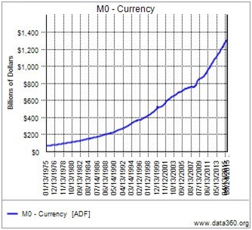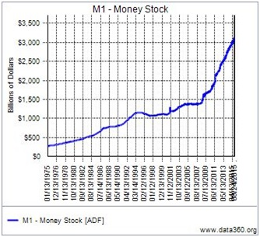

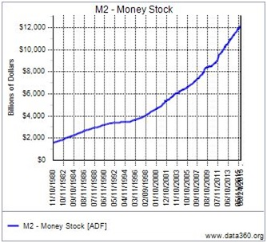

As shown in the above graph, M2>> M1>>M0. Why? (10 points)

- Imagine that you just deposited $100 in Bank A. Imagine also that the fractional banking system is fully functioning. After three cycles, what is the amount that has been deposited and what is the total amount that has been lent out? Fill up the blanks in the following table (10 points)
Iteration # | Deposited by | Amount Held | Amount | Total Amount that | Total Amount that | Total Amount | Total Amount that
 | Customer | in Reserve | Currently | “Can” be | Has Been | Held in Reserve | Customers Believe
 |  | from Deposit | Available to | Lent Out | Lent Out |  | They Have
 |  |  | Lend Out
 |  |  | from Deposit
1
2
3

- Time value of money question: After graduation, you plan to work for 12 years and then start your own business. You expect to save $7,500 each year for the first 6 years and $15,000 annually for the following 6 years. The first deposit is expected to be made one year from today. In addition, you just received a $25,000 graduation gift which you will deposit right away. If the interest rate = 9%, compounded annually. Calculate how much you will have 12 years from now when you start your business? ------ Just write down the equation. Hint: use the future value formula future value = present value *(1+ rate)^n (10 points)

- You are a fan of Apple products. You anticipate the rising of Apple’s stock prices after the releasing of iphone X. How can you use different order types to achieve the goal such as earn a respectable return with almost no risk at all (or as little as possible)? (Order types to consider: market order, limit order, stop loss order)

- DCPH (Deciphera Pharmaceuticals) went public on 9/28. Deciphera Pharmaceuticals, Inc. (NASDAQ: DCPH), a clinical-stage biopharmaceutical company focused on addressing key mechanisms of tumor drug resistance, today announced the pricing of its initial public offering of 7,500,000 shares of common stock at a public offering price of $17.00 per share for aggregate gross proceeds of $127,500,000. All of the shares of common stock are being offered by Deciphera. In addition, Deciphera granted the underwriters a 30-day option to purchase up to 1,125,000 additional shares of its common stock at the initial public offering price. The shares are scheduled to begin trading on the NASDAQ Global Select Market on September 28, 2017 under the ticker symbol “DCPH.” The offering is expected to close on October 2, 2017, subject to customary closing conditions.
J.P. Morgan and Piper Jaffray & Co. are acting as joint book-running managers for the offering. JMP Securities LLC is acting as lead manager and Nomura Securities International, Inc. is acting as a co-manager for the offering.
As of 10/7/2017, the stock price of DCPH is $22.91/share. The offering price at IPO was $17, a return of 29.41% in a short period of time. JP Morgan is one of the underwriters. Why did not JP Morgan set the price right at the IPO, such as at $22 per share? Why do they leave money on the table? Is that cheating?

Refer to the following stock price chart for price information.

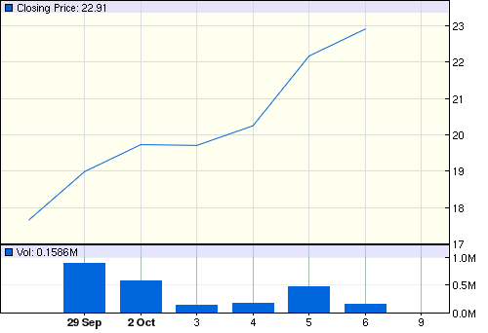

10. “A basic principle of U.S. stock exchanges is that the first investor to place an order at the best current price generally should be the one whose order is filled first.” Refer to the article “How ‘hide not slide’ orders work” and answer why using ‘hide not slide’ orders can violate this SEC rule.

