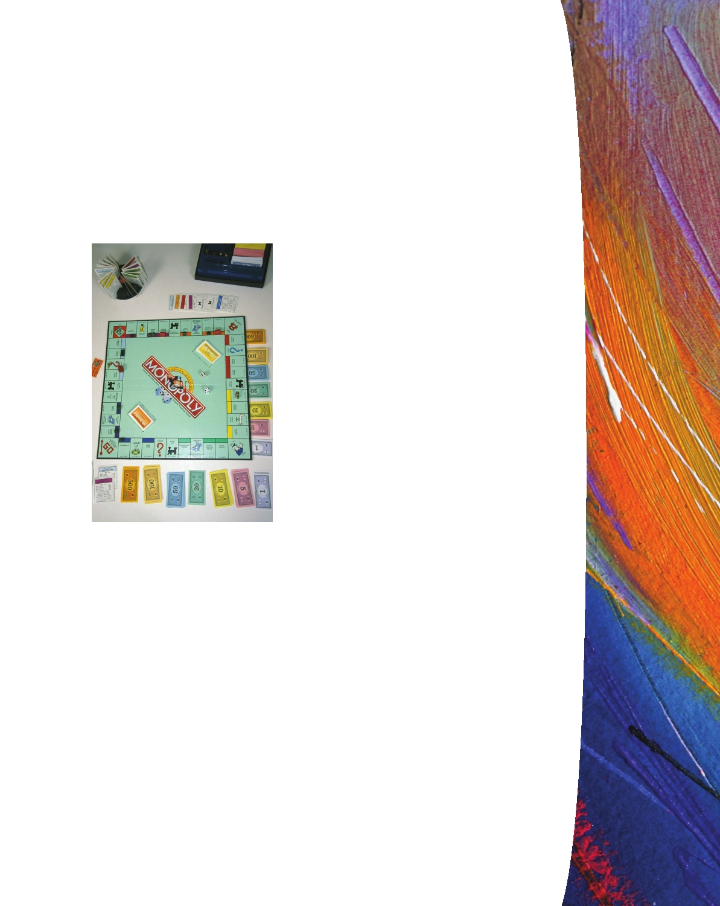
Chapter 2
Money and the Payments System

The makers of the board game Monopoly print about $50 billion of Monopoly money every year—coincidentally about the same as the amount of new U.S. currency issued in 2008. Every game has bills totaling 15,140 Monopoly dollars. At a cost of about 13 U.S. dollars per set, this "money" would be a good deal if you could buy things other than Boardwalk and Park Place with it. Unfortunately, attempts to pay for gro- ceries, books, or rent with this particular form of money have been unsuccessful. And that's probably a good thing. Since the mid-1930s, Parker Brothers has sold more than 200 million Monopoly games, containing more than 3 tril-
lion Monopoly dollars.1
When we pay for our purchases in the real world, we have lots of choices: crisp new $20 bills, credit cards, debit cards, checks, or more complicated electronic methods. Re-

Parker Brothers' bestselling board
game.
gardless of the choice we make, we are using money to buy our food and clothes and pay our bills. To make sure we can do it, thousands of

people work through every night, for the payments system really never sleeps. And the volume of payments is astounding. The Federal Reserve reports that in 2006 there were 93 billion noncash payments made in the United States, 33 percent of which were paper checks. That means something like 120 million paper checks and 250 million electronic payments were processed on an average business day. And, regardless of how you choose to pay, the path that the payment follows is pretty complicated.
To understand why money is so important to the smooth functioning of the econ- omy and how it improves everyone's well-being, we need to understand exactly what money is. Just why is a $20 bill issued by the U.S. government much more useful than $20 in Monopoly money? Furthermore, to quantify the impact of money on the economy, we need to be able to measure it. Those are the goals of this chapter: to understand what money is, how we use it, and how we measure it.

1

For more fun facts about Monopoly, see www.monopoly.com.

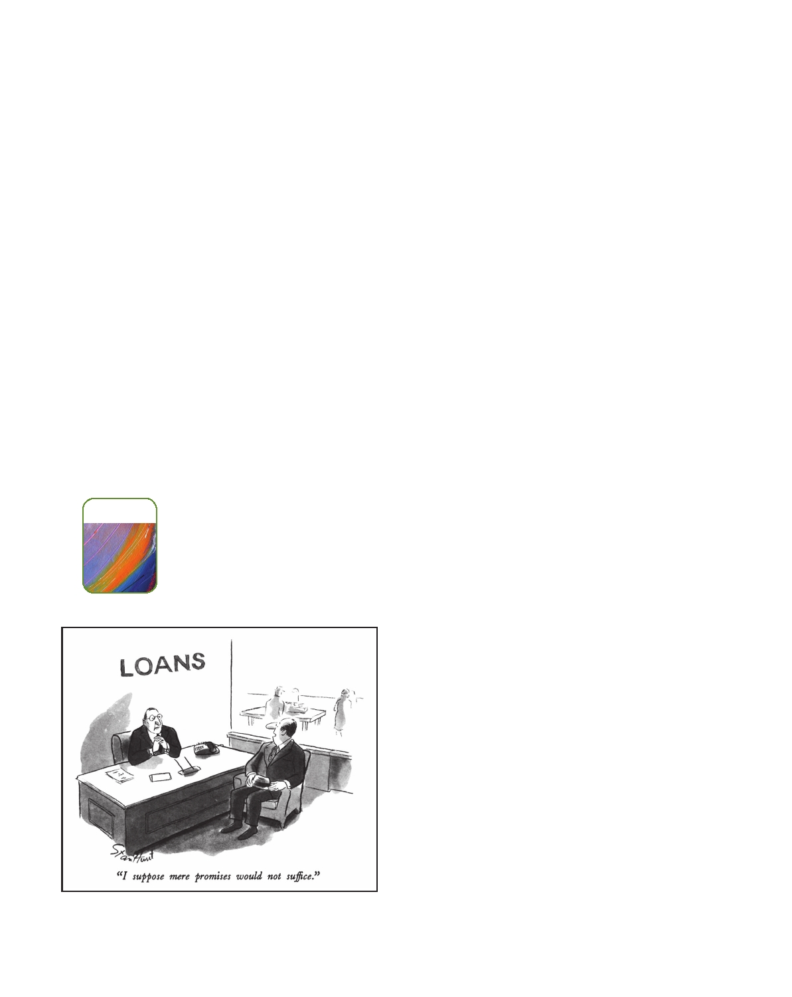
20
l Chapter 2 Money and the Payments System

Money and How We Use It
When people use the word money in conversation, they mean many different things.
Someone who "makes lots of money" has a high income; a person who "has lots of money" is wealthy. We will use the word money in a narrower, specialized sense to mean anything that can readily be used to make economic transactions. Formally defined, money is an asset that is generally accepted as payment for goods and services or repayment of debt. Income, in contrast, is a flow of earnings over time. Wealth is the value of assets minus liabilities. Money is one of those assets, albeit a very minor one.
Money, in the sense we are talking about, has three characteristics. It is (1) a means of payment, (2) a unit of account, and (3) a store of value. The first of these characteristics is the most important. Anything that is used as a means of payment must be a store of value and thus is very likely to become a unit of account. Let's see why this is so.

Means of Payment
The primary use of money is as a means of payment. Most people insist on payment
in money at the time a good or service is supplied because the alternatives just don't work very well. Barter, in which a good or service is exchanged directly for another good or service, requires that a plumber who needs food find a grocer who needs a plumbing repair. Relying on this "double coincidence of wants" surely causes the economy to run less smoothly. The plumber could pay for his breakfast cereal with a "promise" of plumbing services, which the grocer could then transfer to someone else.

INFORMATION
But while it would be possible to certify the plumber's trustworthiness, certainly tak- ing payment in money is easier. Money finalizes payments so that buyers and sellers have no further claim on each other. That is money's special role. In fact, so long as a buyer has money, there is nothing more the seller needs to know.
As economies have become more complex and physically dispersed, reducing the likelihood that a seller will have good information about a buyer, the need for money has grown. The increase in both the number of transactions and the number
of potential buyers and sellers (the vast majority of whom may never even have seen one another) argues for something that makes payment final and whose value is easily verified. That something is money.

Unit of Account
Just as we measure length using feet and inches, we
measure value using dollars and cents. Money is the unit of account that we use to quote prices and record debts. We could also refer to it as a standard of value.
Having a unit of account is an incredible con- venience. Remember from microeconomics that prices provide the information consumers and pro- ducers use to ensure that resources are allocated to their best uses. What matters are the relative

SOURCE: © Stan Hunt/The New Yorker
Collection/www.cartoonbank.com. prices of goods and services. When the price of one

Money and How We Use It Chapter 2 l 21

YOUR FINANCIAL WORLD
Debit Cards versus Credit Cards

When you go shopping, should you pay with a credit card or a debit card? To decide, you need to understand the difference between the two. First make sure you know which one of your cards is which. Usually an ATM card (the one that you got from the bank when you opened your checking account) is a debit card. But check to make sure.
What's the real difference, from the shopper's point of view? A debit card works just like a check, only faster. When you write a paper check, it usually takes a day or two to go through the system. A debit card transaction goes through right away. The electronic message gets to your bank on the same day, and your account is debited immediately. So, if you want to use your debit card, your account balance has to be higher than the payment you want to make.
A credit card creates a deferred payment. The issuer agrees to make the payment for you, and you repay the

debt later. That sounds good, but there's a catch. If you're late paying, there's a late fee. And if you don't pay the en- tire debt every month, you pay interest on the balance—at what is usually a very high interest rate. If you do pay the entire debt every month, however, there is no late fee and no interest charge. And because you don't pay right away, you get an interest-free loan from the time you make the purchase to the time you pay the balance. If you can pay off your credit cards in full and on time, it's to your advan- tage to use them.
Credit cards have another advantage over debit cards. They help you to build a credit history, which you'll need when the time comes to buy a car or a house. Because debit cards are just extensions of your bank account, they don't show potential lenders that you are creditworthy. In fact, some businesses, like car rental companies, require their customers to use credit cards for this reason.

product is higher than the price of another, that product is worth more to both producers and consumers. Using dollars makes these comparisons easy. Imagine what would happen if we needed to compute relative prices for each pair of goods. With two goods, we would need only one price. With three goods, we would need three prices. But with 100 goods, we would need 4,950 prices, and with 10,000 goods (substantially less than the 70,000 products in a typical supermarket), we would need nearly 50 million prices.2 Using money as a yardstick and quoting all prices in dollars certainly is easier.

Store of Value
For money to function as a means of payment, it has to be a store of value, too. That
is, if we are going to use money to pay for goods and services, then it must retain its worth from day to day. Sellers are much less likely to accept things that are perishable, like milk or lettuce. So the means of payment has to be durable and capable of trans- ferring purchasing power from one day to the next. Paper currency does degrade with use ($1 bills have an average lifetime of 21 months in circulation), but regardless of its physical condition, it is usually accepted at face value in transactions.
Of course, money is not the only store of value. We hold our wealth in lots of other forms—stocks, bonds, houses, even cars. Many of these are actually preferable to money as stores of value. Some, like bonds, pay higher interest rates than money. Others, like stocks, offer the potential for appreciation in nominal value, which money does not. Still others, like houses, deliver other services over time. Yet we all hold

2

The general formula is that for n goods we need n(n

1)/2 prices, so for 10,000 goods, the number would be

10,000 (9,999)/2 49,995,000.

22 l Chapter 2 Money and the Payments System

TIME

money because money is liquid. Liquidity is a measure of the ease with which an asset can be turned into a means of payment, namely money. For example, a bond is much more liquid than a house because it is so much easier and cheaper to sell. The more costly it is to convert an asset into money, the less liquid it is. Because constantly transforming assets into money every time we wished to make a purchase would be extremely costly, we keep some money around.
Financial institutions often use a more specific term—market liquidity—for their ability to sell assets for money. A second, related concept—funding liquidity—refers to their ability to borrow money to buy securities or make loans. For financial institu- tions, liquidity in both those senses is critical to their daily operations: A shortfall of either type can lead to their outright failure (see Lessons from the Crisis: Market Liquidity, Funding Liquidity, and Making Markets on page 28).

The Functions of Money

1. Means of payment: Used in exchange for goods and services.
2. Unit of account: Used to quote prices.
3. Store of value: Used to move purchasing power into the future.

The Payments System
The payments system is the web of arrangements that allow for the exchange of
goods and services, as well as assets, among different people. Because the efficient operation of our economy depends on the payments system, a critical public policy concern is that it functions well. As we will see in Part IV, that is why central banks are directly involved.
Money is at the heart of the payments system. Whether we realize it or not, virtu- ally every transaction we engage in involves the use of money at some point. Let's go through all the possible methods of payment to see how the system works.

Commodity and Fiat Monies
The first means of payment were things with intrinsic value. These commodity
monies included everything from silk in China to butter in Norway, whale teeth in Fiji, and salt in Venice. All these things had value even if they were not used as money. The worth of a block of salt, for instance, came from its value as a preserva- tive. But successful commodity monies had other characteristics: They were usable in some form by most people; they could be made into standardized quantities; they were durable; they had high value relative to their weight and size so that they were easily transportable; and they were divisible into small units so that they were easy to trade. For most of human history, gold has been the most common commodity money. It is widely accepted as payment; can be purified and made into standard weight units like coins; and is extremely durable since it does not corrode or tarnish. Moreover, gold is rare (there is only enough in existence to fill about one-third of the Washington

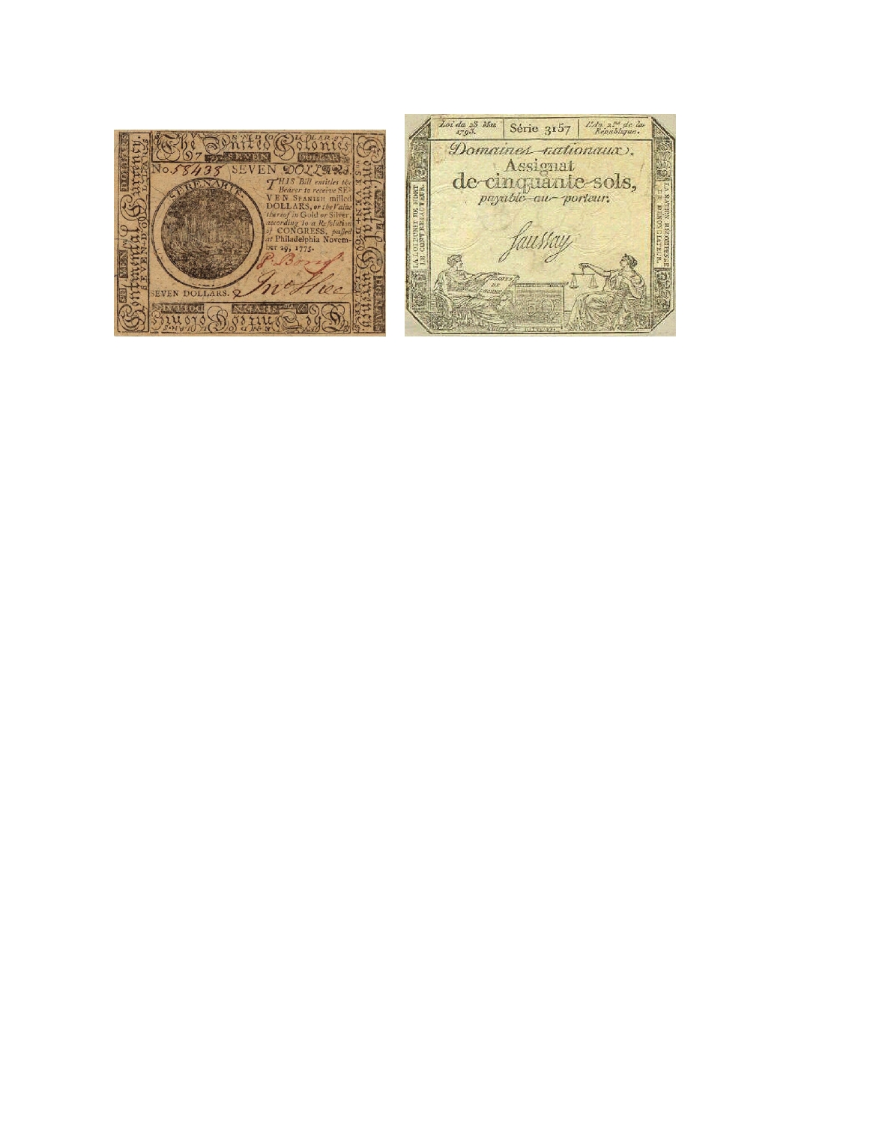
The Payments System Chapter 2 l 23

A Revolutionary War "continental" issued by the Continental Congress in 1775.
The new government of the United States
eventually printed $200 million worth, and by 1781 they no longer had any value.

An assignat issued by the French
Revolutionary Government in 1793. Faced
with the need to finance wars and food
shortages, the government eventually
printed 40 billion of them and by the late 1790s they were worthless.

Monument with solid gold), so it has high value relative to weight. And it can be cut into smaller pieces without losing its value.
In 1656, a Swede named Johan Palmstruck founded the Stockholm Banco. Five years later he issued Europe's first paper money.3 At the time, the Swedish currency was copper ingots, which works poorly as money because of its low value per unit of weight. (Today, copper is worth only about 18 cents per ounce, or roughly 1/100 the value of silver and 1/6,000 the value of gold.) Thus, easy-to-handle paper was wel- comed, at least at first.
After a few years of printing paper currency, Palmstruck and his sponsor, the King of Sweden, became overly enamored of the new money. The king needed to finance some wars he was fighting, so he convinced Palmstruck to print more and more notes. Because the bills were redeemable on demand for metal, the system worked only as long as people believed there was enough metal sitting in Palmstruck's vaults. As the number of notes increased, Swedes lost confidence in them and started to redeem them for the metal they supposedly stood for. But Palmstruck had issued too many notes, and his bank failed.
Other people tried issuing paper money during the early 1700s. Eventually govern- ments got into the act. In 1775, the newly formed Continental Congress of the United States of America issued "continentals" to finance the Revolutionary War. Twenty years later, revolutionary France issued the "assignat." Lacking any other source of funding for their wars, both governments issued huge quantities of the currencies, and both currencies eventually became worthless.
The reaction was predictable: People became suspicious of government-issued paper money. But governments need funds and will use all available means to get

3

The Chinese were the real monetary pioneers, issuing their first paper currency in the 7th century, 1,000 years

before the Europeans.

24
l Chapter 2 Money and the Payments System

them. In the United States, the Civil War put pressure on government finances and the two warring parties had little choice but to issue paper money to pay for salaries and supplies. Beginning in 1862, both the Confederate and the Union governments printed and used paper money with no explicit backing. The North's "greenbacks" are still legal tender in the United States, but collectors are the only people who value the Confederate currency.
After the Civil War, the United States reverted to the use of gold as money. Both gold coins and notes backed by gold circulated well into the 20th century. Today, though, we use paper money—high-quality paper, nicely engraved, with lots of special security features. This type of currency is called fiat money, because its value comes from government decree, or fiat. Some countries print notes that are durable and at- tractive, bearing famous works of art in multiple colors. The Australians make their notes out of plastic. But in all cases the money has very little intrinsic worth, and the cost of production is only a small fraction of the face value. The U.S. Treasury's Bureau of Engraving and Printing pays less than 7 cents to print a note, regardless of whether it's a $1 or a $100 bill.
Why are we willing to accept these bills as payment for goods or in settle- ment of debts? There are two reasons. First, we take them because we believe we can use them in the future; someone else will take them from us. Second, the law says we must accept them. That is, the U.S. government stands behind its paper money. Since the first greenbacks were issued in 1862, all U.S. currency has borne the short and simple phrase "This note is legal tender for all debts, public and private." In practice, this means that private businesses must accept dollar bills as payment. More important, the U.S. government is committed to accepting the currency it has issued in settlement of debts. We will always be able to pay our taxes in dollars. As long as the government stands behind its paper money and doesn't issue too much of it, we will use it. In the end, money is about trust.

Checks
Checks are another way of paying for things. Unlike currency, the checks you use
to pay your rent and electric bill are not legal tender. In fact, they aren't money at all. A check is just an instruction to the bank to take funds from your account and transfer them to the person or firm whose name you have written in the "Pay to the order of " line. Thus, when you give someone a check in exchange for a good or ser- vice, it is not a final payment—at least, not in the same sense as currency. Instead, your check sets in motion a series of transactions that eventually lead to the final payment.
Here are the steps. You hand the check over to a merchant, who then takes it to the bank. Depending on the arrangement, the bank will credit the amount of the check to the merchant's account either immediately or with a short lag. At the end of the day, the bank sends the check (or an electronic image) through the check- clearing system along with the other millions of checks to be processed that night by shipping them to a check-processing center run by the Federal Reserve or to a private check clearinghouse. (The first check clearinghouses were pubs where bank employees met to have a drink and exchange checks.) At the center, the check is transferred from the bank that sent it in to the bank on which it is written—your bank. The account of the bank presenting the check is credited, and the account of

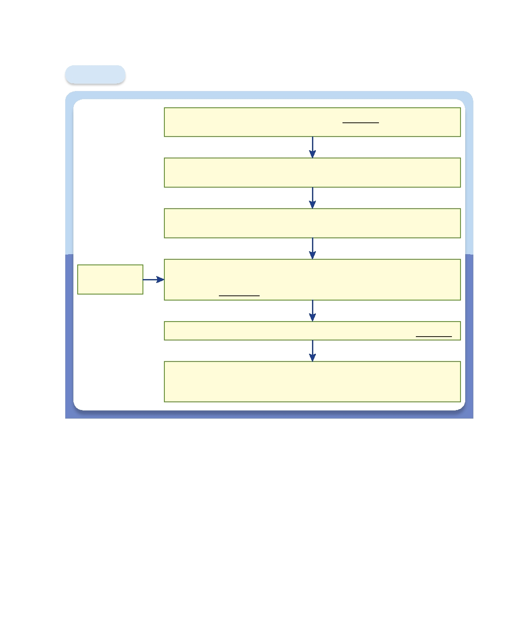
The Payments System Chapter 2 l 25

Figure 2.1 The Path of a Paper Check

You hand a paper check from your bank to a
merchant in exchange for groceries.

The merchant deposits the check or an electronic image of the check
into the merchant's bank and the merchant's account is credited.

The merchant's bank sends an electronic image of the check
to the local Federal Reserve Bank.

The Federal Reserve:

This step uses
money.
1. Credits the merchant's bank's reserve account and 2. Debits your bank's reserve account.

The Federal Reserve returns an electronic image of the check to your bank.

Your bank debits your checking account by the amount of the check.
(Your bank has several days to send the check back through the system if
you have insufficient funds in your account.)

the bank on which the check is written is debited (see Figure 2.1). This is the step that uses money.
Finally, on receipt of the check, your bank debits your account. (If the balance in your account is insufficient to cover the check, your bank has a few days to re- turn it to the sending bank, so the transaction isn't actually final until that period has passed.) In the past all paper checks were returned to the people who originally wrote them. Today, they are scanned and customers can view electronic images on their bank's Web sites. (See Your Financial World: Paper Checks Become Digital
Images.)
Recently check volumes have fallen, but paper checks are still with us for sev- eral reasons. A canceled check is legal proof of payment and, in many states, laws require banks to return checks to customers. Then there is force of habit. Over time, people may get used to receiving bank statements without their checks, but so

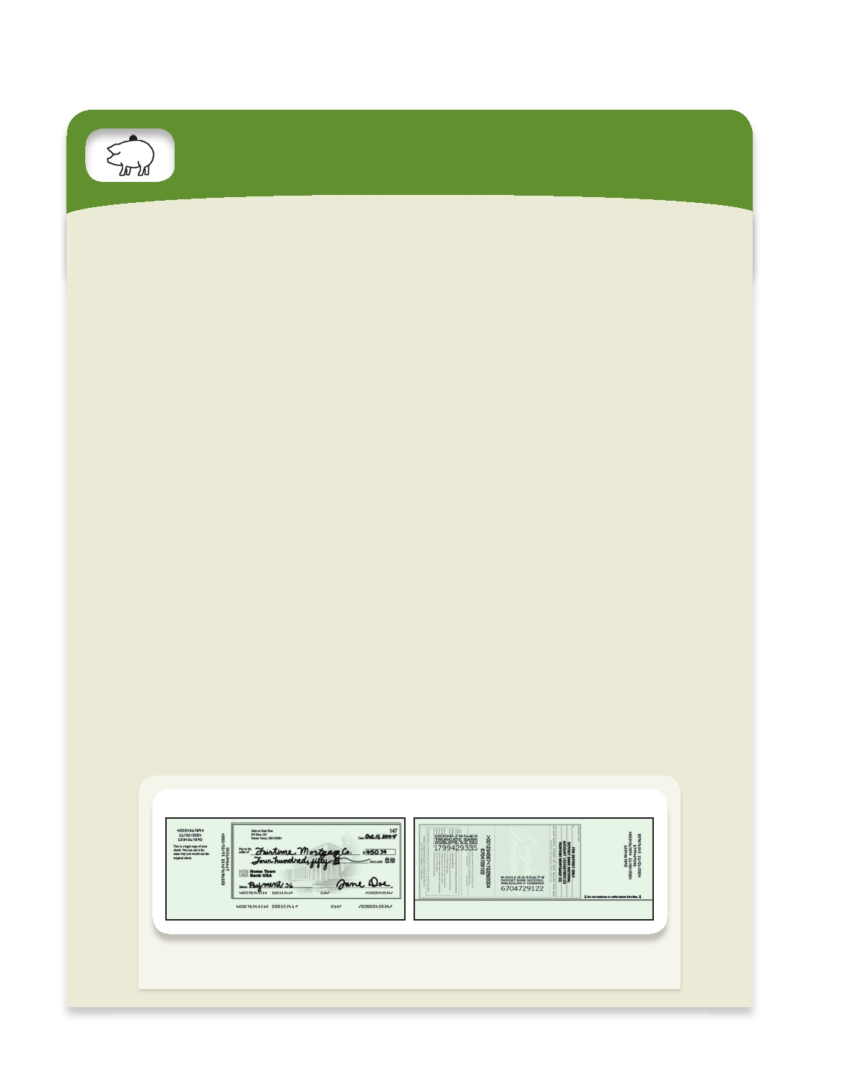
26 l Chapter 2 Money and the Payments System

YOUR FINANCIAL WORLD
Paper Checks Become Digital Images

For at least 30 years, there have been predictions that paper checks would disappear. Credit cards, ATM ma- chines, debit cards, automatic bill payment, and Internet banking were all supposed to get rid of them. Instead, each month millions of people received thick envelopes from their banks that included canceled checks along with their monthly statements. Paper checks accounted for 60 per- cent of payments in 2000. But no more! On October 28, 2004, Check 21—the Check Clearing for the 21st Century Act—went into effect.
Banks are thrilled. Until the fall of 2004, the check veri- fication and payment process required commercial banks to transport all paper checks to and from a Federal Reserve Bank, and eventually back to the people who wrote them. Paper checks were legal proof of payment, so customers wanted them back. But transporting tons and tons of checks around the country was an expensive headache for banks.
Check 21 gives banks the leeway to process checks electronically. Instead of shipping paper across the coun- try, banks transmit digital images of each check that was written. These images create "substitute checks," and have the same legal standing as the original checks.
Payments in long-distance transactions are now much less complicated. Before Check 21, if someone living in Houston sent a check to make a payment to a business in Chicago, the piece of paper had to go from Texas to Illinois, and then back again. Now, the check can be scanned and shredded in Chicago and the image is saved and transmit- ted. If the person who wrote it in Houston wants a paper copy of the canceled check, their bank can print a substi- tute check. A check processing system that used to take a few days now takes a few hours.
Processing checks electronically is definitely cheaper. With the volume of paper checks dwindling and most checks now clearing electronically, the Federal Reserve has reduced the number of its processing centers to 1—down

Front of Substitute Check

from 45 before Check 21. And, experts estimate that by scanning checks and transmitting the images, the banks will save $2 billion a year. These savings include $250 mil- lion spent on courier services to move checks around the country.
In fact, reducing the risks of physically transport- ing checks was one of the big reasons for the passage of Check 21. For several days following the September 11, 2001, terrorist attacks, only military planes were allowed to ﬂy in U.S. airspace and that disrupted the check trans- portation system eventually grounding $47 billion worth of paper checks.
Speeding up paper check processing does have one downside: People can't write checks with the expectation that they will have a day or two to make a deposit to cover it. There is no more ﬂoat. The new rules shrink the time between when a check is written and when the account is
debited, especially for out-of-town checks.*
By speeding up the processing of paper checks, Check 21 provides a further incentive for individuals to use debit cards, credit cards, or other forms of electronic payments. Nevertheless, billions of checks are likely to be written for years to come.
For more details on Check 21, payments system de- velopment and policies, see the Federal Reserve Board's payment system Web site http://www.federalreserve.gov/ paymentsys.htm.

*Just because banks are able to move checks through the clearing system more quickly doesn't mean that they are going to offer the depositor more timely access to the funds. In an attempt to reduce fraud, banks restrict access to funds from so-called high- risk checks, such as those for more than $5,000 that are deposited into newly opened accounts, for as long as 11 business days. If you have to shift large quantities of funds and use them quickly, it is important to find out the policies of the financial intermediaries involved before you do it.

Back of Substitute Check

The front of the substitute check includes the following: "This is a legal copy of your
check. You can use it the same way you would use the original check."

The Payments System

far not many people have chosen the option. Finally, new electronic mechanisms for clearing checks have lowered costs and kept checks as an attractive means of payment.

Electronic Payments
The third and final method of payment is electronic. We are all familiar with credit
cards and debit cards. A less well-known form of payment is electronic funds transfers. While there are a large number of credit and debit card transactions, electronic funds transfers account for the bulk of the $35 trillion worth of noncash, noncheck pay- ments made each year in the United States.
What is the difference between debit cards and credit cards? A debit card works the same way as a check in that it provides the bank with instructions to transfer funds from the cardholder's account directly to a merchant's account. There is usu- ally a charge for this; the processor of the payment takes a fee based on the size of the transaction.
A credit card is a promise by a bank to lend the cardholder money with which to make purchases. When a shopper buys a pair of shoes with a credit card, the shoe store's bank account receives payment immediately, but the money that is used for payment does not belong to the buyer. Instead, the bank that issued the credit card makes the payment, creating a loan the cardholder must repay. For this reason, credit cards do not represent money; rather, they represent access to someone else's money.
Electronic funds transfers are movements of funds directly from one account to another. These transactions are used extensively by banks and are becoming increasingly popular for individuals as well. For individuals, the most common form is the automated clearinghouse transaction (ACH), which is generally used for recurring payments such as paychecks and utility bills. Some merchants use them for one-time transactions as well. ACH transactions are just like checks except that they are entirely electronic. Your bank account is debited or cred- ited automatically, and you receive periodic notifications of the activity in your account.
Banks use electronic transfers to handle transactions among themselves. The most common method is to send money through a system maintained by the Federal Reserve, called Fedwire. The volume and value of payments made through this system are substantial. On a typical day in 2009, the system completed 495,000 transactions with a total value of about $2.5 trillion.
Retail businesses, together with their banks, are experimenting with a variety of new methods of electronic payment. One is the stored-value card, which looks like a credit or debit card except that it doesn't bear your name. To use one, you go to the bank or ATM machine and put the card into an electronic device that transfers funds from your checking account to your card. Then you take the card to a merchant who has a reader that is capable of deducting funds from the card and depositing them directly into the store's account. The stuff on the card is in fact money, and the system can be set up so that if you lose your card, its current value can be canceled.
So far, these cards have limited usefulness. The New York City Metropolitan Transit Authority and other city transit systems sell stored-value cards, but it's hard to buy anything with them other than subway and bus rides. The same is true of long-distance phone cards and gift cards sold by chain stores like Barnes & Noble.
Chapter 2 l 27

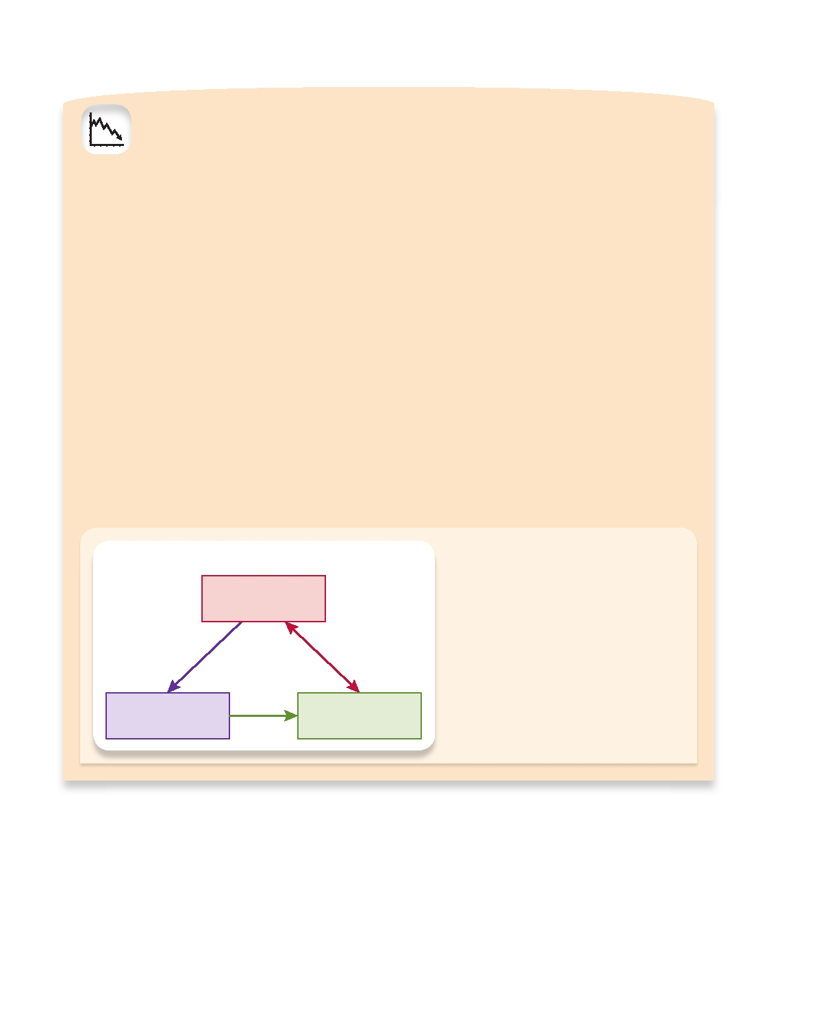
28
l Chapter 2 Money and the Payments System

LESSONS FROM THE CRISIS
MARKET LIQUIDITY, FUNDING
LIQUIDITY, AND MAKING MARKETS

A "market maker" in stocks, bonds, or other securities is usually a financial institution that buys and sells securi- ties on behalf of clients. If buy orders at a market maker exceed sell orders for a particular security, the market maker must be able to act as the seller to clear the market. Therefore, market makers usually hold inventories of the specific financial instruments in which they trade, and they borrow to maintain inventories at adequate levels.
Market liquidity—the ability to sell assets—and funding liquidity—the ability to borrow money—are both needed to make financial markets function smoothly. If a loss of funding liquidity prevents market makers from holding adequate inventories, trading and market liquidity suf- fer. Conversely, if market liquidity for some financial in- struments declines, the prices of those instruments will fall as they become less attractive to investors; result- ing concerns about the safety of the market makers that hold the assets with falling prices may reduce their ability to borrow.
A sudden loss of liquidity was central to the 2007- 2009 financial crisis. Before the crisis, many financial

Liquidity Spiral

Price Decline of a Security

institutions relied on short-term borrowing to hold long- term financial instruments because their managers believed that funding liquidity would remain readily avail- able. They also believed that markets would always be liquid—that is, they would always be able to sell the secu- rities and loans that they held. They were wrong on both counts.
In the summer of 2007, investors began to doubt the value of a wide class of securities. As a result, market liquidity for those instruments disappeared, and financial institutions that held them faced large potential losses. In turn, funding liquidity for these institutions evaporated as the potential losses caused their lenders to worry about their safety.
This double "liquidity shock" led many financial institu- tions to increase cash holdings that they might otherwise have lent to others. Reduced loan supply intensified the vicious spiral of dwindling liquidity and falling securities prices. The financial system as a whole could not provide sufficient market liquidity or funding liquidity to satisfy heightened demands.
One lesson from the financial crisis is clear: Liquid- ity is a highly valuable resource that can disappear when it is most needed, so it should not be taken for granted. Even large and seemingly wealthy financial firms can fail if liquidity evaporates.

In the accompanying figure, a decline of
the price of a security makes it more costly for a financial institution to make a market
in that security, resulting in a decline
of market liquidity. That decline makes
the security less attractive to investors,
further reducing its price. If the price falls sufficiently, concern about the well-being
of market makers diminishes their funding liquidity, advancing a vicious cycle.

Funding Market Liquidity
Liquidity Decline Decline

Attempts to implement the stored-value card more broadly haven't worked very well because most merchants lack the hardware to read the cards. And few of us know how to use them.
E-money is another new method of payment. It can be used to pay for purchases on the Internet. You open an account by transferring funds to the issuer of the e-money. Then, when you are shopping online, you instruct the issuer to send your e-money to the merchant.

The Future of Money

E-money is really a form of private money. It is not issued or guaranteed by the government, so you can't use it to pay your taxes. It's hard to even define what the term e-money means. One definition that seems helpful is "monetary value, as repre- sented by a claim on the issuer, which is (a) stored on an electronic device, (b) issued on receipt of funds, and (c) accepted as a means of payment by persons other than
the issuer."4
But at this point, e-money is questionable at best. Will individuals develop enough trust in e-money to be willing to use it? Will merchants install the expensive equip- ment to handle it? Who will be allowed to issue e-money? Still, the day may come when you can park your car and pay the parking meter by simply punching a series of numbers into your cell phone that transfers e-money issued by your phone provider to the city government that owns the parking meter.

The Future of Money
Let's speculate about what might happen to money and each of its three functions in
the future. As a means of payment, it has already undergone big changes. The time is rapidly approaching when safe and secure systems for payment will use virtually no money at all.
We will always need money as a unit of account in which to quote values and prices; the efficiency of quoting prices in commonly understood terms isn't going to change. But the question is, how many units of account will we need? Today, many countries have their own currencies, which give rise to their own units of account. In the future, though, there will be little reason to maintain different units of ac- count across different countries. Price systems will be more like systems of weights and measures. Today, there are two commonly used systems of weights and measures: English ounces and yards and metric grams and meters. We will likely see a similar sort of standardization of money and a dramatic reduction in the number of units of account.
Finally, money as a store of value is clearly on the way out. With the advances in financial markets, many financial instruments have become highly liquid. They are easily bought and sold and can be converted into a means of payment quickly and cheaply. These instruments and the financial markets in which they trade are the subject of the next chapter. For now, though, we can conclude that in the future, there will almost surely be less and less money.
One caution is in order. As we look into the future and try to discern what will happen to money, we should remember that 150 years ago there was virtually no paper currency in circulation. The first credit card was issued in the early 1950s; the first ATM was installed around 1970. Not until the mid-1990s could we shop via the Internet. Forecasting most of these developments, as well as any other trend in technology, is nearly impossible. After all, who could have predicted even 10 years ago that today we would be able to check our bank balances, buy and sell stocks, and pay our utility bills 24 hours a day, seven days a week from the comfort
of our homes? (See In the News: Dad, Can You Text Me $200?)
Chapter 2 l 29

4

This definition comes from Directive 2000/46 of the European Parliament and the Council of 18 September

2000, "On the Taking Up, Pursuit and Prudential Supervision of the Business of Electronic Money Institutions," Official Journal of the European Communities, 275/39, 27 October 2000.

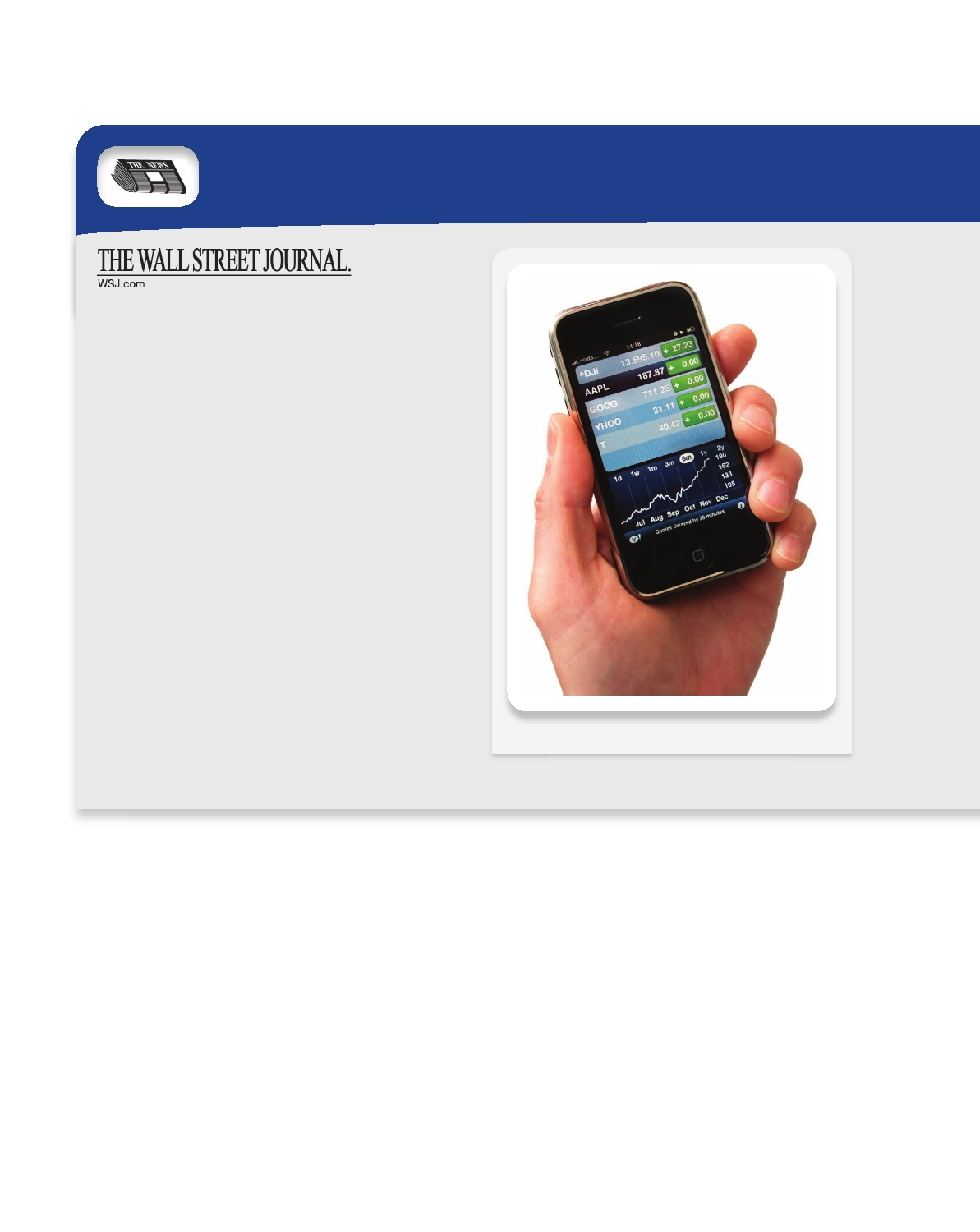
30 l Chapter 2 Money and the Payments System

IN THE NEWS
Dad, Can You Text Me $200?

by Jonnelle Marte
June 23, 2009

Parents, used to receiving kids' requests for money via email and cellphone, are now able to send that money via text message, email or cell.
A new service by CashEdge Inc., which provides online banking services for financial institutions, would let users send money to friends and family through a text message or email—further cutting down on our need to stop at ATMs or write checks when we owe people money.
"Paper transactions are shrinking and electronic trans- actions are growing and this just seems to be the next step along that path," said Steve Kenneally of the American Bankers Association.
The new service, called POPmoney, will let consumers "Pay Other People" through their bank's online or mobile banking application by providing the recipient's email address, cell phone number or account number.
Once users enter their friends' information online, they would be able to send the person-to-person payments di- rectly from their cell phones.
"You will be using your mobile phone to do small transfers over dinner" and to make other quick payments to friends or relatives, says CashEdge president Sanjeev Dheer.

Measuring Money

OMG, plz txt me $!

Changes in the amount of money in the economy are related to changes in interest
rates, economic growth, and most important, inflation. Inflation is the rate at which prices in general are increasing over time—and the inflation rate is a measure of that process.5 With inflation, you need more units of money to buy the same basket of goods you bought a month or a year ago. Put another way, inflation makes money less valuable. And the primary cause of inflation is the issuance of too much money. When the Continental Congress issued too much currency to finance the Revolutionary

5

The terms "inflation" and "inflation rate" are often used interchangeably. We will refer to inflation as the

process of prices rising, and inflation rate as the measurement of the process. The relationship between these terms is analogous to that between "heat" and "temperature." The second is the measure of the first.

Measuring Money Chapter 2 l 31

Recipients at participating banks will be able to accept the cash deposits through their own online banking ac- counts. They can also automatically deposit payments from specific users. For example, college students could have pay- ments from mom and dad automatically deposited into their checking accounts or vice versa.
The service will likely come with a fee, which Mr. Dheer says will be set by the financial institutions. A demo trans- action showed a standard transfer, which could take a few days, costing $2 and an express one costing $10.
The concept isn't completely new. Mobile banking apps already let people check their balances and transfer money from one account to another by pushing a few buttons. Pay- Pal, which most online shoppers know well, lets consum- ers send money electronically to friends using their email address. Zoompass, a service recently launched in Canada, lets users send, receive and request money from their mobile phones to an intermediary account—similar to PayPal— linked to their bank accounts.
But POPmoney's key feature is that it will allow users to send money directly from one bank account to another.
"This is a function that people should be able to do within their banks and not have to sign up for another ser- vice," says Mr. Dheer.
Those with banks that don't offer the service will be able to sign on to an online payment hub where they can provide their bank account information in order to receive the money.
Larger transactions will have added security measures, said Mr. Dheer. For instance, the person sending money will

have to give both an email and phone number for the recipi- ent, who would be required to submit a code sent to them via text before they could accept the money.
At first, consumers will only have the option to send and accept cash, not to request it, but CashEdge is hop- ing to offer that feature in later releases, said Mr. Dheer. POPmoney will likely be up and running around September, after banks integrate the service into their online banking hubs, says Mr. Dheer.

SOURCE: The Wall Street Journal Online. "Dad, Can You Text Me $200?" by Jonnelle Marte, June 23, 2009. Copyright 2009 by Dow Jones & Company, Inc. Reproduced with permission of Dow Jones & Company, Inc. in the formats Textbook and Other Book via Copyright Clearance Center.

LESSONS OF THE ARTICLE
Technological advances are constantly cre-
ating new methods of payment. While their adoption depends on many things, one thing is for certain: Someone will always be searching for easier and cheaper ways for us to pay for things. And as the payments system evolves, so will the assets that we need to hold. As our cell phones transform into a part of the pay- ments sytem, we will need to carry less and less cash.

War, the number of continentals people needed to purchase food and shelter rose dramatically. Continentals slowly became less valuable. So the value of the means of payment depends on how much of it is circulating.
To use the insight that money growth is somehow related to inflation, we must be able to measure how much money is circulating. This is no easy task. Let's start with money's primary function, as a means of payment. If that were the definition of money, we would measure the quantity of money as the quantity of currency in circulation— an unrealistically limited measure, since there are many ways to complete transactions (effect final payment) without using currency.
A reasonable alternative would be to consider the functionality of a broad category of financial assets and sort them by their degree of liquidity. That is, we could sort them by the ease with which they can be converted into a means of payment, arrang- ing them along a spectrum from the most liquid (currency) to the least liquid (art,

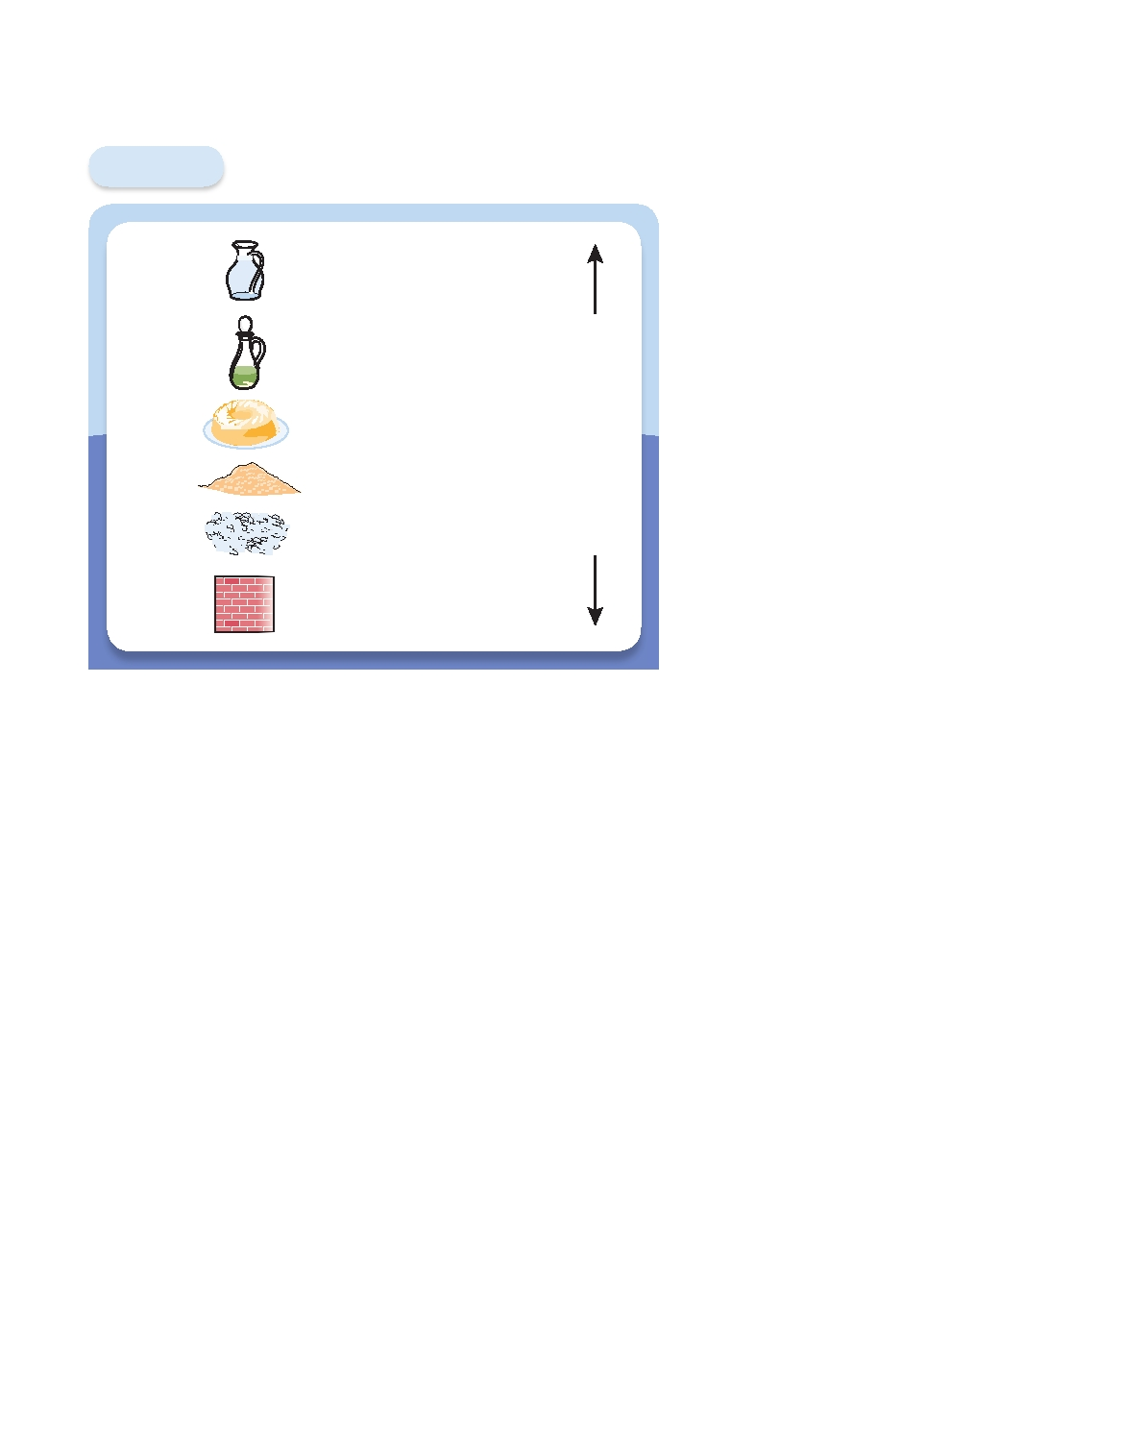
32 l Chapter 2 Money and the Payments System

antique cars, and the like). Figure 2.2

Figure 2.2

Water

Oil

Gelatin

Dirt
The Liquidity Spectrum

Currency

Checking Account (Demand Deposits)

Saving Accounts
(Certificates of Deposit)
U.S. Treasury Bonds

More
Liquid

Less
shows what our liquidity spectrum would look like.
Once we have our list, we could draw a line and include everything on one side of the line in our measure of money. Over the years, figuring out just where to draw the line has proven very difficult, especially since the in- troduction of new types of checking accounts. There really is no perfect solution. Instead, we have drawn the line in a number of different places and computed several measures of money, called the monetary aggregates: M1
and M2.6

Gravel

Brick
Stocks and Corporate Bonds Liquid

Houses
Art
Table 2.1 shows the components
of the two monetary aggregates as de- fined by the Federal Reserve, along with the size of each as of January 2010. Let's go through each one to understand how it is constructed. M1, the narrowest definition of money, in-

Liquidity is the ease with which you can turn an asset into a means of
payment without loss of value.
cludes only currency and various de- posit accounts on which people can

write checks. These are the most liquid assets in the financial system. The components of M1 include currency in the hands of the public, which is the quantity of dollar bills outstanding excluding the ones in the vaults of banks; travelers' checks issued by travel companies, banks, and credit card companies, which are guaranteed by the issuer and usually work just like cash; demand deposits at commercial banks, which are standard checking accounts that pay no interest; and other checkable deposits, which are depos- its in checking accounts that pay interest.
M2 equals all of M1 plus assets that cannot be used directly as a means of pay- ment and are difficult to turn into currency quickly. These assets in M2 include small- denomination time deposits (less than $100,000) that cannot be withdrawn without advance notice; savings deposits, including money-market deposit accounts, which pay interest and offer limited check-writing privileges; retail money-market mutual fund shares, or shares in funds that collect relatively small sums from individuals, pool them together, and invest them in short-term marketable debt issued by large corporations. Money-market mutual fund shares can be issued by nonbank financial intermediaries, such as brokerage firms. They do carry check-writing privileges. M2 is the most com- monly quoted monetary aggregate, since its movements are most closely related to interest rates and economic growth.
To clarify what the monetary aggregates mean, let's compare their size to the size of the economy. In winter 2010, nominal U.S. gross domestic product (GDP) was

6

On March 23, 2006, the Federal Reserve Board ceased collection and publication of a third monetary

aggregate, M3. In announcing their decision, officials wrote: "M3 does not appear to convey any additional
information about economic activity that is not already embodied in M2 and has not played a role in the
monetary policy process for many years."

Measuring Money Chapter 2 l 33

Table 2.1 The Monetary Aggregates

Value as of
January 2010
Monetary Aggregates (US$ billions)

M1

M2

Currency in the hands of the public
Traveler's Checks Demand Deposits
Other Checkable Deposits
Total M1

M1
Small-denomination time deposits
Savings Deposits and Money Market Deposit Accounts
Retail Money Market Mutual Fund Shares
Total M2

861.1
5.1
435.0 375.3
1676.5

1139.8
4856.5
790.7
8463.5

SOURCE: Board of Governors of the Federal Reserve.

$14.5 trillion. Putting that number into the same units as those in Table 2.1, that's $14,500 billion. So GDP is nearly nine times as large as M1 and about 70 percent larger than M2.
Which one of the Ms should we use to understand inflation? That's a difficult ques- tion whose answer has changed over time. Until the early 1980s, economists and poli- cymakers looked at M1. But with the introduction of substitutes for standard checking accounts, especially money-market mutual fund shares, M1 became less useful than M2. These innovations enabled people to shift their balances out of the noninterest- bearing accounts in M1 and into accounts that paid interest. As Table 2.1 shows, demand deposits and other checkable deposits in M1 total about $810 billion, which represents less than 6 percent of GDP. By comparison, the savings deposits, money- market deposit accounts, and retail money-market mutual fund shares in M2 total over $6.7 trillion, representing nearly one-half of GDP. M1 is no longer a useful mea- sure of money.
Looking at Figure 2.3 on page 35, you can see that from 1960 to 1980 the growth rates of the two measures of money moved together. After 1980, however, M1 be- haved very differently from M2. Here's what happened. In the late 1970s and early 1980s, inflation climbed to over 10 percent for a few years. Needless to say, people who had money in zero-interest checking accounts were upset. Their money was losing value at a rapid rate. They went looking for ways to get checking services along with interest. Soon financial firms began to offer "money market" accounts that compensated depositors at least in part for inflation. These accounts are part of M2. The movement of funds into the non-M1 portion of M2 meant that the two measures no longer moved together. At the same time, the new money market ac- counts made M2 accounts more liquid. Analysts stopped looking at M1 and began to look at M2.

34 l Chapter 2 Money and the Payments System

TOOLS OF THE TRADE
The Consumer Price Index

Understanding how to measure inﬂation is central to un- And for 2011, we get $165. Choosing 2010 as the base year,
derstanding economics and finance. Most of us keep a the index level in each year equals

close eye on measures like the Consumer Price Index (CPI) to help gauge the value of our salary increases or the purchasing power of the money we hold. And adjusting

CPI
Cost of the basket in current year _________________________________
Cost of the basket in base year

100

The result of this computation is the fifth column of the table.
interest rates for inﬂation is critical for making investment
Finally, we can use the index number to compute the
decisions. (See Chapter 4.)
inﬂation rate from the previous year. From 2010 to 2011,
The CPI is designed to answer the following question:
this means that
How much more would it cost for people to purchase today

the same basket of goods and services that they actually
bought at some fixed time in the past?
Inﬂation Rate 2011
_________________________ CPI in 2011 CPI in 2010
CPI in 2010
100

To calculate the CPI, every few years statisticians at the Bureau of Labor Statistics (BLS) survey people to find
Using the numbers from Table 2.2 to compute the inﬂation
rate in 2011, we get that

out what they bought. This gives us the basket of goods
and services bought by the typical consumer. Next, every month the BLS collects information on the prices of thou- sands of goods and services—everything from breakfast
__________ 110 100
100
and for 2012 the result is

100

10%

cereal to gasoline to washing machines to the cost of cable television. Combining the expenditure and price surveys
120 110 __________
110
100
9.1%

allows statisticians to compute the current cost of the bas-
ket. Finally, this current cost is compared to a benchmark to yield an index. And the percentage change in this index is a measure of inﬂation.
To see how this works, let's look at an example. As- sume people spend 25 percent of their income on food, 50 percent on housing and 25 percent on transportation. That's the survey information. Examples of the prices are in Table 2.2. Importantly, these are the prices of exactly the same bundle of food, the same size and quality of housing, and the same transportation for each year.
Using the numbers in Table 2.2 we can compute the
cost of the basket of goods in each year:

Cost of the basket in 2010
(These numbers are just for illustration. The U.S. inﬂation
rate is closer to 2 percent.)
Inﬂation measured using the CPI tells us how much more money we need to give someone to restore the pur- chasing power they had in the earlier period when the survey was done. But adjustments in wages based on fixed- expenditure-weight inﬂation indices like the CPI are known to overcompensate people in an unintended way. This over- statement of inﬂation comes from what is known as sub- stitution bias. Because inﬂation is not uniform, the prices of some products will increase by more than the prices of others. People can escape some of the inﬂation by substi- tuting goods and services that have sustained less inﬂation for those that have sustained more. By assuming that any substitution makes people worse off, the index overstates

0.25
Price of food
0.5
Price of housing
the impact of price changes. To address this problem, and

0.25 Price of transportation take into account changes in spending patterns, the Bu-

0.25
$150
$100
0.5
$200
0.25
$100
reau of Labor Statistics now changes the weights every two years. As a result, today's CPI is a much more accurate measure of inﬂation than the one published a decade ago.

Table 2.2 Computing the Consumer Price Index

Price of Price of Price of Cost of Consumer
Year Food Housing Transportation the Basket Price Index

2010 $100 $200 $100 $150 100
2011 110 205 140 165 110
2012 120 210 180 180 120

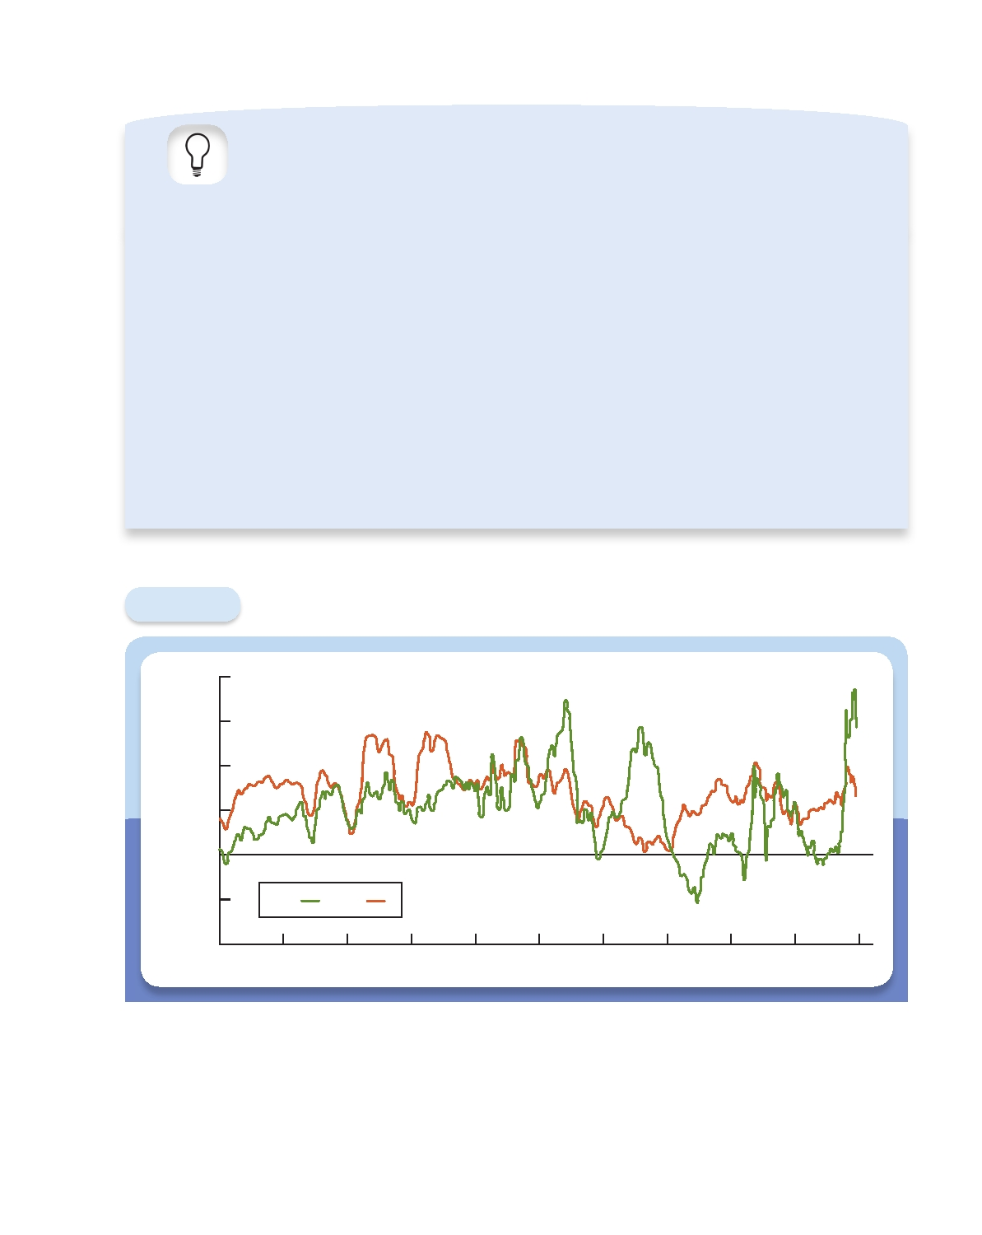
Measuring Money Chapter 2 l 35
Annual Growth Rate (%)

APPLYING THE CONCEPT
WHERE ARE ALL THOSE
$100 BILLS?

A quick look at the Federal Reserve's Web site, www. federalreserve.gov, tells us that during the winter of 2009, the public held about $880 billion in United States cur- rency. That's a huge amount. To get some sense of the size of this number, you can divide it by the U.S. population, 310 million, to get roughly $2,800 per person. For a house- hold of four, that's an average of more than $11,000 in cash. What's even more absurd is that nearly 80 percent of the $880 billion is held in the form of $100 bills, meaning that there must be twenty-two $100 bills for each United States resident. Clearly, we do not hold all this cash in our wallets or our homes, nor does it fill the cash registers of
local businesses. Where are all those $100 bills?
Not in the United States. In many countries, people do not trust their governments to protect the value of the currency they print. They fear the authorities will print too

much, creating inﬂation. And because money is all about trust, if you don't have confidence in your government, you don't want to hold your wealth in the government's money. In many cases, the lack of faith has been warranted. When the Soviet Union collapsed in the early 1990s, the currency issued by the old regime became nearly worthless. The same thing happened in Argentina in the 1980s.
When people stop trusting the local currency, they look for substitutes. The most sought-after is the U.S. dol- lar bill. With the stability of the constant addition of new security features, and the stability of the government, everyone seems to have faith in it.* The U.S. Treasury esti- mates that between two-thirds and three-quarters of U.S. currency is held outside the United States. That's around
$600 billion—and most of it is in hundreds!

*For a guide to the security features in U.S. currency, go to www. moneyfactory.gov. This constant redesign has been successful in thwarting counterfeiting. Estimates are that the total quantity [of counterfeit bills] is less than 10,000 bills outstanding. This is definitely not something that anyone should worry about.

Figure 2.3

20

15

10

5

0

Growth Rates of Monetary Aggregates, 1960-2009

-5 M1 M2

-10
1960 1965 1970 1975 1980 1985 1990 1995 2000 2005 2010

SOURCE: Board of Governors of the Federal Reserve System, Release H.6.

How useful is M2 in tracking inflation? We already know that when the quantity of money grows quickly, it produces very high inflation. A cross-country analysis of money growth supports this conclusion. In Turkey, Venezuela, and Ukraine, where in the last half of the 1990s the inflation rate ranged from 30 to 75 percent per year, the

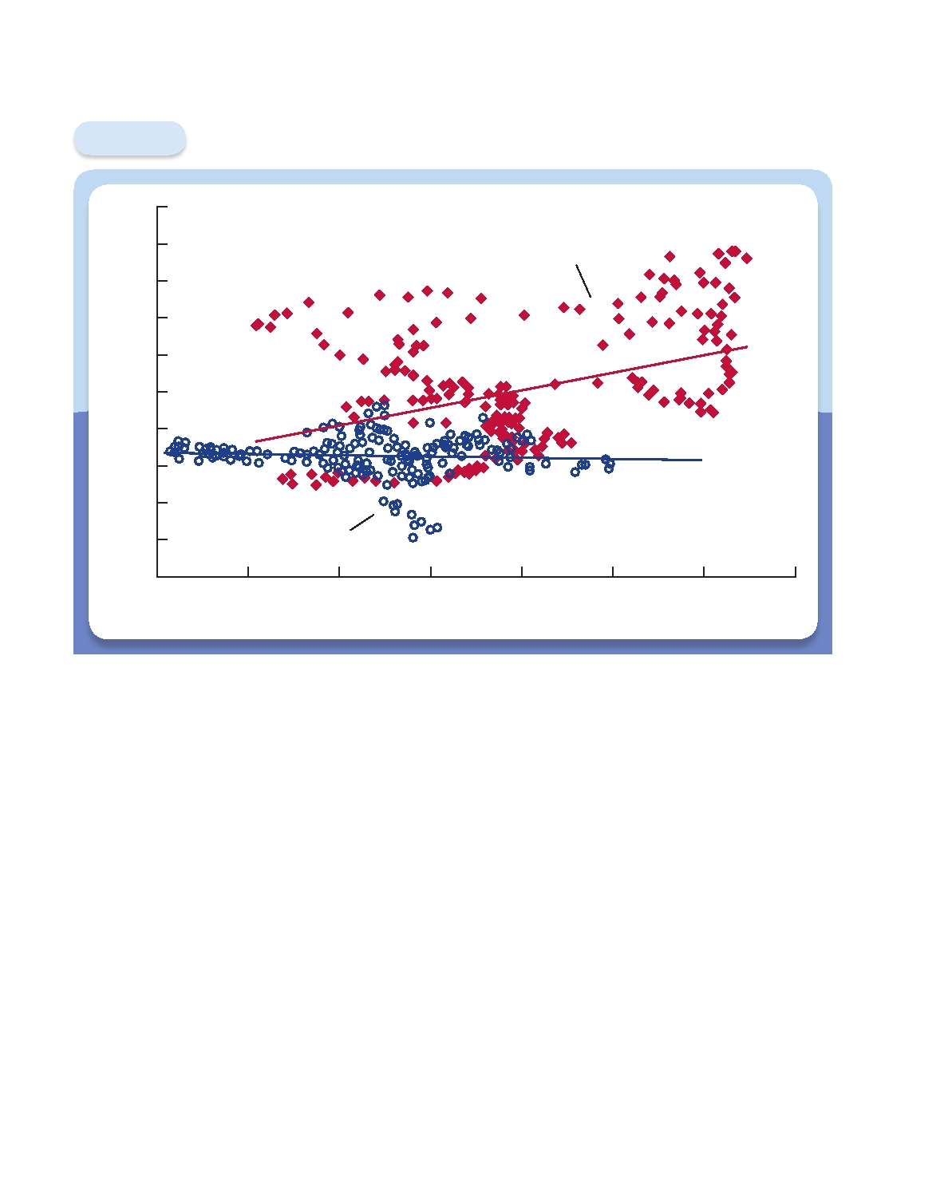
36 l Chapter 2 Money and the Payments System
Inflation Rate 2 Years Later (%)

Figure 2.4

16

14

12

10

8

6

4

2

0

2

4

Money Growth and Inﬂation, Monthly 1960-2009

1990-2009

1960-1980

0 2 4 6 8 10 12 14
Money Growth Rate (%)

Money growth measured as the 12-month change in M2, and inﬂation measured as the 12-month change in the Consumer Price Index.
SOURCE: Board of Governors of the Federal Reserve System and Bureau of Labor Statistics.

money supply grew at comparable rates.7 By contrast, in the United States, Canada, and Europe, the inflation rate averaged only about 2 percent, and the money growth rate stayed in the range of 6 to 7 percent. Because high money growth means high in- flation, controlling inflation means controlling the money supply. Imagine how much inflation there would be if people could spend the $3 trillion in Monopoly dollars
Parker Brothers has printed over the past seven decades!
How useful is money growth in helping us to control moderate inflation? We will address this question in detail in Chapter 20 of this book. For now, though, let's look at whether money growth helps to forecast inflation.
Figure 2.4 shows the inflation rate on the vertical axis and M2 growth two years earlier on the horizontal axis, both for the United States. The solid red diamonds represent data from 1960 to 1980. Note that, while the relationship is far from perfect

7

From 1995 to 2000, inflation averaged 74 percent, 42 percent, and 30 percent, respectively, in Turkey,

Venezuela, and Ukraine. At the same time, a measure of money that is close to U.S. M2 grew at 86, 33, and 36 percent per year. Data for these comparisons come from the International Monetary Fund's International Financial Statistics.

Terms
www.mhhe.com/cecchetti3e

in those years, higher money growth was clearly associated with higher inflation two years later. In fact, the correlation was over 0.5.8 But look at what has happened to the relationship more recently. The hollow blue dots represent data from 1990 to 2009, when there was virtually no relationship at all between the two measures. (The corre- lation was slightly negative.) Growth in M2 stopped being a useful tool for forecasting inflation.
There are two possible explanations for the fact that M2 no longer predicts infla- tion. One is that the relationship between the two applies only at high levels of infla- tion. Figure 2.4 shows that during the period 1960-1980, the inflation rate often rose higher than 5 percent, but from 1990 to 2009, it rarely did. Maybe the relationship between money growth and inflation doesn't exist at low levels of inflation, or it shows up only over longer periods of time. All we really know is that at low levels of money growth, inflation is likely to stay low.
An alternative explanation is that we need a new measure of money that takes into account recent changes in the way we make payments and use money. Once economists have identified the right measure, we'll be able to predict inflation again.
Chapter 2 l
37

8

Correlation is a measure of how closely two quantities are related, or change together. The numerical value

ranges from 1 to 1. A positive correlation signifies that the two variables move up and down together, while a negative correlation means that they move in opposite directions.

Terms

automated clearinghouse transaction
(ACH), 27
check, 24
credit card, 27
currency, 21
debit card, 27
demand deposits, 32
electronic funds transfer, 27
e-money, 28
fiat money, 24
funding liquidity, 22
gross domestic product (GDP), 32
inflation, 30
inflation rate, 30

liquidity, 22
market liquidity, 22
M1, 32 M2, 32
means of payment, 20
monetary aggregates, 32
money, 20
payments system, 22
store of value, 21
stored-value card, 27
time deposits, 32
unit of account, 20
wealth, 20

38
www.mhhe.com/cecchetti3e
l Chapter 2 Money and the Payments System

Chapter Lessons

1. Money is an asset that is generally accepted in payment for goods and services or
repayment of debts.
a. Money has three basic uses:
i. Means of payment
ii. Unit of account
iii. Store of value
b. Money is liquid. Liquidity is the ease with which an asset can be turned into a
means of payment.
c. For financial institutions, market liquidity is the ease with which they can sell
a security or loan for money. Funding liquidity is the ease with which they can borrow to acquire a security or loan.
2. Money makes the payments system work. The payments system is the web of
arrangements that allows people to exchange goods and services. There are three broad categories of payments, all of which use money at some stage.
a. Cash
b. Checks
c. Electronic payments
3. In the future, money will be used less and less as a means of payment.
4. To understand the links among money, inflation, and economic growth, we need
to measure the quantity of money in the economy. There are two basic measures of money.
a. M1, the narrowest measure, includes only the most liquid assets.
b. M2, a broader measure, includes assets not usable as means of payment. c. Countries with high money growth have high inflation.
d. In countries with low inflation, money growth is a poor forecaster of inflation.

Conceptual Problems

1.

2.

3.

The country of Brieonia has an economy that is based largely on farming and
agricultural products. The inhabitants of Brieonia use cheese as their money.
a. Not surprisingly, the Brieonians complain bitterly about the problems that
their commodity money creates. What are they?
b. Modern medical science arrives in Brieonia, and doctors begin giving the
Brieonians cholesterol tests. The results lead to the recommendation that the Brieonians reduce the amount of cheese they eat. What is the impact of
this recommendation on their economy?
c. As the economy of Brieonia becomes industrialized, what changes in the
monetary system would you expect to see, and why?
Describe at least three ways you could pay for your morning cup of coffee. What
are the advantages and disadvantages of each?
Explain how money encourages specialization, and how specialization improves
everyone's standard of living.

Analytical Problems Chapter 2 l 39
www.mhhe.com/cecchetti3e

4.* Could the dollar still function as the unit of account in a totally cashless society?

5.

6.

7.

8.

9.
Explain why a security for which there is a financial institution acting as a mar-
ket maker would be more attractive to an investor.
As of March 2010, 16 of the 27 countries of the European Union have adopted
the euro. The remaining 11 countries, including Great Britain, Denmark, and Sweden, have retained their own currencies. What are the advantages of a com-
mon currency for someone who is traveling through Europe?
Using the current level of M2 from the Federal Reserve's Web site, compute
the quantity of money divided by the (approximate) population of the United
States. Do you think that your answer is large? Why?
Using data from the Federal Reserve's Web site, compute the annual percentage
change in M1 and M2 since 1980. Use the data to reproduce Figure 2.3. Com- ment on the pattern over the last five years. Would it matter which of the two
monetary aggregates you looked at?
Despite the efforts of the United States Treasury and the Secret Service, some-
one discovers a cheap way to counterfeit $100 bills. What will be the impact of
this discovery on the economy?

10.* You have decided to issue your own currency and use your computer to produce
some impressive looking notes. What could you do to increase the chances of
these notes being accepted as a means of payment?

11.
Over a nine-year period in the 16th century, King Henry VIII reduced the
silver content of the British pound to one-sixth its initial value. Why do you think he did so? What do you think happened to the use of pounds as a means of payment? If you held both the old and new pounds, which would you use
first, and why?

Analytical Problems

12.

13.

14.

Under what circumstances might you expect barter to reemerge in an economy that has fiat money as a means of payment? Can you think of an example of a
country where this has happened recently?
You visit a tropical island that has only four goods in its economy—oranges,
pineapples, coconuts, and bananas. There is no money in this economy.
a. Draw a grid showing all the prices for this economy. (You should check your
answer using the n(n 1)/2 formula where n is the number of goods.)
b. An islander suggests designating oranges as the means of payment and unit of
account for the economy. How many prices would there be if her suggestion
was followed?
c. Do you think the change suggested in part b is worth implementing? Why or
why not?
Consider again the tropical island described in question 13. Under what circum-
stances would you recommend the issue of a paper currency by the government of the island? What advantages might this strategy have over the use of oranges
as money?

*Indicates more difficult problems

40 l Chapter 2 Money and the Payments System
www.mhhe.com/cecchetti3e

15.

What factors should you take into account when considering using the follow-
ing assets as stores of value?
a. Gold
b. Real estate
c. Stocks
d. Government bonds

16.* Under what circumstances might money in the form of currency be the best
option as a store of value?
17. Suppose a significant fall in the price of certain stocks caused the market makers
in those stocks to worry about their funding liquidity. Under what circumstances
might that development lead to liquidity problems in markets for other assets?
18.* Consider an economy that only produces and consumes two goods—food and
apparel. Suppose the inflation rate based on the consumer price index is higher during the year than that based on the GDP deflator. Assuming underlying tastes and preferences in the economy stay the same, what can you say about food and
apparel price movements during the year?

