Chapter 3
Financial Instruments, Financial Markets,
and Financial Institutions

Long before formal financial institutions and instruments became common, there were times when people lacked the resources to meet their immediate needs. In the terminology of introductory economics, people's incomes were exceeded by their necessary consumption. When a harvest was poor, they would dip into the reserves stored from previous years or exchange assets like land and livestock for food. But often those measures were insufficient, so communities developed informal financial arrangements that allowed people to borrow or lend among themselves. After a poor harvest, those people with relatively good yields would help those with relatively poor ones. When the tables were turned, help would flow the other way. In some societ- ies, families spread out geographically to facilitate these arrangements. For example, in rural Indian communities, households deliberately married off their daughters to families in different regions to increase the chance that their in-laws would be able to respond in a time of crisis.1 These informal insurance arrangements ensured that everyone had enough to eat.
While family members and friends still make loans among themselves, the informal arrangements that were the mainstay of the financial system centuries ago have given way to the formal financial instruments of the modern world. Today, the international financial system exists to facilitate the design, sale, and exchange of a broad set of contracts with a very specific set of characteristics. As shown in Figure 3.1 we obtain the financial resources we need through this system in two ways: directly from markets and indirectly through institutions.
In indirect finance, an institution like a bank stands between the lender and the borrower, borrowing from the lender and then providing the funds to the borrower. Most of us do our borrowing and lending indirectly. If we need a loan to buy a car, we get it from a bank or finance company—that's indirect finance. Once we get the loan, the car becomes one of our assets, and the loan becomes our liability. We all have assets and liabilities. Your assets probably include things of value like a bank account and a computer. If you have a student loan or credit card debt, those are your liabilities.
In direct finance, borrowers sell securities directly to lenders in the financial mar- kets. Governments and corporations finance their activities in this way. These securi- ties become assets for the lenders who buy them and liabilities to the government or corporation that initially sells them.
Financial development is inextricably linked to economic growth. A country's fi- nancial system has to grow as its level of economic activity rises, or the country will stagnate. The role of the financial system is to facilitate production, employment, and

1

See M. R. Rosenzweig, "Risk, Implicit Contracts, and the Family in Rural Areas of Low-Income Countries,"

Economic Journal 98 (December 1988).

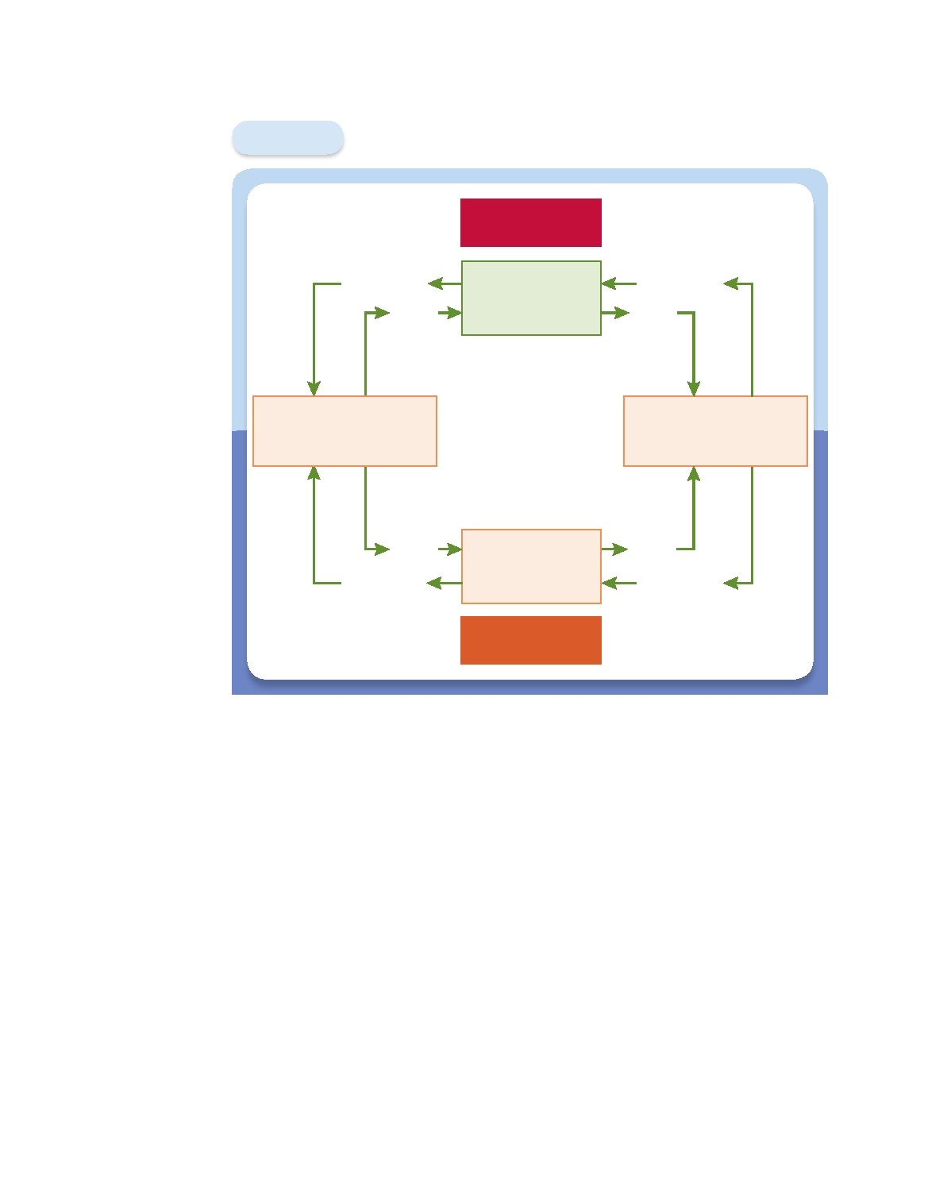
42 l Chapter 3 Financial Instruments, Financial Markets, and Financial Institutions

Figure 3.1 Funds Flowing through the Financial System

Financial
Instrument
Funds

Direct Finance

Financial
Markets

Financial
Instrument
Funds

Lenders/Savers
(Primarily Households)

Borrowers/Spenders (Mostly Governments
and Firms)

Funds
Financial
Instrument

Financial
Institutions

Indirect Finance

Funds
Financial
Instrument

The financial system channels funds from lenders to borrowers in two ways: directly and
indirectly. In direct finance, borrowers obtain resources by selling financial instruments like
bonds and stocks in financial markets directly to lenders. In indirect finance, a financial
institution like a bank takes the resources from the lender in the form of a deposit (or something like it) and then provides them to the borrower in the form of a loan (or the equivalent).

consumption. In a prosperous economy, people have the means to pay for things, and resources flow to their most efficient uses. Savings are funneled through the system so that they can finance investment and allow the economy to grow. The decisions made by the people who do the saving direct the investment.
In this chapter, we will survey the financial system in three steps. First, we'll study financial instruments, or securities, as they are often called. Stocks, bonds, and loans of all types are financial instruments, as are more exotic agreements like options and insurance. Exactly what are these financial instruments, and what is their role in our economy? Second, we'll look at financial markets, such as the New York Stock Exchange and the Nasdaq (National Association of Securities Dealers Automatic Quotations), where investors can buy and sell stocks, bonds, and various other in- struments. And finally, we'll look at financial institutions—what they are and what they do.

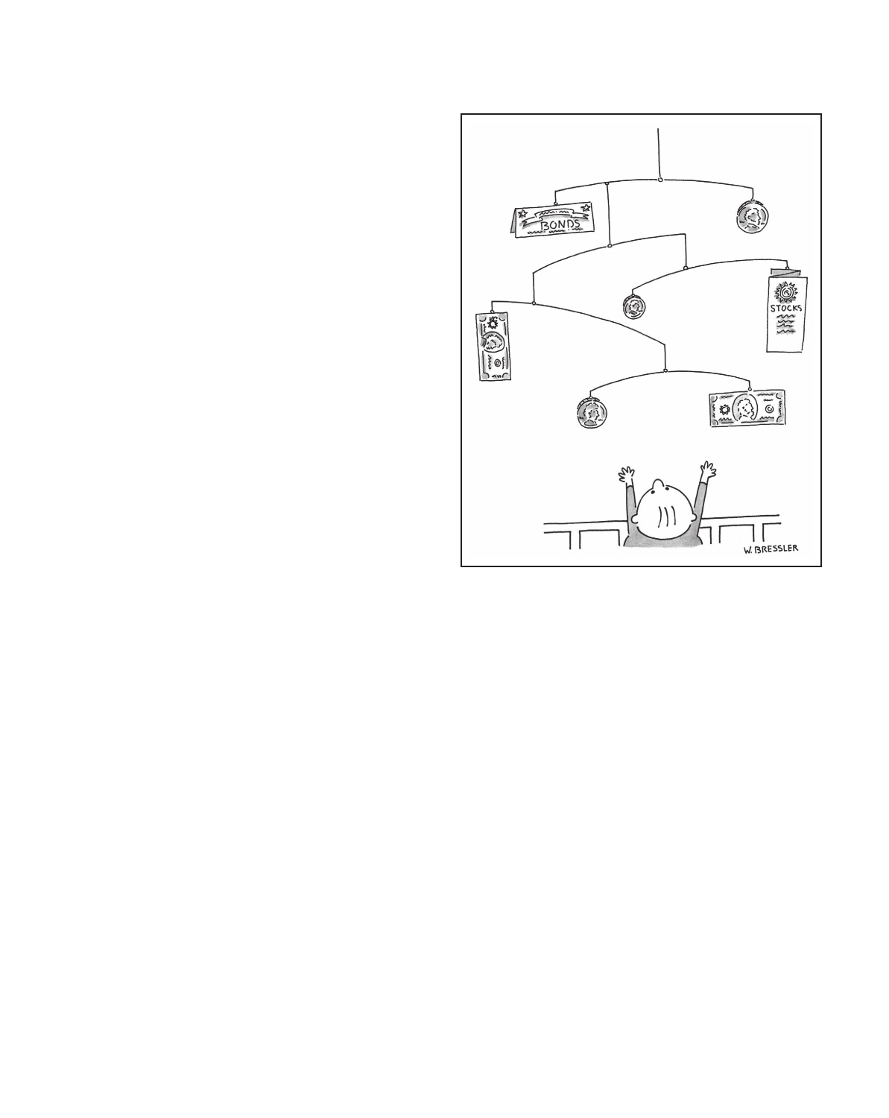

Financial Instruments
A financial instrument is the written legal obliga-
tion of one party to transfer something of value, usu- ally money, to another party at some future date, under certain conditions. Let's dissect this definition to understand it better. First, a financial instru- ment is a written legal obligation that is subject to government enforcement. That is, a person can be compelled to take the action specified in the agreement. The enforceability of the obligation is an important feature of a financial instrument. Without enforcement of the specified terms, fi-
nancial instruments would not exist.2
Second, a financial instrument obligates one party to transfer something of value, usually money, to another party. By party, we mean a person, com- pany, or government. Usually the financial instru- ment specifies that payments will be made. For example, if you get a car loan, you are obligated to make monthly payments of a particular amount to the lender. And if you have an accident, your insurance company is obligated to fix your car,
though the cost of the repair is left unspecified.
Third, a financial instrument specifies that
Financial Instruments
Chapter 3 l 43

payment will be made at some future date. In SOURCE: © Wayne Bressler/The New Yorker
some cases, such as a car loan that requires pay- Collection/www.cartoonbank.com.
ments, the dates may be very specific. In others,
such as car insurance, the payment is triggered when something specific happens, like an accident.
Finally, a financial instrument specifies certain conditions under which a payment will be made. Some agreements specify payments only when certain events happen. That is clearly the case with car insurance and with stocks as well. The holder of a stock owns a small part of a firm and so can expect to receive occasional cash pay- ments, called dividends, when the company is profitable. There is no way to know in advance, however, exactly when such payments will be made. In general, financial instruments specify a number of possible contingencies under which one party is re- quired to make a payment to another.
Uses of Financial Instruments
Stocks, loans, and insurance are all examples of financial instruments. Taking them
as a group, we can see that they have three functions (see Table 3.1). Financial in- struments can act as a means of payment, and they can also be stores of value. Thus, they offer two of the three uses of money. (Remember from Chapter 2 that money is a means of payment, a unit of account, and a store of value.) But financial instruments have a third function that can make them very different from money: They allow for the transfer of risk.

2

A myriad of financial arrangements that exist outside the legal system, like loan sharking, are also enforced,

but those sorts of obligations are not part of the formal financial system.

44 l Chapter 3 Financial Instruments, Financial Markets, and Financial Institutions

Table 3.1

Uses of Financial Instruments

Recall that a means of payment is something that is generally accepted as payment for goods and services or repayment of a debt. It is possible to pay for purchases with financial instruments,

Means of Payment: Purchase of goods or services.
Store of Value: Transfer of purchasing power into
the future.
Transfer of Risk: Transfer of risk from one person
or company to another.
even if they don't look much like money. An example is the willingness of employees to ac- cept a company's stock as payment for working. (This means of payment was very popular in the late 1990s, when the stock market was booming.) While we cannot yet pay for groceries with shares of stock, the time may come when we can. For

now, although some financial instruments may function as means of payment, they aren't terribly good ones.
Having a store of value means that your consumption doesn't need to exactly match your income. For days, months, and years, if necessary, you can spend more than you make, repaying the difference later. Even though most of us are paid weekly or monthly, we eat every day. As stores of value, financial instruments like stocks and

RISK
bonds are thought to be better than money. Over time, they generate increases in wealth that are bigger than those we can obtain from holding money in most of its forms. These higher payoffs are compensation for higher levels of risk, because the payoffs from holding most financial instruments are generally more uncertain than those that arise from holding money. Nevertheless, many financial instruments can be used to transfer purchasing power into the future.
The third use of a financial instrument lies in its ability to transfer risk between the buyer and the seller. Most financial instruments involve some sort of risk transfer. For example, think of wheat farmers. If only one farm has a huge harvest, that farmer does very well. But if everyone's harvest is huge, then prices can plummet and individual farms can lose money. The risk that the harvest will be too good, resulting in low grain prices, is a risk that most individual farmers do not want to take. A wheat futures con- tract allows the farmer to transfer that risk to someone else. A wheat futures contract is a financial instrument in which two parties agree to exchange a fixed quantity of wheat on a prearranged future date at a specified price. By fixing the price at which the crop will be sold well in advance of the harvest, the farmer can forget about what happens in the wheat market because the risk has been transferred to someone else.
Insurance contracts are another example of a financial instrument that transfers risk—in this case, from individuals to an insurance company. Because a car accident can be financially catastrophic, we buy car insurance and transfer the risk to an in- surance company. Because insurance companies make similar guarantees to a large group of people, they have the capacity to shoulder the risk. While the timing of an individual automobile accident is impossible to forecast, a predictable percentage of a large group of drivers will experience accidents over a given period.

Characteristics of Financial Instruments:
Standardization and Information
As is obvious from the definition of a financial instrument, these sorts of contracts can
be very complex. If you don't believe it, take a look at the fine print in a car insurance policy, a student loan, or even a credit card agreement. Complexity is costly. The more complicated something is, the more it costs to create and the more difficult it is to

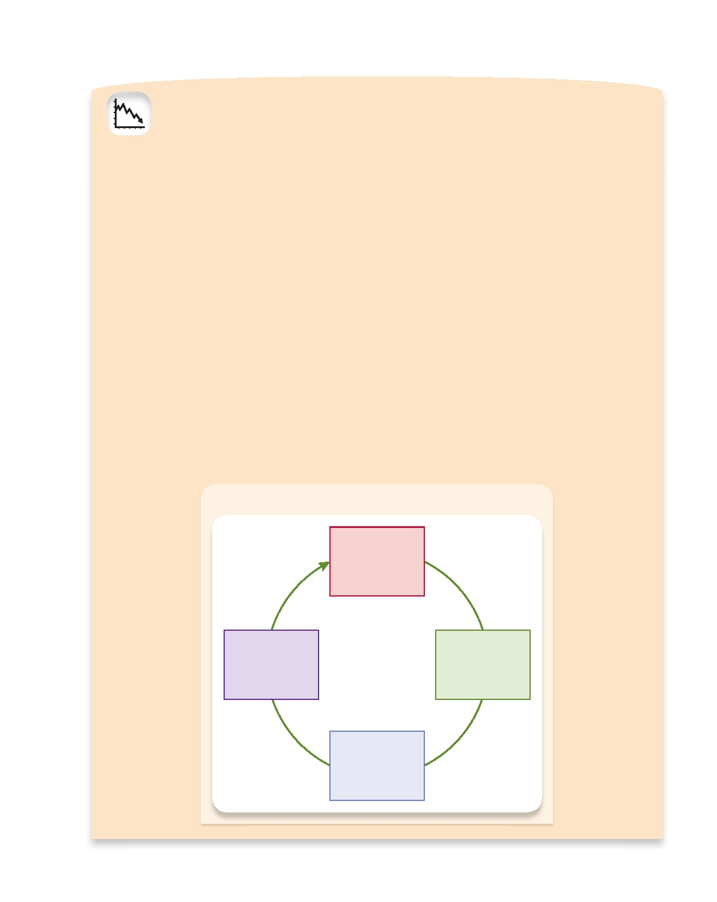
Financial Instruments Chapter 3 l 45

LESSONS FROM THE CRISIS
LEVERAGE

Households and firms often borrow to make investments. Obtaining a mortgage for a new home or selling a corpo- rate bond to build a new plant are common examples. The use of borrowing to finance part of an investment is called leverage.* Leverage played a key role in the financial crisis of 2007-2009, so it is worth understanding how leverage relates to risk and how it can make the financial system vulnerable.
Modern economies rely heavily on borrowing to make investments. They are all leveraged. Yet, the more lever- age, the greater the risk that an adverse surprise will lead to bankruptcy. If two households own houses of the same value, the one that has borrowed more—the one that is more highly leveraged and has less net worth—is the more likely to default during a temporary slump in income. This example could apply equally well to firms, financial institu- tions, or even countries.
Financial institutions are much more highly leveraged than households or firms, typically owning assets of about 10 times their net worth. During the crisis, some impor- tant financial firms leveraged more than 30 times their net worth.† Such high leverage meant that these firms would be vulnerable even to a minor decline in the value of their assets. For example, when a borrower is leveraged more

Deleveraging Spiral

than 30 times, a drop as small as 3 percent in asset prices could eliminate the cushion created by the net worth and lead to bankruptcy.
When highly leveraged financial institutions experi- ence a loss, they usually try to reduce their leverage—that is, to deleverage—by selling assets and issuing securities that raise their net worth (see accompanying figure). How- ever, the financial system cannot deleverage all at once. When too many institutions try to sell assets simultane- ously, their efforts will almost surely prove counterpro- ductive: falling prices will mean more losses, diminishing their net worth further, raising leverage, and making the assets they hold seem riskier, thereby compelling further sales.
This "paradox of leverage" reinforces the destabilizing liquidity spiral discussed in Chapter 2 (see Lessons from the Crisis: Market Liquidity, Funding Liquidity, and Making Markets). Both spirals feed a vicious cycle of falling prices and widespread deleveraging that was a hallmark of the financial crisis of 2007-2009. The financial system stead- ied only after a plunge of many asset prices and massive government interventions.

*For a technical definition of leverage, see the Tools of the Trade box in Chapter 5.
†A bank's net worth—its assets minus liabilities—is commonly
known as bank capital. We will discuss this in more detail in Chapter 12.

Bank
Wishes to Deleverage

Net Worth
Declines and Some Assets
Assets Become are Sold
Riskier

Asset Prices
Decline

46 l Chapter 3 Financial Instruments, Financial Markets, and Financial Institutions

understand. As a rule, people do not want to bear these costs. Yes, the owner of an oil tanker may be willing to go to the expense of negotiating a specific insurance contract for each voyage a ship makes. The same owner may agree to make premium payments based on the load carried, the distance traveled, the route taken, and the weather ex- pected. But for most of us, the cost of such custom contracts is simply too high.
In fact, people on both sides of financial contracts shy away from specialized agree- ments. Instead, they use standardized financial instruments to overcome the potential costs of complexity. Because of standardization, most of the financial instruments that we encounter on a day-to-day basis are very homogeneous. For example, most mort- gages feature a standard application process and offer standardized terms. Automobile insurance contracts generally offer only certain standard options.
Standardization of terms makes sense. If all financial instruments differed in criti- cal ways, most of us would not be able to understand them. Their usefulness would be severely limited. If the shares of Microsoft stock sold to one person differed in a crucial way from the shares sold to someone else, for instance, potential inves- tors might not understand what they were buying. Even more important, the resale and trading of the shares would become virtually impossible, which would certainly discourage anyone from purchasing them in the first place. From this, we conclude that arrangements that obligate people to make payments to one another cannot all be one-of-a-kind arrangements.

INFORMATION
Another characteristic of financial instruments is that they communicate informa- tion, summarizing certain essential details about the issuer. How much do you really want to learn about the original issuer of a financial instrument? Or if you are purchas- ing an existing instrument, how much do you want to have to know about the person who is selling it to you? Surely, the less you feel you need to know to feel secure about the transaction, the better. Regardless of whether the instrument is a stock, a bond, a futures contract, or an insurance contract, the holder does not want to have to watch the issuer too closely; continuous monitoring is costly and difficult. Thus, financial instruments are designed to eliminate the expensive and time-consuming process of collecting such information.
A number of mechanisms exist to reduce the cost of monitoring the behavior of the counterparties to a financial arrangement. A counterparty is the person or insti- tution on the other side of a contract. If you obtain a car loan from your local bank, then you are the bank's counterparty and the bank is yours. In the case of a stock or bond, the issuing firm and the investors who hold the instrument are counterparties.
The solution to the high cost of obtaining information on the parties to a financial instrument is to standardize both the instrument and the information provided about the issuer. We can also hire a specialist whom we all trust to do the monitoring. The institutions that have arisen over the years to support the existence of financial instru- ments provide an environment in which everyone can feel secure about the behavior of the counterparties to an agreement.
In addition to simply summarizing information, financial instruments are designed to handle the problem of asymmetric information, which comes from the fact that bor- rowers have some information they don't disclose to lenders. Instead of buying new ovens, will a bread baker use a $50,000 loan to take an extended vacation in Tahiti? The lender wants to make sure the borrower is not misrepresenting what he or she will do with borrowed funds. Thus, the financial system is set up to gather information on borrowers before giving them resources and to monitor their use of the resources afterwards. These specialized mechanisms were developed to handle the problem of asymmetric information.

Financial Instruments Chapter 3 l 47

Underlying versus Derivative Instruments

There are two fundamental classes of financial instruments. The first, underlying
instruments (sometimes called primitive securities), are used by savers/lenders to transfer resources directly to investors/borrowers. Through these instruments, the financial system improves the efficient allocation of resources in the real economy.
The primary examples of underlying securities or instruments are stocks and bonds that offer payments based solely on the issuer's status. Bonds, for example, make pay- ments depending on the solvency of the firm that issued them. Stocks sometimes pay dividends when the issuing corporation's profits are sufficient.
The second class of financial instruments is known as derivative instruments. Their value and payoffs are "derived" from the behavior of the underlying instru- ments. The most common examples of derivatives are futures and options. In general, derivatives specify a payment to be made between the person who sells the instrument and the person who buys it. The amount of the payment depends on various factors associated with the price of the underlying asset. The primary use of derivatives is to shift risk among investors. We will see some examples in a moment; Chapter 9 dis- cusses derivatives in detail.

A Primer for Valuing Financial Instruments
Why are some financial instruments more valuable than others? If you look at The
Wall Street Journal, you'll see the prices of many bonds and stocks. They are quite dif- ferent from each other. Not only that, but from day to day, the prices of an individual bond or stock can vary quite a bit. What characteristics affect the price someone will
pay to buy or sell a financial instrument?
Four fundamental characteristics influence the value of a financial instrument (see Table 3.2): (1) the size of the payment that is promised, (2) when the promised payment is to be made, (3) the likelihood that the payment will be made, and (4) the circum-
stances under which the payment is to be made. Let's look at each one of these traits.
First, people will pay more for an instrument that obligates the issuer to pay the holder $1,000 than for one that offers a payment of $100. Regardless of any other conditions, this simply must be true: The bigger the promised payment, the more valuable the financial instrument.
Second, if you are promised a payment of $100 sometime in the future, you will want to know when you will receive it. Receiving $100 tomorrow is different from receiving $100 next year. This simple example illustrates a very general proposition: The sooner the payment is made, the more valuable is the promise to make it. Time has

TIME

Table 3.2 What Makes a Financial Instrument Valuable?

Size: Payments that are larger are more valuable.
Timing: Payments that are made sooner are more valuable.
Likelihood: Payments that are more likely to be made are more valuable.
Circumstances: Payments that are made when we need them most are more valuable.

48 l Chapter 3 Financial Instruments, Financial Markets, and Financial Institutions

value because of opportunity cost. If you receive a payment immediately, you have an
opportunity to invest or consume it right away. If you don't receive the payment until later, you lose that opportunity.

RISK
The third factor that affects the value of a financial instrument is the odds that the issuer will meet the obligation to make the payment. Regardless of how conscientious and diligent the party who made the promise is, there remains some possibility that the payment will not be made. Because risk requires compensation, the impact of this uncertainty on the value of a financial instrument is clear: The more likely it is that the payment will be made, the more valuable the financial instrument.
Finally, the value of a financial instrument is affected by the conditions under which a promised payment is to be made. Insurance is the best example. We buy car insurance to receive a payment if we have an accident, so we can repair the car. No one buys insurance that pays off when good things happen. Payments that are made
when we need them most are more valuable than other payments.3

Examples of Financial Instruments
We'll have quite a bit to say about financial instruments in Part II of the book. For
now, let's take a look at some of the most common varieties. The best way to organize them is by whether they are used primarily as stores of value or for trading risk.
Financial Instruments Used Primarily as Stores of Value
1. Bank loans. A borrower obtains resources from a lender immediately in ex-
change for a promised set of payments in the future. The borrower, who can be either an individual or a firm, needs funds to make an investment or purchase, while the lender is looking for a way to store value into the future.
2. Bonds. Bonds are a form of loan. In exchange for obtaining funds today, a cor-
poration or government promises to make payments in the future. While bond payments are often stated in fixed dollars, they need not be. Unlike most bank loans, most bonds can be bought and sold in financial markets. Like bank loans, bonds are used by the borrower to finance current operations and by the lender to store value.
3. Home mortgages. Most people who wish to purchase a home need to borrow
some portion of the funds. A mortgage is a loan that is used to purchase real estate. In exchange for the funds, the borrower promises to make a series of payments. The house is collateral for the loan. Collateral is the term used to describe specific assets a borrower pledges to protect the lender's interests in the event of nonpayment. If the payments aren't made, the lender can take the house, a process called foreclosure.
4. Stocks. The holder of a share of a company's stock owns a small piece of the firm
and is entitled to part of its profits. The owner of a firm sells stock as a way of rais- ing funds to enlarge operations as well as a way of transferring the risk of owner- ship to someone else. Buyers of stocks use them primarily as stores of wealth.

3

This conclusion is related to the principle of declining marginal utility, which you may recall from your

study of microeconomics. The idea is that the satisfaction obtained from consumption declines as the level
of consumption increases. Each succeeding candy bar brings less pleasure than the last one. Thus, a financial
instrument that pays off when marginal utility is high is worth more than one that pays off when marginal
utility is low. This means that payoffs that are made when income and wealth are low are more valuable than payoffs that are made when income and wealth are high.

Financial Instruments Chapter 3 l 49

YOUR FINANCIAL WORLD
Disability Income Insurance

People insure their houses so they can rebuild them if they burn down. They insure their cars so they can re- pair them if they have an accident. And they insure their lives so their families will be financially secure if they die prematurely. But few people insure their most important asset: their ability to produce an income. The biggest risk all of us face is that we will become disabled and lose our earning capacity. Insuring it should be one of our highest priorities.
If you think this advice is alarmist, just look at a few numbers. The odds of a man becoming disabled for 90 days or longer between the ages of 20 and 60 are one in five. For women they're somewhat lower, more like one in seven. In fact, the chance you'll become disabled during your working life is far higher than the chance of your house burning down—which over 40 years is about
1 in 30.*

Fortunately, you may already have some disability in- surance. The government provides some through Social Security; your employer may insure you; and if you're in- jured on the job and can't work, there is always workers' compensation insurance. But is that enough? You should evaluate what your needs are likely to be. If the disabil- ity insurance you already have is not enough, you should buy more. While it isn't very pleasant to think about what would happen if you became disabled, you need to do it. Surely this is one risk you should transfer to someone else.

*The chance of any particular house burning down is 1 in 1,200 in a given year. So there is a 1,199 chance in 1,200 of a house not burning down in a particular year. This means that the probability of a house not burning down in 40 years is (1,199/1,200)40 0.967. So the probability of the house burning down is 0.033, which is 1 in 30.

5. Asset-backed securities. Asset-backed securities are shares in the returns or
payments arising from specific assets, such as home mortgages, student loans, credit card debt, or even movie box-office receipts. Investors purchase shares in the revenue that comes from these underlying assets. The most prominent of these instruments are mortgage-backed securities, which bundle a large num- ber of mortgages together into a pool in which shares are then sold. Securities backed by subprime mortgages—loans to borrowers who are less likely to repay than borrowers of conventional mortgages—played an important role in the financial crisis of 2007-2009 (see Chapter 7, Lessons from the Crisis: Subprime Mortgages). The owners of these securities receive a share of the payments made by the homeowners who borrowed the funds. Asset-backed securities are an in- novation that allows funds in one part of the country to find productive uses elsewhere. Thus, the availability of some sorts of financing no longer depends on
local credit conditions.4
Financial Instruments Used Primarily to Transfer Risk
1. Insurance contracts. The primary purpose of insurance policies is to assure that
payments will be made under particular, and often rare, circumstances. These instruments exist expressly to transfer risk from one party to another.
2. Futures contracts. A futures contract is an agreement between two parties to
exchange a fixed quantity of a commodity (such as wheat or corn) or an asset (such as a bond) at a fixed price on a set future date. A futures contract always specifies the price at which the transaction will take place. A futures contract is a

4

For an introduction to how asset-backed securities work, see Andreas Jobst, "What is Securitization?" Finance

and Development, International Monetary Fund, September 2008.

50 l Chapter 3 Financial Instruments, Financial Markets, and Financial Institutions

type of derivative instrument, since its value is based on the price of some other asset. It is used to transfer the risk of price fluctuations from one party to another.
3. Options. Like futures contracts, options are derivative instruments whose prices
are based on the value of some underlying asset. Options give the holder the right, but not the obligation, to buy or sell a fixed quantity of the underlying asset at a predetermined price either on a specified date or at any time during a specified period.
These are just a few examples of the most prominent financial instruments.
Together, they allow people to buy and sell almost any sort of payment on any date under any circumstances. Thus, they offer the opportunity to store value and trade risk in almost any way that one might want.5 When you encounter a financial instrument for the first time, try to figure out whether it is used primarily for storing value or for transferring risk. Then try to identify which characteristics determine its value.

Financial Markets

MARKETS
Financial markets are the places where financial instruments are bought and sold.
They are the economy's central nervous system, relaying and reacting to information quickly, allocating resources, and determining prices. In doing so, financial markets enable both firms and individuals to find financing for their activities. When they are working well, new firms can start up and existing firms can grow; individuals who don't have sufficient savings can borrow to purchase cars and houses. By ensuring that resources are available to those who can put them to the best use, and by keeping the costs of transactions as low as possible, these markets promote economic efficiency. When financial markets cease to function properly, resources are no longer channeled
to their best possible use, and we all suffer.6
In this section, we will look at the role of financial markets and the economic jus- tification for their existence. Next, we will examine the structure of the markets and how they are organized. Finally, we will look at the characteristics that are essential for the markets to work smoothly.

The Role of Financial Markets
Financial markets serve three roles in our economic system (see Table 3.3). They
offer savers and borrowers liquidity; they pool and communicate information; and they allow risk sharing. We encountered the concept of liquidity in our discussion of money, where we defined it as the ease with which an asset can be turned into money without loss of value. Without financial markets and the institutional structure that supports them, selling the assets we own would be extremely difficult. Thus, we cannot over- state the importance of liquidity for the smooth operation of an economy. Just think what would happen if the stock market were open only one day a month. Stocks would surely become less attractive investments. If you had an emergency and needed

5

An important exception is the common desire to borrow using future income as collateral. While young

people with good career prospects might wish to spend their future earnings now, lenders worry that such loans will diminish the borrower's incentive to work and repay.
6An example demonstrates the point. Following the September 11, 2001, terrorist attacks, the New York Stock
Exchange became inaccessible, and other markets were not functioning properly. Alarmed government officials
took measures to ensure that markets would open as soon as possible so that trading could proceed. Without these
efforts to get the financial markets up and running, the financial system might quickly have come to a standstill.

Financial Markets Chapter 3 l 51

money immediately, you probably would not be able to sell your stocks in time. Liquidity is a crucial characteristic of financial markets.
Related to liquidity is the fact that financial mar-

Table 3.3

The Role of Financial Markets

kets need to be designed in a way that keeps trans- actions costs—the cost of buying and selling—low. If you want to buy or sell a stock, you have to hire someone to do it for you. The process is complex, and we need not go into it in detail, but you must pay a broker to complete the purchase or sale on your behalf. While this service can't be free, it is im- portant to keep its cost relatively low. The very high trading volumes that we see in the stock market—
Liquidity: Ensure that owners of financial
instruments can buy and sell them cheaply and easily.
Information: Pool and communicate information
about the issuer of a financial instrument.
Risk Sharing: Provide individuals with a place to
buy and sell risks, sharing them with others.

several billion shares per day in the United States—is evidence that U.S. stock markets have low transactions costs as well as being liquid. (One market in which transactions costs are high is the market for housing. Once you add together everything you pay agents, bankers, and lawyers, you have spent almost 10 percent of the sale price of the
house to complete the transaction. The housing market is not very liquid.)
Financial markets pool and communicate information about the issuers of financial instruments, summarizing it in the form of a price. Does a company have good pros- pects for future growth and profits? If so, its stock price will be high; if not, its stock price will be low. Is a borrower likely to repay a bond? The more likely repayment is, the higher the price of the bond. Obtaining the answers to these questions is time consuming and costly. Most of us just don't have the resources or know-how to do it. Instead, we turn to the financial markets to summarize the information for us so that we can look it up in the newspaper or on the Internet.
Finally, while financial instruments are the means for transferring risk, financial markets are the place where we can do it. The markets allow us to buy and sell risks, holding the ones we want and getting rid of the ones we don't want. As we will see in Chapter 5, a prudent investor holds a collection of assets called a portfolio, which includes a number of stocks and bonds as well as various forms of money. A well- designed portfolio has a lower overall risk than any individual stock or bond. An investor constructs it by buying and selling financial instruments in the marketplace. Without the market, we wouldn't be able to share risk.

The Structure of Financial Markets
There are lots of financial markets and many ways to categorize them. Just take a look
at any source of business news. You will see charts and tables for domestic stocks, global stocks, bonds and interest rates, the dollar exchange rate, commodities, and more. Keep going and you will find references to stock markets, bond markets, credit markets, currency trading, options, futures, new securities, and on and on. Grasping the overall structure of all of these financial markets requires grouping them in some
sort of meaningful way—but how?
There are three possibilities (see Table 3.4 on page 54). First, we can distinguish between markets where new financial instruments are sold and those where they are resold, or traded. Second, we can categorize the markets by the way they trade finan- cial instruments—whether on a centralized exchange or not. And third, we can group them based on the type of instrument they trade—those that are used primarily as a store of value or those that are used to transfer risk. We'll use the vocabulary that is

52 l Chapter 3 Financial Instruments, Financial Markets, and Financial Institutions

TOOLS OF THE TRADE
Trading in Financial Markets

Trading is what makes financial markets work. No one would ever buy a stock or bond if he or she couldn't sell it. Let's take a brief look at how trading works. For this example, we will focus on the stock market.
Placing an order in a stock market is a bit like going to a fast-food restaurant or a coffee shop. You have to enter your order and wait to be served. Not only that, but the order can be very complicated, and how long you wait depends on both what you ordered and on how many other people are waiting to be served.
If you place an order, it will have a number of important characteristics.

broker can provide "direct access" to electronic trading net- works. Even though IBM is traded on the New York Stock Exchange, you are not required to send an order to buy 100 shares of IBM to the ﬂoor of the exchange. Instead, you can request execution through an electronic communication network (ECN) like Arca (that is part of the NYSE) or Instinet (that is part of Nasdaq).
Electronic networks operate in a very simple way. If you want to buy, you enter a bid. If your bid is better than everyone else's, and there is someone willing to sell at or below the price you bid, then you trade immediately. Other- wise, your bid goes into an order book to wait for a seller. On a network like Arca or Instinet, customer orders interact

•
••

•
The stock you wish to trade.
Whether you wish to buy or sell.
The size of the order—how many shares you wish to
trade.
The price at which you would like to trade.
automatically following a set of priority rules established by the network, but with no one acting as an intermediary in the transaction. The liquidity in the market is provided by the customers.
For a stock like IBM or GE, the New York Stock Exchange is an alternative place to send the order. A NYSE order may be satisfied electronically, through Arca. On the NYSE, liquidity

You can place either a market order, in which case your order is executed at the most favorable price currently available on the other side, or a limit order, which places a maximum on the price you wish to pay to buy or a minimum on the price you will accept to sell. Placing a market order means you value speed over price; you want the trade to occur as soon as possible and are willing to pay for the privi- lege. By contrast, you can specify a time at which the limit order is canceled if it hasn't been filled.
Executing the trade requires finding someone to take the other side. To do this, you can ask a broker to do it, or your
provided by customer orders is supplemented by designated market makers (DMMs). A DMM is the person on the ﬂoor of the Stock Exchange charged with making a market, ensuring that it is liquid so that people can both buy and sell and that prices aren't overly volatile. Electronic mechanisms match the orders as they come in, keeping track of orders that are outstanding. To make the system work, DMMs often buy and
sell on their own account.*
On the next page is a portion of the screen from an inde- pendent ECN known as BATS. The screen shows outstanding bids and offers for the common stock of General Electric (GE)

common as of this writing. Bear in mind that there are no hard and fast rules for the terminology used to describe these markets, so it may change.

Primary versus Secondary Markets A primary financial market is one
in which a borrower obtains funds from a lender by selling newly issued securities. Businesses use primary markets to raise the resources they need to grow. Governments use them to finance ongoing operations. Most of the action in primary markets occurs out of public view. While some companies that want to raise funds go directly to the financial markets themselves, most use an investment bank. The bank examines the company's financial health to determine whether the proposed issue is sound Assuming that it is, the bank will determine a price and then purchase the securities in preparation for resale to clients. This activity, called underwriting, is usually very profitable. Since small investors are not customers of large investment banks, most of us do not have access to these new securities.

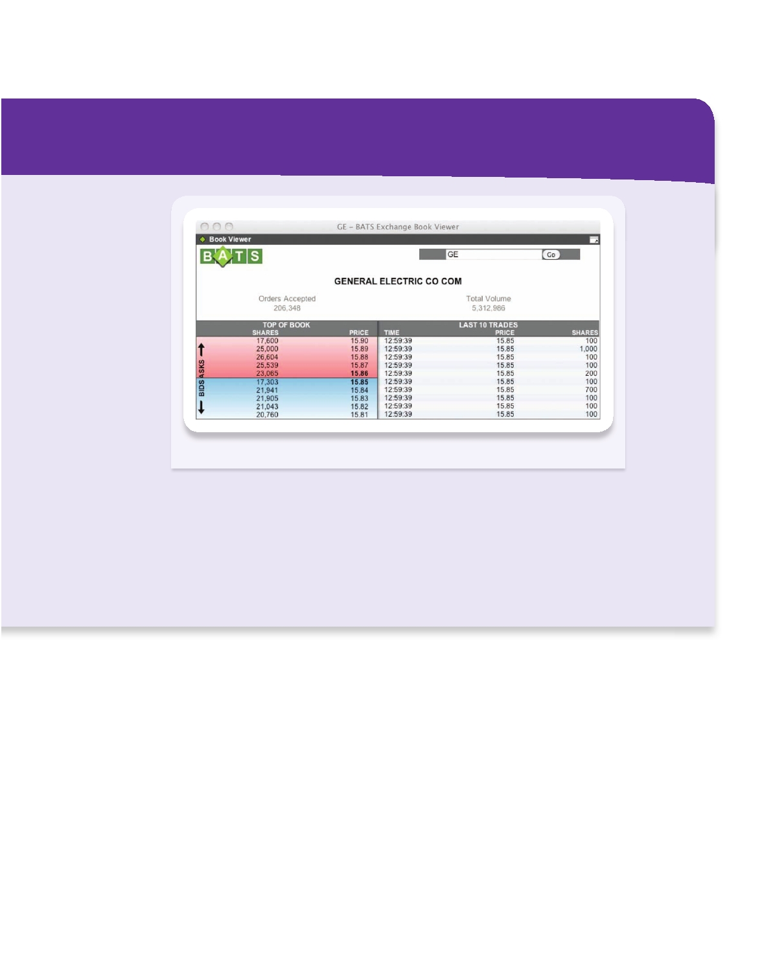
Financial Markets Chapter 3 l 53

FPO

SOURCE: www.batstrading.com, 1:00 pm, November 9, 2009.

at 1:00 pm on November 9, 2009. The system shows more than 100,000 limit orders on each side of the market (bids in blue; asks in pink) within a few cents of the most recent execution price ($15.85). The system combines the sell (buy) orders of different customers at each price, so we see the aggregate supply (demand) for the stock at that price. If a market sell order for 100 shares were to arrive, the system would match that order with the highest bid ($15.85). If a

market buy order for 100 shares were to arrive, the system would match that order with the lowest offer ($15.86). More than 5,000,000 GE shares already had traded that day.

*For a description of designated market makers, see http://www. nyse.com/pdfs/fact_sheet_dmm.pdf.

Everyone knows about secondary financial markets. Those are the markets where people can buy and sell existing securities. If you want to buy a share of stock in IBM or Microsoft, you won't get it from the company itself. Instead, you'll buy it in a sec- ondary market from another investor. The prices in the secondary markets are the ones we hear about in the news.
Centralized Exchanges, Over-the-Counter Markets, and Electronic
Communication Networks Buying a stock or bond is not like buying a new pair of shoes. You can't just go into a store, ask for the stock you want, pay for it with your credit card, and walk out with it in a bag. Instead, you can either ask a bro- ker to buy the stock for you or you can do it yourself on an electronic exchange. In both cases, the transaction is in a secondary market. The organization of secondary financial markets is changing rapidly. Historically there have been two types. Some organizations, like the New York Stock Exchange and the large exchanges in London

54 l Chapter 3 Financial Instruments, Financial Markets, and Financial Institutions

Table 3.4 The Structure of Financial Markets

Primary versus Secondary Markets
Primary markets: Markets where newly issued securities are sold.
Secondary markets: Markets where existing securities are traded.

Centralized Exchanges versus Over-the-Counter Markets

Centralized exchanges:

Over-the-counter markets:

Electronic communication
networks (ECNs):
Secondary markets where buyers and sellers meet in a
central, physical location.
Decentralized secondary markets where dealers stand
ready to buy and sell securities electronically.
An electronic system that brings buyers and sellers
together for electronic execution of trades without the use of a broker or dealer.

Debt and Equity versus Derivatives Markets
Debt and equity markets: Markets where financial claims are bought and sold for
immediate cash payment.
Derivatives markets: Markets where claims based on an underlying asset
are traded for payment at a later date.

and Tokyo, are centralized exchanges. Others, like the Nasdaq, are over-the-counter (OTC) markets, which are merely a collection of dealers who trade with one an- other via computer from wherever they are sitting. Today, we can add electronic com- munication networks (ECNs) to the list of secondary-market types—Instinet and Archipelago (Arca) are the biggest. While all of these markets allow for the trading
of existing (that is, already issued) financial instruments, they do it in different ways.
To understand how things work today, we need to start with how they worked a few years ago. Let's begin with the New York Stock Exchange (NYSE). The NYSE is a place with an address where trading takes place in person on the floor of the exchange. To get onto the floor and trade, a firm purchases one of the licenses issued by the exchange. For the year 2010, the price of a trading license was set at $40,000. Most licenses are purchased by brokerage firms that earn revenue from trading on behalf of their customers. Until recently, others were acquired by specialists who oversaw the trading of individual stocks. Every one of the roughly 3,500 stocks traded on the NYSE was assigned to a specialist whose job it was to maintain order in the market for that stock. While not all of the trading in stocks that are listed on the New York Stock Exchange actually takes place at the exchange itself, a significant fraction does. And all of that trading went through the specialists.
In the past, the only alternative to a centralized exchange was an over-the-counter (OTC) market. These dealer-based markets are best thought of as networks of physi- cally dispersed dealers, each of whom has a computer screen on which buy and sell or- ders are posted. The dealers buy and sell various securities both for themselves and for their customers. With the exception of stocks that are sold on organized exchanges, financial instruments are sold in dealer-based markets. The biggest is the Nasdaq, which trades the stocks of roughly 4,000 companies, most of them small. The dealers use their computers to match the orders and execute the trades.

Financial Markets

Compared with a physically centralized exchange, a financial market that is organized as an electronic network—such as an OTC market or an ECN—has both advantages and disadvantages. On the plus side, customers can see the orders (look at the Tools of the Trade: Trading in Financial Markets on page 52), orders are executed quickly, costs are low, and trading is 24 hours a day. But electronic networks are not perfect. When dealers are in a hurry or simply get tired, they can push the wrong but- ton, turning a $3 million trade into a $30 million or $300 million trade. On the morn- ing of December 8, 2005, an unlucky clerk for the Japanese firm Mizuho Securities discovered the risks. Instead of entering an order to sell one single share of J-Com, a small Japanese recruiting firm, at a price of ¥610,000 (about $5,200), the clerk placed an order to sell 610,000 shares at ¥1 (less than $0.01) apiece. The sell order was for 40 times the number of J-Com shares in existence! Because Mizuho was acting as a broker for a client, the mistake was theirs and the firm was financially responsible. What became known as the "fat-finger incident" eventually cost Mizuho $340 million. Such mistakes cannot occur on the floor of centralized exchanges where trades are executed face to face between two people who write them down for verification later.
On the other side, a clear advantage of electronic networks was evident on September 11, 2001. The NYSE building stands only a few blocks from the site of the World Trade Center. When the twin towers fell, the floor of the exchange became inaccessible. Because its operation depends on the ability of people to gather there, trading stopped and did not restart until Monday, September 17, 2001. Meanwhile, the Nasdaq could have continued functioning. The New York dealers shut down, but those located elsewhere in the country were able to continue. Networks are designed so that if one section shuts down, the rest of it can continue working, and that is what happened. In a dealer-based market, when one dealer can't trade, someone else is usually waiting to step in.
Returning to the structure of financial markets, in late 2005 the NYSE merged with Archipelago (now NYSE Arca), and Nasdaq merged with Instinet. That is, the larg- est centralized exchange and the largest over-the-counter dealer-based system each
merged with one of the two largest ECNs. At the time, trading volume on the NYSE averaged a bit over 1.5 billion shares a day, and Nasdaq's average volume was about 1 billion shares daily. Meanwhile, trading on the two ECNs was between 600 and 800 million shares per day. For the Nasdaq, the merge wasn't much of a change, as it merged with a system that is similar to the one that it already had.
For the NYSE, the change was huge. The fact that the NYSE oc- cupies a physical space is now much less important. Today, electronic mechanisms keep track of orders, and specialists have been replaced by designated market makers, who add their orders to the electronic flow to keep the market functioning smoothly. The rationale for hav- ing specialists was that they were necessary to maintain liquidity in the market—especially for small stocks that trade infrequently. But today, even individuals can enter and execute trades on their own, so one has to wonder if designated market makers and other NYSE liquidity sup- pliers are necessary. We'll have to wait and see.
The continuing globalization of finance is also altering exchanges. In 2007, for example, the NYSE merged with Paris-based Euronext, a pan-European stock exchange, to become the first international opera-
Chapter 3 l 55

tor of major exchanges. Nasdaq attempted to acquire the London Stock The trading ﬂoor of a stock
Exchange but dropped its bid in 2007 shortly before the financial crisis exchange.

56 l Chapter 3 Financial Instruments, Financial Markets, and Financial Institutions

IN THE NEWS
Lessons of the Financial Crisis—One Year Later

So what have investors learned from all this? With a full
year of hindsight, here are some lessons of the crisis:
Diversification doesn't always work. Financial advisers

by Gregory Zuckerman
August 30, 2009

The numbers hardly tell the story.
Today, the Dow Jones Industrial Average stands roughly 2000 points below where it was on this end-of-summer weekend one year ago. No one knew then, of course, but the U.S. stock market and the world economy were just days from historic calamity, unprecedented in the lives of anyone born in the last 80 years.
And today? We are nearly six months into one of the most impressive bull markets in memory. . . .
Go figure. It's been a year of horrors and opportunities for investors.
The troubles began in 2007 with rising defaults among "subprime" mortgage borrowers and a market slowly drifting downward from an all-time high set that October.
But then critical mass was reached over a stunning two- week period last September. The U.S. government rapidly took over mortgage-lending giants Fannie Mae and Freddie Mac, along with huge insurer American International Group.
Onetime Wall Street power Lehman Brothers filed for bankruptcy, wounded brokerage giant Merrill Lynch rushed into the arms of Bank of America, and federal regulators seized Washington Mutual in the largest bank failure in U.S. history.
At one point, panicked investors offered to buy U.S. Trea- sury bills without asking for any return on their investment, hoping to simply find somewhere safe to put their money.
By early 2009, when the stock market hit what looks like its post-crisis bottom, the collapse had vaporized more than $30 trillion, a decade's worth of investment gains.
Yet, almost as stunning as the fall, has been the stock market's recovery. Although still well below 2007 levels, the market has defied horrible levels of unemployment, a hous- ing market that is still barely breathing, and an economy bound in recession.
There are ample signs that the worst is over, of course, and a recovery may already be under way. (Yes, but tell that to the millions who have lost jobs, business owners who have shut down their companies, or the legions whose re- tirement nest eggs may not recover in time. Their personal
recessions may never be over.)
have drilled into investors the need for diversification. But the past year has taught that spreading money around the globe and into different asset classes sometimes results in less safety than one would expect. The lesson isn't to put more eggs in a single basket, but to acknowledge the limits of diversification.
Markets are more interlocked than ever before. When the U.S. markets began to fall, investors pulled money from foreign stocks, almost every kind of bond and even investments that sometimes are sold as a way to protect a portfolio, such as commodities and hedge funds. Even gold, a traditional haven, experienced some rough periods as in- vestors raised cash by selling almost anything they could get rid of.
Understand every investment. Even the most so- phisticated investors can be fooled by complicated investments.
In October of last year, Chuck Prince, Citigroup's CEO [chief executive officer], said "we expect to return to a more normal earnings environment as the year progresses," while UBS CEO Marcel Rohner said "we expect positive invest- ment bank performance." But Citigroup and UBS turned into two of the biggest losers from the crisis, as the seem- ingly safe collateralized debt obligations on their books led to billions of dollars in losses.
Just as banks need to make sure they understand the risks and downsides of their holdings, so do individual investors.
Make sure your portfolio is as liquid as you need it to be. Some of the biggest mistakes were made by investors who thought their holdings were more "liquid," or easy to exit without incurring big cost, than they actually were.
Even university endowments run by some of the most so- phisticated investors were surprised to find that their hedge funds, private equity and other holdings were difficult to exit in the heat of the crisis. They've vowed to do a better job of matching their needs and their investments.
Government works. The aggressive steps by the govern- ment seem to have helped avert an even deeper recession, or even a depression, suggesting that big government can sometimes be a friend of business.
But questions remain about whether all the spending will eventually lead to inflation or other problems, making this a qualified lesson of the period.

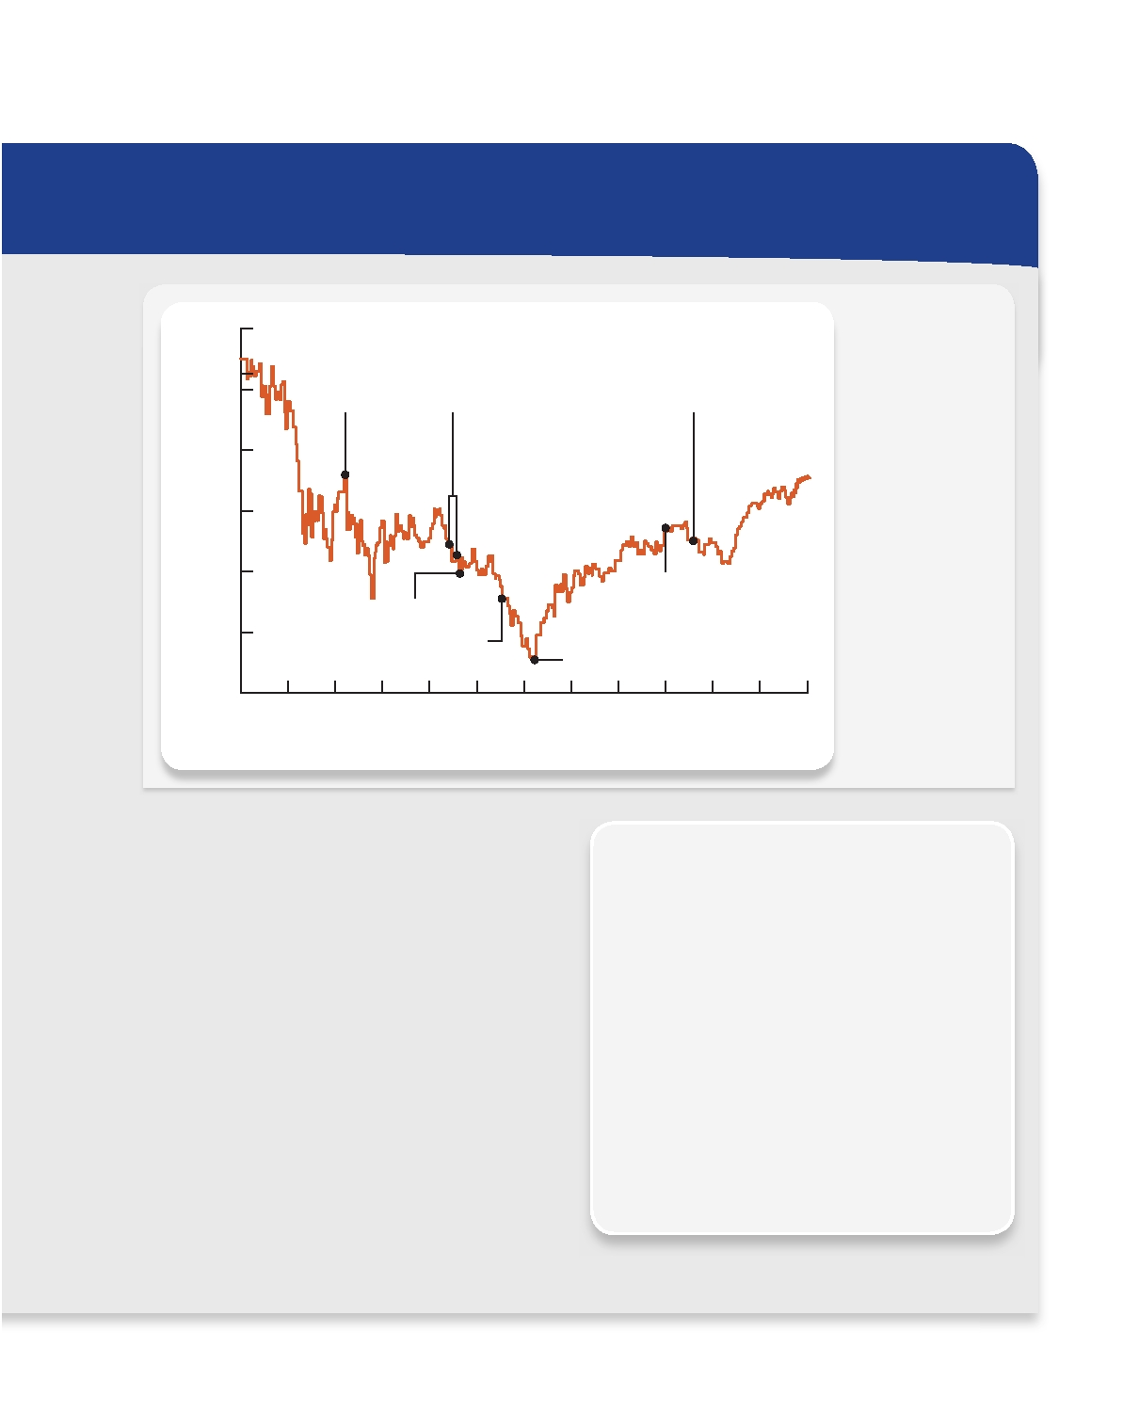
Financial Markets Chapter 3 l 57

12000

11000

10000

9000

8000

Barack
Obama is
elected
president

Banks including
Citigroup and Bank of America report fourth-
quarter earnings

Ten financial firms,
including Goldman Sachs
and J.P. Morgan Chase,
pay back TARP funds

General Motors files
for bankruptcy

What a Ride
The Dow Jones
Industrial Average
zigged and
zagged over the past year as the
market reacted to economic calamity and unprecedented
government involvement.
SOURCE: WSJ Market
Data Group

7000

6000
Obama is swom in
Obama signs
stimulus bill into law

Stock market
hits bottom

S O N D J F M A M J J A
2008 '09

Don't let financial companies become too big to fail. It's not clear if regulators fully understand this lesson of the fi- asco. For years, critics said companies like Fannie Mae and Freddie Mac had grown too large, and that firms like Lehman Brothers carried too much debt. Today, firms like Goldman Sachs and J.P. Morgan Chase are growing and might end up too big to be allowed to crumble, some analysts say.
Factor into any investment equation a worst-case sce- nario. Too many investors piled into housing-related invest- ments, confident that real estate never had dropped on a national basis or that investment-grade mortgage invest- ments never defaulted. They would have been better served to examine potential holes in their bullish stance.
Don't get too gloomy. Like the old saying goes, in every cri- sis is an opportunity. As nations around the globe confronted the crisis and pumped huge sums into their economies, the economy stabilized. And even as the recession looked its worst, the stock market began to sense that a recovery was coming.

SOURCE: The Wall Street Journal Online. "Lessons of the Financial Crisis—One Year Later" by Gregory Zuckerman, August 30, 2009. Copyright 2009 by Dow Jones & Company, Inc. Reproduced with permission of Dow Jones & Company, Inc. in the formats Textbook and Other Book via Copyright Clearance Center.

LESSONS OF THE ARTICLE
The article highlights the large swings in fi-
nancial markets during the financial crisis of 2007-2009. Before the crisis, professional in- vestors had made their own institutions and the overall financial system vulnerable by tak- ing on too much risk (see Lessons from the Crisis: Leverage, earlier in this chapter). When the crisis hit, they faced a shortfall of liquidity (see Chapter 2, Lessons from the Crisis: Mar- ket Liquidity, Funding Liquidity, and Making Markets). At the height of the crisis, panic purchases of Treasury bills constituted a clas- sic "ﬂight to safety" by investors seeking the most liquid assets. Liquidity swings caused many financial markets—including the stock market—to plunge and rebound together.

58
l Chapter 3 Financial Instruments, Financial Markets, and Financial Institutions

erupted. Exchanges seem inclined to take advantage of their technologies and customer relationships by linking across borders to lower costs and speed transactions. Whether these economies of scale and scope lead to further international consolidation will de- pend both on performance and on the attitudes of various governments toward foreign ownership and operation of national exchanges.

Debt and Equity versus Derivative Markets A useful way to think
of the structure of financial markets is to distinguish between markets where debt and equity are traded and those where derivative instruments are traded. Debt markets are the markets for loans, mortgages, and bonds—the instruments that allow for the transfer of resources from lenders to borrowers and at the same time give investors a store of value for their wealth. Equity markets are the markets for stocks. For the most part, stocks are traded in the countries where the companies are based. U.S. companies' stocks are traded in the United States, Japanese stocks in Japan, Chinese stocks in China, and so on. Derivative markets are the markets where investors trade instruments like futures and options, which are designed primarily to transfer risk. To put it another way, in debt and equity markets, actual claims are bought and sold for immediate cash payment; in derivative markets, investors make agreements that are settled later.
Looking at debt instruments in more detail, we can place them in one of two cat- egories, depending on the length of time until the final payment, called the loan's maturity. Debt instruments that are completely repaid in less than a year (from their original issue date) are traded in money markets, while those with a maturity of more than a year are traded in bond markets. Money market instruments have different names and are treated somewhat differently from bond market instruments. For ex- ample, the United States Treasury issues Treasury bills, which have a maturity of less than one year when they are issued and are traded in the money market. U.S. Treasury bonds, which are repaid over 10 years or more, are traded in the bond markets. The same distinction can be made for large private corporations, which issue commercial paper when borrowing for short periods and corporate bonds when borrowing for long periods.

Characteristics of a Well-Run Financial Market
Well-run financial markets exhibit a few essential characteristics that are related to
the role we ask them to play in our economies. First, these markets must be designed to keep transaction costs low. Second, the information the market pools and commu- nicates must be both accurate and widely available. If analysts do not communicate

INFORMATION
accurate assessments of the firms they follow, the markets will not generate the correct prices for the firms' stocks. The prices of financial instruments reflect all the informa- tion that is available to market participants. Those prices are the link between the financial markets and the real economy, ensuring that resources are allocated to their most efficient uses. If the information that goes into the market is wrong, then the prices will be wrong, and the economy will not operate as effectively as it could.
Finally, investors need protection. For the financial system to work at all, borrow- ers' promises to pay lenders must be credible. Individuals must be assured that their investments will not simply be stolen. In countries that have weak investor protec- tions, firms can behave deceptively, borrowing when they have no intention of repay- ing the funds and going unpunished. The lack of proper safeguards dampens people's willingness to invest. Thus, governments are an essential part of financial markets,

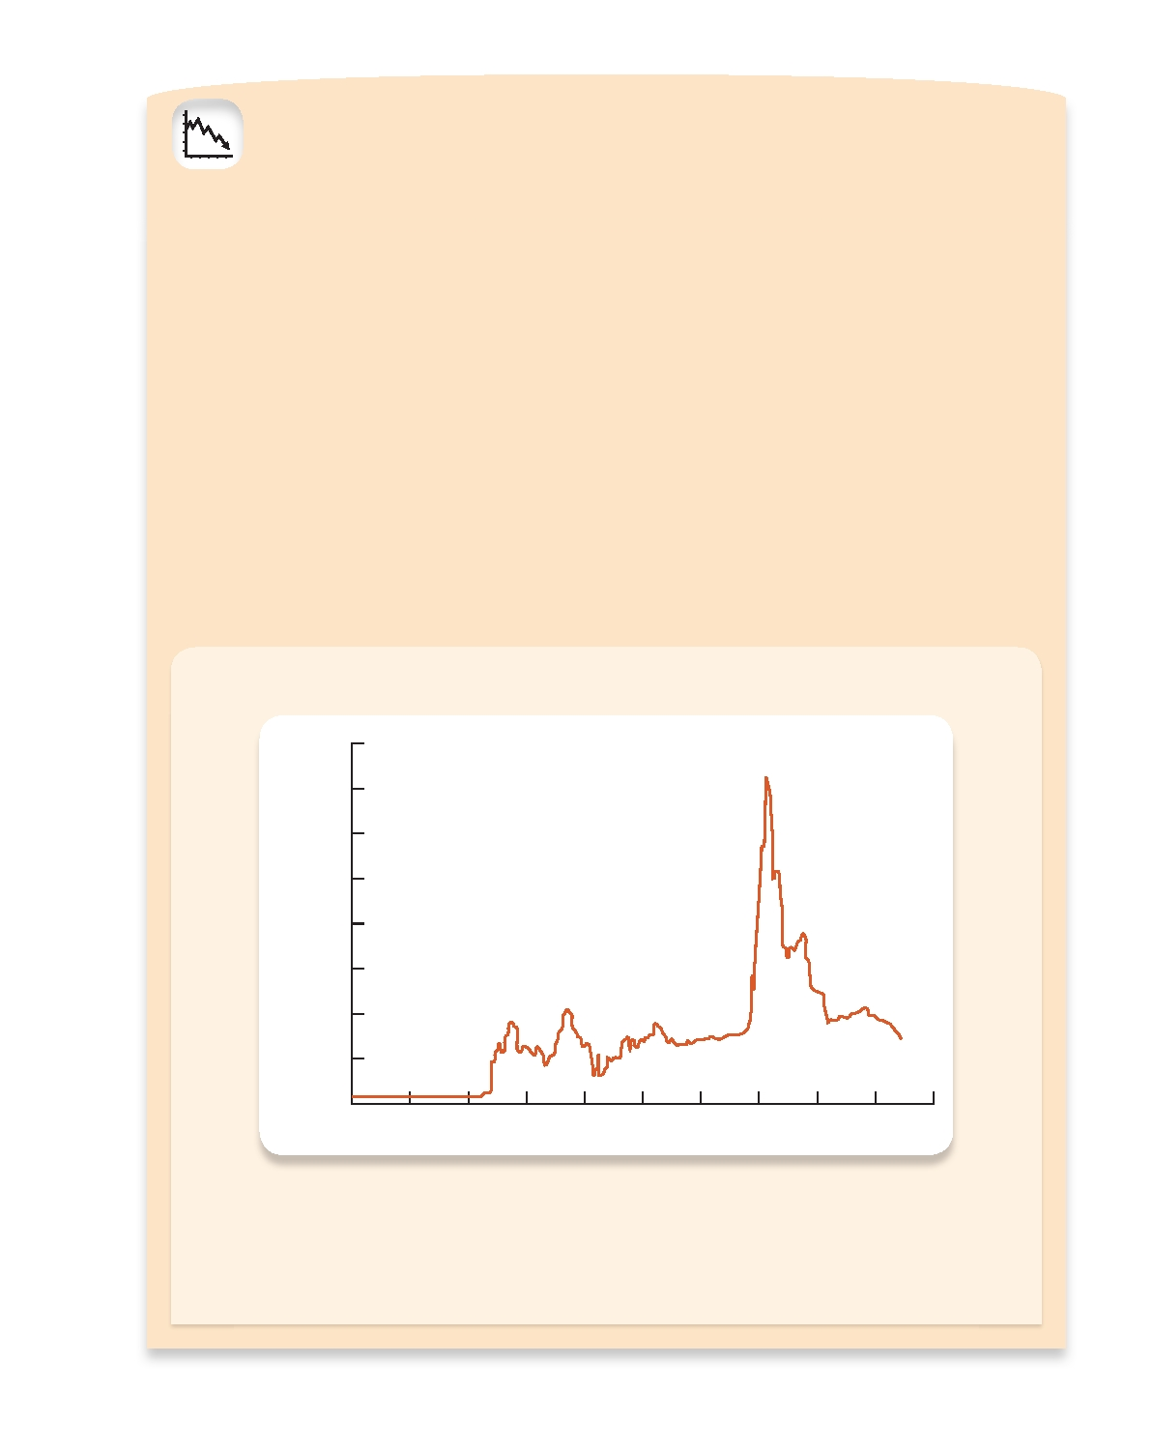
LESSONS FROM THE CRISIS
Basis Points
INTERBANK LENDING

Interbank lending is a critical foundation of modern finan- cial markets. In normal times, banks lend to each other in large volumes at low cost for periods ranging from over- night to a few months. These liquid, interbank loans are the marginal source of funds for many banks, and their cost guides other lending rates.
Interbank lending helps smooth the function of markets because it allows banks to satisfy temporary, localized excess demand for funding liquidity (see Chapter 2, Lessons from the Crisis: Market Liquidity, Funding Liquidity, and Making Mar- kets). If a bank could not reliably borrow and lend each day to offset the random ebbs and ﬂows of its deposits and loans, it would need to hold a larger volume of cash to insure it- self against unanticipated payment outﬂows or loan demand. For the banking system as a whole, such extra cash holdings waste resources that could be lent profitably elsewhere.
Events occasionally strain the interbank market. For ex- ample, on September 11, 2001, physical disruptions and com- munication obstacles boosted banks' demand for funds. The Federal Reserve supplied extraordinary amounts of liquidity for a few days until efficient interbank lending was restored.
The financial crisis of 2007-2009 triggered much greater,
and more prolonged, strains in interbank lending. Rather than lend out additional liquid assets, anxious banks preferred to hold them in case their own needs might rise. Banks also grew concerned about the safety of their trading partners as the level of trust and confidence plunged. The rising cost and reduced availability of interbank loans created a vicious circle of increased caution, greater demand for liquid assets, reduced willingness to lend, and higher loan rates.
The waves of the financial crisis may be seen in the ac- companying figure that shows the extra cost (or spread) of an interbank loan over the expected federal funds rate (the interest rate that the U.S. Federal Reserve chooses to control as its primary policy tool—see Chapter 16). Be- ginning in August 2007, this spread jumped and remained elevated. When Lehman Brothers failed on September 15, 2008, the spread leapt above 350 basis points as panic dried up interbank lending.
Unprecedented actions by governments to add liquid- ity and guarantee bank debt eventually eased the record interbank lending strains in 2009, but these actions did not prevent extensive disruptions in the financial system and the global economy. The financial crisis made painfully clear to surviving financial institutions that they cannot always count on being able to borrow at a low cost when needed.

Strains in the Interbank Market: Interbank Lending Rate Minus Expected Federal Reserve Policy
Interest Rate, 2007-2009

400

350

300

250

200

150

100

50

0
1-07 4-07 7-07 10-07 1-08 4-08 7-08 10-08 1-09 4-09

SOURCE: www.bloomberg.com
Note: The vertical scale is in basis points (a basis point is 0.01 percent). The figure shows the gap between two
measures: (1) the cost of an interbank loan, represented by the three-month London Interbank Offered Rate (LIBOR, see Chapter 13) and (2) the expected federal funds rate (the Federal Reserve's policy interest rate),
represented by a financial instrument called the overnight indexed swap (OIS). One party in an OIS pays a fixed
interest rate in return for a payment from the other party equal to the average federal funds rate over the life of the swap. The OIS rate should closely reﬂect the expected federal funds rate.

59

60 l Chapter 3 Financial Instruments, Financial Markets, and Financial Institutions

because they set and enforce the rules of the game. While informal lending networks do develop and flourish spontaneously, they can accommodate only simple, small- scale transactions. Because modern financial markets require a legal structure that is designed and enforced by the government, countries with better investor protections have bigger and deeper financial markets than other countries.

Financial Institutions
Financial institutions are the firms that provide access to the financial markets, both
to savers who wish to purchase financial instruments directly and to borrowers who want to issue them. Because financial institutions sit between savers and borrowers, they are also known as financial intermediaries, and what they do is known as interme- diation. Banks, insurance companies, securities firms, and pension funds are all finan- cial intermediaries. These institutions are essential; any disturbance to the services they provide will have severe adverse effects on the economy.
To understand the importance of financial institutions, think what the world would be like if they didn't exist. Without a bank, individuals and households wishing to save would either have to hold their wealth in cash or figure out some way to funnel it directly to companies or households that could put it to use. The assets of these household savers would be some combination of government liabilities and the equity and debt issued by corporations and other households. All finance would be direct, with borrowers obtaining funds straight from the lenders.
Such a system would be unlikely to work very well, for a number of reasons. First, individual transactions between saver-lenders and spender-borrowers would likely be extremely expensive. Not only would the two sides have difficulty finding each other, but even if they did, writing the contract to effect the transaction would be very costly. Second, lenders need to evaluate the creditworthiness of borrowers and then monitor them to ensure that they don't abscond with the funds. Individuals are not specialists in monitoring. Third, most borrowers want to borrow for the long term, while lenders favor more liquid short-term loans. Lenders would surely require compensation for the illiquidity of long-term loans, driving the price of borrowing up.
A financial market could be created in which the loans and other securities could be resold, but that would create the risk of price fluctuations. All these problems would restrict the flow of resources through the economy. Healthy financial institu- tions open up the flow, directing it to the most productive investments and increasing the system's efficiency.

The Role of Financial Institutions
Financial institutions reduce transactions costs by specializing in the issuance of stan-
dardized securities. They reduce the information costs of screening and monitoring borrowers to make sure they are creditworthy and they use the proceeds of a loan or security issue properly. In other words, financial institutions curb information asym- metries and the problems that go along with them, helping resources flow to their most productive uses.
At the same time that they make long-term loans, financial institutions also give savers ready access to their funds. That is, they issue short-term liabilities to lenders while making long-term loans to borrowers. By making loans to many different bor- rowers at once, financial institutions can provide savers with financial instruments

Financial Institutions Chapter 3 l 61

LESSONS FROM THE CRISIS
SHADOW BANKS

Over the past few decades, financial intermediation and leverage in the United States has shifted away from tradi- tional banks* and toward other financial institutions that are less subject to government rules. These other interme- diaries include brokerages, consumer and mortgage finance firms, insurers, investment organizations (such as hedge funds and private equity firms†), money-market mutual funds (MMMFs), and even bank-created asset-management firms, such as special investment vehicles (SIVs).
These other intermediaries have come to be known as shadow banks because they provide services that compete with or substitute for those supplied by traditional banks. Unlike banks, however, shadow banks do not accept de- posits. In addition, the leverage and risk taking of shadow banks can be greater than that of traditional banks while being less transparent.
Beginning in the 1970s, financial innovation sped the shift of intermediation to the shadow banks and was, in turn, stimulated by it. Broader markets, plunging infor- mation costs, new profit opportunities, and government practices all encouraged the development of new financial instruments and institutions to meet customer needs at lower cost.
Over time, the rise of highly leveraged shadow banks— combined with government relaxation of rules for tradi- tional banks—permitted a rise of leverage in the financial system as a whole, making it more vulnerable to shocks (see
Lessons from the Crisis: Leverage earlier in this chapter).
Rapid growth in some new financial instruments made it easier to conceal leverage and risk-taking. Derivatives—

options, futures, and the like—allow investors to transfer risks at low cost (see Chapter 9). After 2000, the use of customized derivatives that do not trade in open markets (so-called over-the-counter, or OTC, derivatives) rose dra- matically. Those derivatives permitted some large finan- cial institutions to take risks that were unknown to their investors and trading partners and to the public officials who were supposed to monitor them. The spillover from the failure of these firms during the financial crisis nearly sank the entire system.
The financial crisis transformed shadow banking. Dur- ing the fateful week that began with the failure of Lehman Brothers on Monday, September 15, 2008, the largest U.S. brokerages failed, merged, or converted themselves into traditional banks in order to gain access to funding. In the same month, the loss of confidence in MMMFs required a U.S. government guarantee to halt withdrawals. Over the past two years, many SIVs failed or were reabsorbed by the banks that created them. Many hedge funds chose to shrink or close as investors ﬂed.
The future of shadow banking remains highly uncertain. The crisis has encouraged governments to scrutinize any financial institution that could, by its risk taking, pose a threat to the financial system. Partly as a result, the scope for leverage and risk taking is lower, at least for now.

*One traditional form of bank is a commercial bank, which is de- fined in Chapter 12 as accepting deposits from and making loans to businesses and individuals.
†Hedge funds (defined in Chapter 13) are private, largely unregu-
lated investment partnerships that bring together small groups of wealthy people who meet certain financial requirements. Private equity funds are investment pools that typically invest directly in private companies.

that are both more liquid and less risky than the individual stocks and bonds they would purchase directly in financial markets.
Figure 3.2 is a schematic overview of the financial system. It shows that there are two types of financial institutions: those that provide brokerage services (top) and those that transform assets (bottom). Broker institutions give households and corpo- rations access to financial markets and direct finance. Institutions that transform as- sets take deposits and issue insurance contracts to households. They use the proceeds to make loans and purchase stocks, bonds, and real estate. That is their transforma- tion function. Figure 3.3 shows what the balance sheet for such an institution would include.

The Structure of the Financial Industry
In analyzing the structure of the financial industry, we can start by dividing interme-
diaries into two broad categories called depository and nondepository institutions. Depository institutions take deposits and make loans; they are what most people think of as banks, whether they are commercial banks, savings banks, or credit unions.

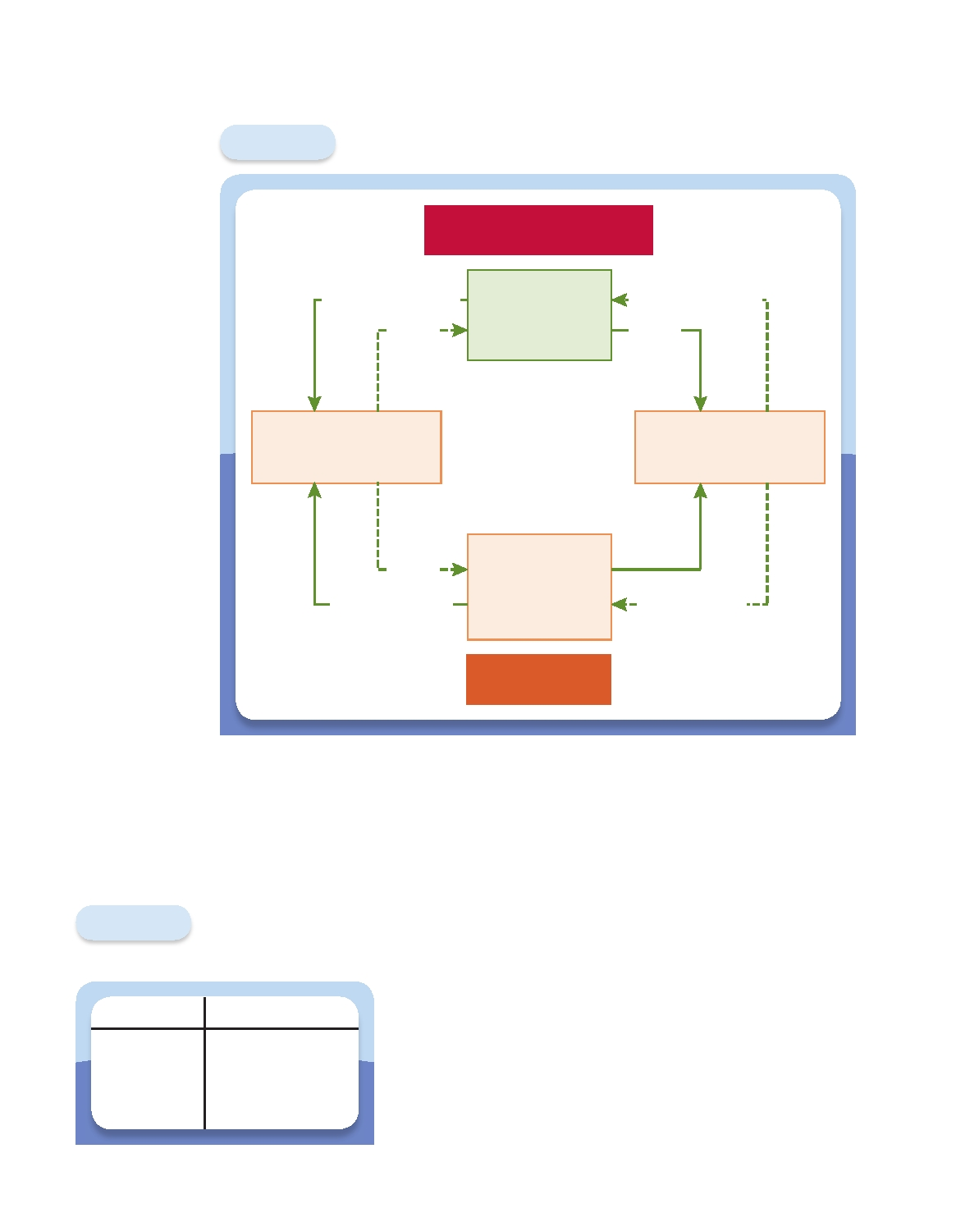
62 l Chapter 3 Financial Instruments, Financial Markets, and Financial Institutions

Figure 3.2 Flow of Funds through Financial Institutions

Access to Financial Markets

Bonds and Stocks
Funds

Financial
Institutions that
Act as Brokers

Bonds and Stocks
Funds

Lenders/Savers
(Primarily Households)

Funds
Deposits and
Insurance Policies

Financial
Institutions that
Transform
Assets

Indirect Finance

Borrowers/Spenders
(Primarily Governments
and Firms)

Funds
Loans, Bonds,
Stocks, and Real Estate

Financial institutions perform both brokerage and asset transformation services. As brokers, they provide access to financial markets, giving households and corporations access to indirect finance.
Institutions transform assets by taking deposits and issuing insurance contracts to households at the same time that they make loans and purchase stocks, bonds, and real estate.

Nondepository institutions include insurance companies, securities firms, mutual fund companies, hedge funds, finance companies,

Figure 3.3

Assets

Bonds
Stocks Loans
Real estate
The Simplified Balance
Sheet of a Financial
Institution

Liabilities

Deposits
Insurance policies
and pension funds. Each of these serves a very different function from a bank. Some screen and monitor borrowers; others trans- fer and reduce risk. Still others are primarily brokers. Here is a list of the major groups of financial institutions, together with a brief description of what they do.
1. Depository institutions (commercial banks, savings
banks, and credit unions) take deposits and make loans.
2. Insurance companies accept premiums, which they in-
vest in securities and real estate (their assets) in return for promising compensation to policyholders should certain events occur (their liabilities). Life insurers protect against

Financial Institutions Chapter 3 l 63

YOUR FINANCIAL WORLD
Shop for a Mortgage

Everyone loves a bargain. There are people who will spend hours making sure they pay the lowest price they can for virtually anything they buy. Borrowing shouldn't be any different. When the time comes to buy a house, most of us need to borrow. That is, we need to get a mortgage. Be- cause the mortgage payment will almost surely be your biggest monthly expense, getting the cheapest mortgage you can will save you more than a year's worth of bargain hunting in stores.
There are a number of ways to shop for a mortgage. Any real estate agent can hand you a list of mortgage pro- viders in your area. You can also find Web sites that pub- lish quotes for mortgages. As you look through these lists, you'll notice that many of the firms on them are not banks. Instead, they are mortgage brokers, firms that have access to pools of funds earmarked for use as mortgages.
Say, for instance, that a financial firm raises a large amount of financing to be used to make mortgages. A pool

of $100 million can finance a thousand $100,000 mort- gages. Shares in these pools are sold to investors. If you get a mortgage from one of these firms, it will go into the pool. In 2009, half of the nearly $15 trillion in mortgages in the United States was in these mortgage pools.
Should you care whether you get your mortgage from a traditional bank or a mortgage broker? Should you care if your mortgage is pooled and sold off? The answer is no; it should make no difference to you. In fact, chances are that regardless of which option you choose—bank or mortgage broker—you'll make your payments to a com- pany that does nothing but collect them and monitor your compliance. From your point of view, a mortgage is a mortgage. Get the one that suits you best. But shop before you sign on the dotted line. And if you let the various brokers know that you are shopping around, they may start competing for your business and give you a better deal.

3.

4.

5.

6.

the risk of untimely death. Property and casualty insurers protect against per- sonal injury loss and losses from theft, accidents, and fire.
Pension funds invest individual and company contributions in stocks, bonds,
and real estate (their assets) in order to provide payments to retired workers (their liabilities).
Securities firms include brokers, investment banks, underwriters, and mutual-
fund companies. Brokers and investment banks issue stocks and bonds for cor- porate customers, trade them, and advise customers. All these activities give customers access to the financial markets. Mutual-fund companies pool the re- sources of individuals and companies and invest them in portfolios of bonds, stocks, and real estate. Hedge funds do the same for small groups of wealthy investors. Customers own shares of the portfolios, so they face the risk that the assets will change in value. But portfolios are less risky than individual securi- ties, and individual savers can purchase smaller units than they could if they went directly to the financial markets.
Finance companies raise funds directly in the financial markets in order to make
loans to individuals and firms. Finance companies tend to specialize in particular types of loans, such as mortgage, automobile, or certain types of business equip- ment. While their assets are similar to a bank's, their liabilities are debt instru- ments that are traded in financial markets, not deposits.
Government-sponsored enterprises are federal credit agencies that provide loans
directly for farmers and home mortgagors. They also guarantee programs that insure loans made by private lenders. The government also provides retirement income and medical care to the elderly through Social Security and Medicare. Pension funds and insurance companies perform these functions privately.

64 l Chapter 3 Financial Instruments, Financial Markets, and Financial Institutions
www.mhhe.com/cecchetti3e

As we continue our study of the relationship between the financial system and the real economy, we will return to the importance of financial institutions, the conduits that channel resources from savers to investors. These intermediaries are absolutely essential to the operation of any economy. When they cease to function, so does everything else. Recall from Chapter 2 that the measures of money (M1 and M2) include checking deposits, savings deposits, and certificates of deposit, among other things. These are all important liabilities of banks. Because they are very liquid, they are accepted as a means of payment. Clearly, the financial structure is tied to the availability of money and credit. But we are getting ahead of ourselves. Before we study financial institutions, we need to look more closely at financial instruments and financial markets, the subjects of Part II of this book.

Terms

asset, 41
asset-backed security, 49
bond market, 58
centralized exchange, 54
collateral, 48
counterparty, 46 debt market, 58
derivative instrument, 47
direct finance, 41
electronic communications networks
(ECNs), 54
equity market, 58
financial institutions, 60

Chapter Lessons

financial instrument, 43
financial markets, 50
indirect finance, 41
liability, 41
money market, 58
mortgage-backed security, 49
over-the-counter (OTC) market, 54
portfolio, 51
primary financial market, 52
secondary financial market, 53
underlying instrument, 47

1. Financial instruments are crucial to the operation of the economy.
a. Financial arrangements can be either formal or informal. Industrial economies
are dominated by formal arrangements.
b. A financial instrument is the written legal obligation of one party to transfer
something of value, usually money, to another party at some future date, under certain conditions.
c. Financial instruments are used primarily as stores of value and means of trading
risk. They are less likely to be used as means of payment, although many of them can be.
d. Financial instruments are most useful when they are simple and standardized.

Conceptual Problems
www.mhhe.com/cecchetti3e

e. There are two basic classes of financial instruments: underlying and derivative.
i. Underlying instruments are used to transfer resources directly from one party
to another.
ii. Derivative instruments derive their value from the behavior of an underlying
instrument.
f. The payments promised by a financial instrument are more valuable
i. The larger they are.
ii. The sooner they are made.
iii. The more likely they are to be made.
iv. If they are made when they are needed most.
g. Common examples of financial instruments include
i. Those that serve primarily as stores of value, including bank loans, bonds,
mortgages, stocks, and asset-backed securities.
ii. Those that are used primarily to transfer risk, including futures and options.
2. Financial markets are essential to the operation of our economic system.
a. Financial markets
i. Offer savers and borrowers liquidity so that they can buy and sell financial
instruments easily.
ii. Pool and communicate information through prices.
iii. Allow for the sharing of risk.
b. There are several ways to categorize financial markets.
i. Primary markets that issue new securities versus secondary markets, where
existing securities are bought and sold.
ii. Physically centralized exchanges, dealer-based electronic systems (over-the-
counter markets), or electronic networks.
iii. Debt and equity markets (where instruments that are used primarily for fi-
nancing are traded) versus derivative markets (where instruments that are used to transfer risk are traded).
c. A well-functioning financial market is characterized by
i. Low transactions costs and sufficient liquidity.
ii. Accurate and widely available information.
iii. Legal protection of investors against the arbitrary seizure of their property.
3. Financial institutions perform brokerage and asset transformation functions.
a. In their role as brokers, they provide access to financial markets. b. In transforming assets, they provide indirect finance.
c. Indirect finance reduces transaction and information costs.
d. Financial institutions, also known as financial intermediaries, help individuals
and firms to transfer and reduce risk.

Conceptual Problems

1. As the end of the month approaches, you realize that you probably will not be
able to pay the next month's rent. Describe both an informal and a formal finan- cial instrument that you might use to solve your dilemma.
2.* While we often associate informal financial arrangements with poorer countries
where financial systems are less developed, informal arrangements often coexist
Chapter 3 l
65

*

Indicates more difficult problems

66 l Chapter 3 Financial Instruments, Financial Markets, and Financial Institutions
www.mhhe.com/cecchetti3e

with even the most developed financial systems. What advantages might there be to engaging in informal arrangements rather than utilizing the formal finan-
cial sector?
3. If higher leverage is associated with greater risk, explain why the process of de-
leveraging (reducing leverage) can be destabilizing.
4. The Chicago Mercantile Exchange has announced the introduction of a finan-
cial instrument that is based on rainfall in the state of Illinois. The standard agreement states that for each inch of rain over and above the average rainfall for a particular month, the seller will pay the buyer $1,000. Who could benefit
from buying such a contract? Who could benefit from selling it?
5. Consider an annuity that makes monthly payments for as long as someone lives.
Describe what happens to the purchase price of the annuity as (1) the age of the purchaser goes up, (2) the size of the monthly payment rises, and (3) the health of the purchaser improves.
6. Consider the investment returns to holding stock. Which of the following
would be more valuable to you: Stocks that rise in value when your income rises
or stocks that rise in value when your income falls? Why?
7. The Wall Street Journal has a daily listing of what are called "Money Rates" or
interest rates on short-term securities. Locate it either in a recent issue of the newspaper by looking at the index on page 1 of the Money and Investing sec- tion, or in the Market Data Center of www.wsj.com. The most important money rates are the prime rate, the federal funds rate, and the Treasury bill rate. De- scribe each of these and report the current rate quoted in the paper.
8. You are asked for advice by the government of a small, less developed country
interested in increasing its rate of economic growth. You notice that the country
has no financial markets. What advice would you give?
9. The design and function of financial instruments, markets, and institutions are
tied to the importance of information. Describe the role played by information in each of these three pieces of the financial system.
10. Suppose you need to take out a personal loan with a bank. Explain how you
could be affected by problems in the interbank lending market such as those seen during the 2007-2009 financial crisis.
11.* Advances in technology have facilitated the widespread use of credit scoring by
financial institutions in making their lending decisions. Credit scoring can be defined broadly as the use of historical data and statistical techniques to rank the attractiveness of potential borrowers and guide lending decisions. In what ways
might this practice enhance the efficiency of the financial system?

Analytical Problems

12.

For each pair of instruments below, use the criteria for valuing a financial instru- ment to choose the one with the highest value.
a. A U.S. Treasury bill that pays $1,000 in six months or a U.S. Treasury bill
that pays $1,000 in three months.
b. A U.S. Treasury bill that pays $1,000 in three months or commercial paper
issued by a private corporation that pays $1,000 in three months.

Analytical Problems
www.mhhe.com/cecchetti3e

c. An insurance policy that pays out in the event of serious illness or one that
pays out when you are healthy, assuming you are equally likely to be ill or healthy.
Explain each of your choices briefly.
Chapter 3 l 67

13.

14.
Consider a situation where there is a huge influx of inexperienced, reckless driv-
ers into your area. Assuming this increase is large enough to influence the mar- ket in which your insurance company operates, explain why the price of your car insurance policy will go up even though your driving record hasn't changed.
Suppose Joe and Mike purchase identical houses for $200,000. Joe makes a down
payment of $40,000, while Mike only puts down $10,000. Assuming everything else is equal, who is more highly leveraged? If house prices in the neighborhood immediately fall by 10 percent (before any mortgage payments are made), what
would happen to Joe's and Mike's net worth?

15.* Everything else being equal, which would be more valuable to you—a derivative
instrument whose value is derived from an underlying instrument with a very volatile price history or one derived from an underlying instrument with a very stable price history? Explain your choice.

16.

17.

18.

19.

20.
Explain why a person starting up a small business is more likely to take out a
bank loan than to issue bonds.
Splitland is a developing economy with two distinct regions. The northern re-
gion has great investment opportunities, but the people who live there need to consume all of their income to survive. Those living in the south are better off than their northern counterparts and save a significant portion of their income. The southern region, however, has few profitable investment opportunities and so most of the savings remain in shoeboxes and under mattresses. Explain how the development of the financial sector could benefit both regions and promote economic growth in Splitland.
Suppose the U.S. government decided to abolish the Securities and Exchange
Commission. What would you expect to happen to investment and growth in
the economy?
Use Core Principle 3 from Chapter 1 to suggest some ways in which the prob-
lems associated with the shadow banking sector during the 2007-2009 financial crisis could be mitigated in the future.
What risks might financial institutions face by funding long-run loans such as
mortgages to borrowers (often at fixed interest rates) with short-term deposits
from savers?

21.* As the manager of a financial institution, what steps could you take to reduce
the risks referred to in question 20?

