Third Mid Term Exam
Name ____________________

- Leman Brother went bankrupt in the fall of 2008. What caused it to occur? Do you think that our governance has anything to do with it? What can our government do to prevent it happening again? (10 Points)

- Compare investment bank with commercial bank (list business strategy, scopes of each banking system) (10 points)

- Explain what is repo? (5 points)

- What is bank run? Why we do not hear any news about bank run anymore? (10 points)

- Remember the “Occupy Wall Street” movement two years ago? Many people believe that bankers are dishonest and too greedy. So why do we need commercial banks? (10 points)

- The following graph shows the changes in Asset/Liability/Capital of Atlantic Southern Bank. (10 points)

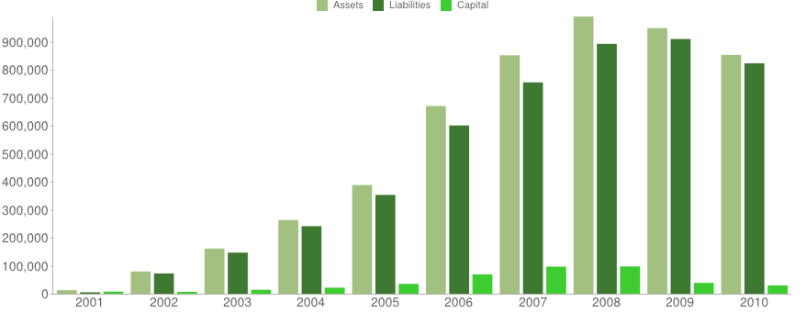

- Circle the correct answer
Cash is Asset /Liability /Capital
Interest bearing deposit is Asset /Liability /Capital
Treasury securities is Asset /Liability /Capital
Borrowed fund is Asset /Liability /Capital
Loan is Asset /Liability /Capital
Common Stock is Asset /Liability /Capital

- Explain why banks in general has a high leverage ratio (this bank’ asset = 1,083,259 and equity = 66,446 in 2009, so this bank’s leverage is around 16.)

- This bank is also reluctant to lend out to small businesses. Instead, it is more willing to lend out to home buyers. Explain why.

- The following is the Atlantic Southern Bank’s performance measure in 2008 and 2009. (10 points)
Performance Ratios (%, annualized) | (Year-to-date) | (Year-to-date)
Net interest margin: | 2.05% | 2.01%
Return on assets (ROA): | -1.31% | -3.92%
Return on equity (ROE): | -34.26% | -49.15%
- What is net interest margin?

- Wells Fargo’s net interest margin (NIM) is about 3.66%. NIM of this bank is about 2%. Which bank is performing better? Why?

- US interest rate is expected to go up in the near future. When that happens, what will happen to US dollars? More valuable or cheaper? Why? (hint: think from the view of demand and supply of $ in the global market) (10 points)

- What do you think of the US debt ceiling? How to fix the debt ceiling problem? (10 points)

- What is purchasing power parity? (5 points)

- What is carry trade? Can you think of a strategy to make profits in today’s global market using carry trade? This question is based on “carry trade ripping across wall street” and “Yen play is blast from the past”. (5 points)

- What is mortgage backed securities (MBS)? Why do investors renew interest in MBS? (5 points)

