Brexit’s Hidden Threats—To Europe

Most think of the consequences of a British exit from the EU in terms of the U.K. economy. But what about Europe?
By RICHARD BARLEY
Updated Feb. 19, 2016 5:33 p.m. ET

The U.K. has put itself in the spotlight. After marathon talks, Prime Minister David Cameron has struck a deal on the country’s status in the European Union that paves the way for a referendum on the U.K.’s membership. But for global investors, it is worth thinking as much about the consequences for the continent as for the U.K.
Given the trials of the global financial crisis, it is remarkable that the European project has continued to make progress. The eurozone, which still has the threat of a Greek exithanging over it, has added members. Estonia joined in 2011, Latvia in 2014 and Lithuania in 2015. No member state has ever left the European Union; from its roots as six countries in the European Coal and Steel Community in 1951, it has reached 28 members.
Any exit would be a big deal. The departure of the U.K., which based on 2014 Eurostat data accounts for roughly one-eighth of the EU’s population and one-sixth of its gross domestic product, would be even bigger.
The process alone of “Brexit” may create risks. Europe, already dealing with a migration crisis, the lingering political and economic fallout from the sovereign-debt crisis and a waterlogged banking system, would have to spend a vast amount of time and effort negotiating with the U.K. on the terms of a future relationship. That is without considering the potential for shifts in the balance of power within the EU with a large country departing. For some, a U.K. exit might signal the removal of a brake on the path toward deeper integration. For others it will look like an invitation for more states to make demands of their own based on national grounds.
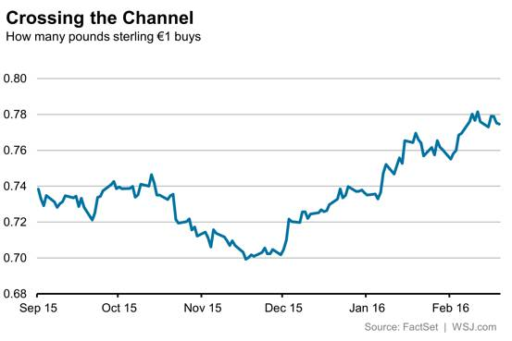
The City of London clearly has a lot at stake in the vote, which may come in June. But that is precisely because the City isn’t just a domestic capital market; it is an international financial center and pre-eminent in Europe. Most significant, London is the home of European bond markets, in particular the corporate-bond market. The infrastructure that makes it easy for Europe’s blue-chip companies to borrow funds in euros is based largely in the City and Canary Wharf.
As such, investors shouldn’t bank on the market turmoil being focused on the U.K. in the run-up to the vote. In that light, the strong run for the euro against sterling—up 5.4% this year and 11% from a low in November—looks somewhat incongruous.
True, some of this rise is because of broader shifts in global markets, including risk aversion and the fading prospect of U.K. rate increases. A U.K. exit could well spur looser policy from the Bank of England, but turmoil in Europe will surely cause further concern at the European Central Bank as well. Perhaps the better play would be to bet on sterling declining further against the dollar.
A vote for Brexit would clearly affect the U.K. most directly. But just like the threat of a Greek exit, don’t assume the rest of Europe can come through the process unscathed.

Bracing for ‘Brexit’: Traders Get Defensive on British Pound

As U.K. weighs leaving EU, cost soars for options that protect investors from a big move in the pound
By CHRISTOPHER WHITTALL and TOMMY STUBBINGTON
Updated Feb. 18, 2016 7:16 p.m. ET

Demand is spiking for contracts that protect investors from a big move in the British pound this summer—an indication that traders are girding for the aftermath of a referendum on the U.K.’s membership in the European Union.
While wider markets have yet to show a clear reaction to the possibility of a U.K. exit, analysts increasingly talk of its potential as a political risk that could affect a host of assets, from gold to British exporters and high-end London real estate.
The cost of options on the pound, by one measure, has in recent days hit its most extreme level since Europe’s sovereign-debt crisis. Implied volatility on six-month euro-sterling options jumped to just over 12% on Thursday, its highest level since late 2011. That is up from a recent low of 8.4% in mid-December, according to Thomson Reuters data.
Investors are mainly using these options to hedge against a fall by the pound. The relative cost of buying protection against a falling pound, as opposed to the currency rising, is at its highest level since the global financial crisis of 2008, according to Hamish Pepper, a currency strategist at Barclays.
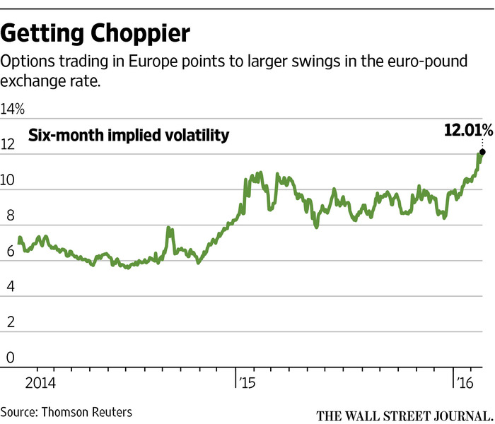
The move comes as U.K. Prime Minister David Cameron seeks to clinch a final dealresetting his country’s relationship with the EU. An agreement this week would pave the way for a vote on Britain’s EU membership in late June, U.K. government officials have said.
“Irrespective of the twists and turns of the debate, uncertainty over the outcome is likely to weigh on U.K. markets for a good few months yet,” said Mike Amey, head of sterling portfolios at Pacific Investment Management Co.
Investors piled into currency options ahead of Scotland’s referendum on its membership of the U.K. in 2014. That referendum hit sterling and caused a wobble in the shares of companies based in Scotland, such as insurer Standard Life PLC. In the end, Scottish voters elected to stay in the U.K., and the pound and stocks bounced back.
‘You’re not seeing a lot of pressure in markets other than on the currency.’
—Charlie Diebel, Aviva Investors
Polls indicate the British population is divided over EU membership. Most investors say the U.K. is likely to stay in the EU, but acknowledge that nervousness over the vote is likely to weigh on markets in coming months.
Pimco puts the chance of a British exit as high as 40%, based on neither option taking a decisive lead in opinion polls.
Uncertainty over whether the U.K. will vote to leave—a move sometimes referred to as a “Brexit”—already has contributed to a slide in the pound this year against other major currencies.
The pound was up 0.5% on the day against the euro in late New York trading Thursday, but it remains down 4.9% against the single currency so far this year.
“Uncertainty is the word that seems to encapsulate everything with respect to Brexit,” said Charlie Diebel, head of rates at Aviva Investors. “You’re not seeing a lot of pressure in markets other than on the currency.”
That is mainly because it isn’t obvious how other asset classes will react following a referendum, investors say. For instance, some investors think an “out” vote would actually benefit U.K. government bonds as the Bank of England would be unlikely to raise interest rates in the near future. Higher interest rates drive up government-bond yields, which rise as prices fall.
For the moment, selling the pound remains the simplest way for investors to express a negative view on the U.K. But as the countdown to the referendum begins, analysts are increasingly looking at what assets will be affected.
Topping most lists is London’s property market. London house prices are among the most expensive in the world, in part due to overseas demand and immigration, and will be susceptible to price falls if Britain leaves the EU.
Gold also may benefit as the potential for a U.K. exit adds to current political and monetary risks that can push money into the haven asset.
If Mr. Cameron fails to reach a deal, “this will definitely lead to higher gold demand,” saidDaniel Briesemann, a commodities analyst at Commerzbank AG.
In equity markets, U.K. companies with significant European activities also could be hit if access to Britain’s biggest trading partner is affected.
For markets, though, it’s not the divorce that matters, said Pimco’s Mr. Amey. It’s the nastiness of the breakup. The aftereffects of “a confrontational separation where the two sides act as if in an unpleasant divorce” could be long-lasting, he said.

Europe Looks Ever More Divided After Brussels Deal

Whatever its citizens decide, U.K.’s push to renegotiate membership shows trend toward weaker union
By STEPHEN FIDLER
Updated Feb. 19, 2016 5:47 p.m. ET

Whether the people of the U.K. decide to remain in the European Union or not in the summer referendum, Britain’s effort to renegotiate its relationship with the bloc that concluded Friday at a summit in Brussels reinforces a trend toward weakening cohesion among its 28 governments.
If the last few years are a harbinger of the future, the high point of European economic and political integration is in the past. Europe’s nation states are reasserting themselves, for better or worse.
A British exit from the EU would likely seriously damage European unity. A new report compiled for the World Economic Forum by a panel under the chairmanship of former Swedish foreign minister Carl Bildt says: “Brexit would be a turning point in EU integration, which has, so far, been seen as largely irreversible,” noting that other governments in Europe would be pressed to offer their citizens a similar choice.
But even a vote to remain risks setting a precedent. Other governments may want deals of their own or seek to take advantage of the exceptions the British accord has carved out, like those limiting social-welfare payments to other EU citizens.
The British negotiation wasn’t the only evidence at the summit of the eroding coherence of the bloc. The fierce fight that took place Thursday night over migration emphasizes that no single issue, not even the crisis of Greece and the euro, has set member states so fiercely at one another’s throats.
German Chancellor Angela Merkel made no attempt to hide her ire at neighboringAustria’s decision to raise barriers against migrants from the south and limit the numbers of asylum seekers it accepts to 80 a day. That threatens to lead one country after another to raise barriers at their borders, trapping thousands in Greece.
Other governments blame Ms. Merkel for accelerating the influx of migrants into the EU by welcoming them last summer, and she is under increasing pressure politically at home too. The sure touch that Germany showed in its leadership of the euro crisis has been absent in the turmoil over migration. The summit revealed Ms. Merkel increasingly dependent on mercurial Turkey to slow the flow of people into Europe.
Germany’s leadership of the euro crisis had many critics, but it was an inescapable fact and had a strong internal logic. A crisis in which German leadership is fitful or absent is one in which the EU’s widely divergent nations—and more divergent now because there are 28 of them compared with just 15 at the start of 2004—have reasserted themselves.
In some ways, though, the high point of European togetherness appears in retrospect to have been something of a chimera. Both the euro and the Schengen passport-free border areas, the deepest manifestations of European integration, look like fair-weather constructions, unable to cope when the storms struck.
From a British perspective, the politicians of Europe wanted the prizes of a common currency and border-free travel but were unwilling to give up the national sovereignty required to make them work. They willed the ends but not the means, launching the euro without a common treasury or bank deposit-guarantee fund, for example, and the Schengen area without a European border force.
Members of the euro and Schengen will probably face more choices over pooling their sovereignty if the two are to survive in the long-term. In the euro area, anxieties about the banking system have intensified in 2016, in part because the “banking union” meant to address its weaknesses is a long way from completion. A European border force appears to be in the making, though that alone will not prevent the re-erection of frontier controls in the face of a further surge of refugees.
Some countries may not want or be able to make those commitments. Even France, whose officials depict themselves as keepers of the flame for eurozone integration, won’t countenance the treaty changes that would shore up the currency—largely because they expect they would lose the necessary referendum on the matter.
Among some, the dream of closer European unity dies hard. Leaders in the countries of continental Western Europe saw World War II as the failure of the nation state, and some of their successors still campaign for more integration. Belgian Prime Minister Charles Michel was the most exercised at the summit about Prime Minister David Cameron’s wish to have the U.K. excluded from the EU treaty’s commitment to “ever closer union.”
For reasons of necessity and idealism, some countries may need or want to integrate further. For others, domestic politics will mean that they will never be able to make that commitment.
This week’s summit appeared to be a further nail in the coffin of “ever closer union.” That will be a cause for regret for some in Brussels and further afield. For others, however, the end of a “one-size-fits-all” approach to the EU and the development of a more modular union may be the best way to ensure its survival.

