Follow the money — sell health-care stocks and buy dividend shares
Published: Jan 25, 2017 7:57 a.m. ET

Sectors including utilities, real estate, home building and consumer staples are about to break out to the upside
Robin Marchant/Getty Images for NYCWFF
Coca-Cola is among consumer-staples stocks that appear ripe for gains, according to Michael Kahn.
By

MICHAELKAHN
Even if the stock market trades within a range over several weeks or even months, there is still money to be made. That is, if you know how to weight sectors the right way.
A market index is a mathematical blend of all its sectors. Some are going to rise and some will fall, so keeping track of the movements of each can result in profits, even over shorter periods.
The health-care sector warrants investors’ attention these days, given potential changes under the new Republican administration. It’s showing signs of cracking. The Health Care Select Sector SPDR ETF XLV, +0.90% appears to be breaking down from a technical formation it’s been in since the election, as you can see on this chart:
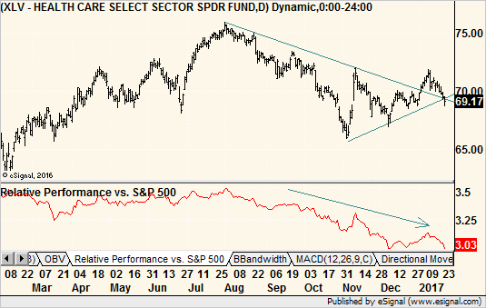eSignal
Not only that, but the sector has lagged behind the broader market since last summer. It looked to be on the mend in November, but its resurgence was short-lived. And, now, it’s moved below the trendline supporting its gains since the election.
This trailing sector is now moving from generating smaller gains than the broader market to producing actual losses. It’s likely a good time to move money from medical-supply, biotechnology and pharmaceutical companies and find another home.
Dividend stocks on the mend
Fortunately, dividend-paying sectors now look to be on the mend. The bond market topped out last summer, and as it fell, it took these bond-like stock groups down with it. The expectation that long-term interest rates would rise as the Federal Reserve boosted short-term interest rates was pervasive. It definitely hurt bonds, as prices and interest rates move inversely to each other.
Unfortunately for bond bears, interest rates have stabilized and now money seems to be moving into stocks with fat payouts. The bond market itself is not rallying, but such stock areas as utilities, real estate, home building and consumer staples are threatening upside breakouts.
Utilities
Let’s start with the Utilities Select Sector SPDR ETF XLU, +0.00% It made a tentative move above the trendline guiding it lower since last summer and is now easing back to test that break. When a stock or ETF tests a breakout, it trades back down to touch the line or pattern. That gives late bulls a second chance to get in at low prices, and if they take it, we’ll see a nice pop back up. So far, no pop, but no aggressive selling, either.
Volume-based indicators such as the accumulation/distribution study held steady during the ETF’s price decline and now moved to new highs. That tells us bullish investors are a bit more aggressive even though it has not shown up in price movement just yet.
To be sure, the buy signal has to wait until prices break free from the two-month range they’ve been in. But with strong underpinnings, it pays to keep this one on the radar screen and even dig deeper for individual utility stocks that look even stronger. Otter Tail Corp. OTTR, +0.13% and Unitil Corp. UTL, +0.06% come to mind, although these two are thinly traded and therefore present a bit more risk.
REITs
Real estate investment trusts (REITs), via the iShares U.S. Real Estate ETF IYR, -0.01%look similar. However, here it pays to dig deeper, because shopping REITs, which hold brick-and-mortar retail stores, are hurting. Housing, mortgage and hotel REITs are in much better shape.
Chimera Investment Corp. CIM, -0.39% a mortgage REIT, and Pebblebrook Hotel Trust PEB, +2.18% a hotel REIT, both have broken out to the upside from short-term patterns. So have many interest-rate sensitive homebuilders such as Beazer Homes USA Inc. BZH, +2.56% following Jan. 24’s release of the Case-Shiller index indicating strong demand for homes.
Consumer-staples
Finally, the Consumer Staples Select Sector SPDR ETF XLP, -0.02% broke out to the upside last week (see the following chart). This sector is home to many stocks paying big dividends, and it also got hurt when bonds peaked last summer. However, since finding its low in late November, it has done quite well, coming back to beat its 50-day average and now test its 200-day average.
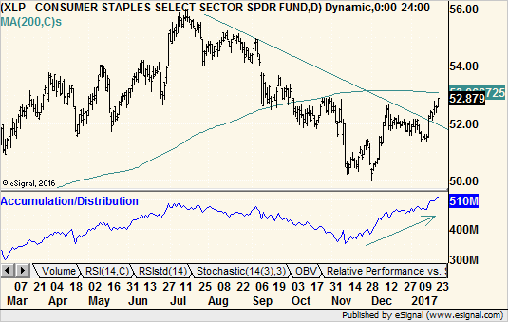eSignal
Procter & Gamble Co. PG, -0.80% was responsible for the ETF’s breakout as it is the most heavily weighted stock in the group. This stock jumped last week on earnings. But many other stocks are on the verge of individual breakouts, including Colgate-Palmolive Co. CL, +0.01% and Coca-Cola Co. KO, +0.53% Kimberly-Clark Corp.KMB, +0.01% exploded higher Jan. 24 on earnings to score a technical breakout of its own.
I am waiting for Archer-Daniels Midland Co. ADM, +1.21% to make its move from a triangle pattern. With volume-based indicators continuing to inch higher as prices pause, the indication is that the stock will eventually break out to the upside. There is no guarantee, of course, so we’ll have to wait for the actual breakout.
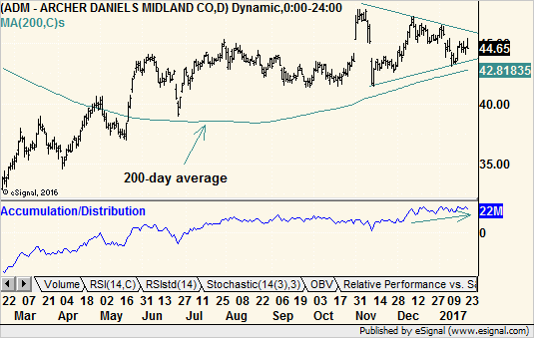eSignal
While pundits fret that interest rates are going to move higher and bond prices are going lower, so far stocks with bigger dividend yields seem resilient. Indeed, they may be benefitting as money moves from bonds to stocks, and settles into the next best thing — high-dividend-paying sectors.
Even if we forget the bond market and just compare the performances of sectors within the stock market, money seems to be moving from health care into income-producing areas. As they say, follow the money.
Michael Kahn, a chartered market technician (CMT), is a columnist for MarketWatch as well as Barrons.com, where he writes the “Getting Technical” column. He is the author of three books on charting, contributes to several trading and investing websites, and speaks at industry events.

