Trump’s game of chicken with China is a lose-lose situation
Published: Jan 11, 2017 10:32 a.m. ET
China won’t cave like Japan did in the 1980s on trade
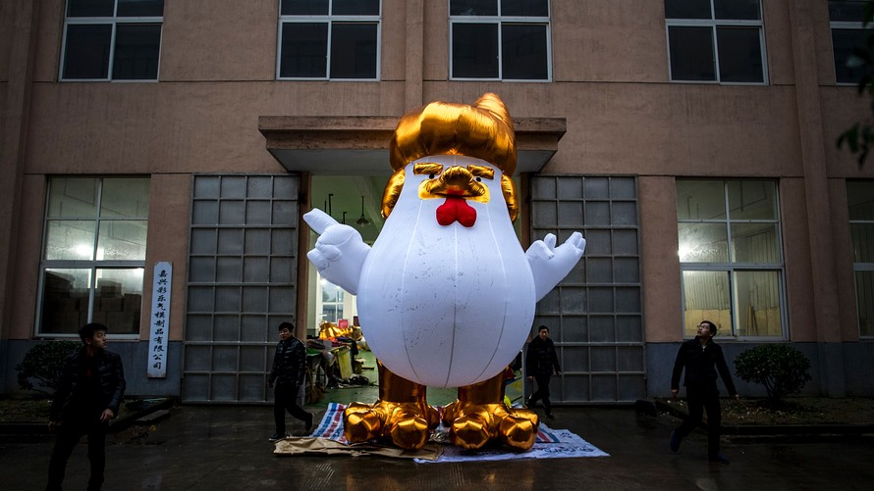AFP/Getty Images
Workers in China inflate a giant chicken resembling Donald Trump as a salute to the year of the rooster.

By

SUECHANG

Despite their shared history and geographic proximity, China is not Japan, something President-elect Donald Trump should remember when he attempts to bully China into submission, according to analysts.
Throughout his campaign, Trump had fired up his base with pledges to take China to task for unfair trade policies. The conventional wisdom among experts is that Trump will move aggressively against China with the aim of forcing the world’s biggest exporter to the negotiating table to win concessions, a ploy that worked with Japan in the 1980s.
However, the outcome of such heavy-handed tactics is expected to be vastly different.

China will not fold like Japan, said Helen Qiao, China and Asia economist at Bank of America Merrill Lynch. “We think China will push back against threatened trade restrictions,” she said in a recent report.
Japan was a leading exporter in the 1980s as brands like Toyota and Sony won the hearts of consumers around the world. Favorable trade terms from its biggest patron, the U.S., also did not hurt.
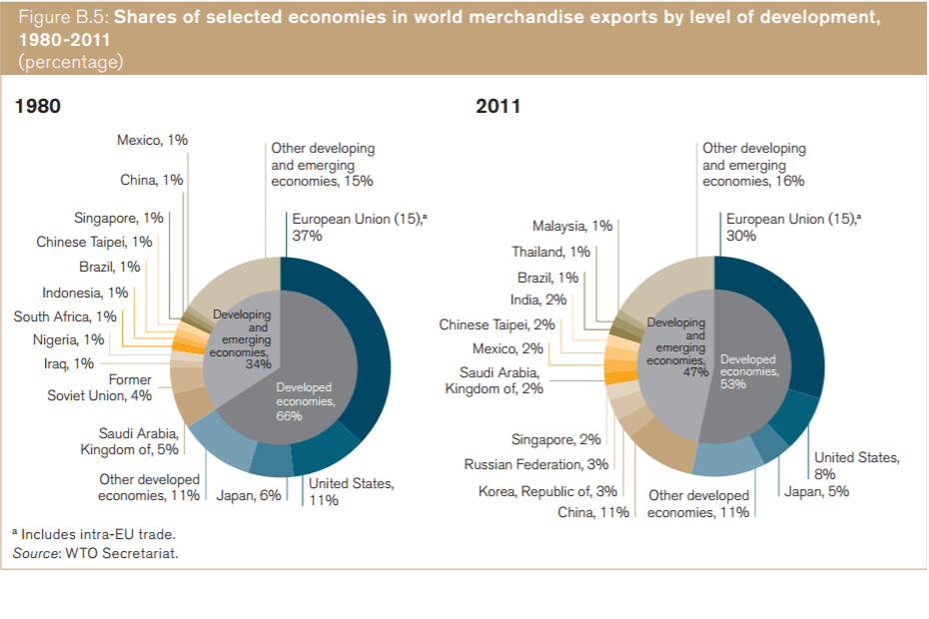The World Trade Organization
However, sentiment quickly turned against the Asian country as the U.S. continued to suffer billions in deficits, prompting the U.S. government to enforce import quotas on Japanese goods and in turn demand greater access for U.S. companies.
The fight with China is likely to be much more hostile and, ultimately, detrimental to both sides.
“China could choose to respond via an ‘asymmetric trade war’ by selectively raising tariffs against the U.S., or employing measures such as restricting the purchase of U.S. goods and services if the U.S. imposes a tariff of 5% or 20%,” said Chetan Ahya, global co-head of economics at Morgan Stanley, in a research note.
A move by the Trump administration to erect trade barriers against China will weigh on the country’s economic growth at a time when fears about a precipitous slowdown in China continue to linger.
Chinese economic growth is projected to slow to 6.4% this year from 6.7% in 2016 and 6.9% in 2015, according to the Organization for Economic Cooperation and Development.
A 5% tariff against Chinese goods could lead to a 0.1 percentage-point drag on China’s GDP growth, while a 45% tariff could slow economic growth by as much as 1.4 percentage points, he said.
The U.S. is likely to suffer as well.
The World Bank on Tuesday warned that efforts by the new U.S. administration to raise tariffs and barriers could led to retaliation and burden the outlook for the U.S. economy.
Given the complexity of imposing a comprehensive tariff on Chinese imports, Trump is expected to take the easier route of labeling China a currency manipulator.
According to U.S. regulations, China is not a currency manipulator, although it is on the watch list along with Switzerland, Japan, Korea, Taiwan and Germany. For the U.S. Treasury to call out a country as a manipulator, it has to meet all three of the following criteria — a trade surplus in excess of $20 billion with the U.S., a current account surplus of 3% of its GDP and persistent interventions in currency markets that are deemed one-sided.
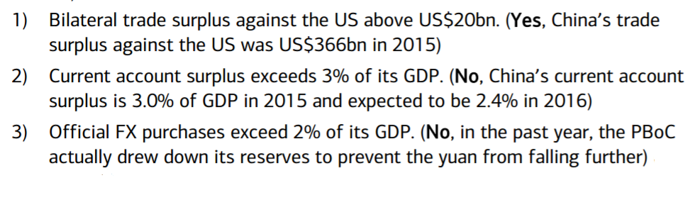Bank of America Merrill Lynch
However, those rules are not legally binding, so Trump could theoretically ask the Treasury to revise the guidelines or even issue an executive edict to slap China with the manipulator label, kicking off bilateral negotiations, according to Bank of America’s Qiao.
If China fails to make adjustments and it remains on the manipulation list after a year, the U.S. has several options, including preventing China from participating in U.S. government procurement deals, increased International Monetary Fund surveillance and the possibility of launching trade negotiations, she said.
“We believe the main point of naming China as a currency manipulator would be to bring China back to the negotiation table at the lowest cost,” said Qiao. “It is possible that the Trump administration will seek to engage China in trade agreement negotiations as soon as possible, even before a manipulation conclusion is drawn.”
But there is no guarantee that China would be willing to parley.
“Instead of caving in and trying to prepare voluntary export restraints like Japan did with their auto exports back in the 1980s, we believe China would start by strongly protesting against the labelling with the IMF,” said Qiao.
Beijing may not go as far as to sell off U.S. Treasury bonds from their foreign exchange reserves, but even a “war of words” will erode confidence in the U.S. and China and by extension, the global economy, she said.
The inauguration of a more combative U.S. president comes at a sensitive time for China as it battles a sharp depreciation of its currency on sizable capital outflows, ensuring that China will not meekly acquiesce to Trump’s demands.
The yuan USDCNY, +0.2152% has softened to 6.92 against the dollar on Tuesday from 6.49 a year earlier and is forecast to retreat to 7.3 in the fourth quarter of 2017, according to Bank of America. The country’s foreign exchange reserves fell to the lowest level in almost six years to $3.01 trillion in December, sinking $41 billion in one month as authorities dipped into the reserves to prop up the yuan.

