Trump is waving adios to the longstanding ‘strong dollar policy’
Published: Jan 18, 2017 10:27 a.m. ET
6

By

WILLIAMWATTS

DEPUTY MARKETS EDITOR

The strong dollar policy—a mantra of Democratic and Republican administrations for more than two decades—may be headed for the scrap heap once Donald Trump is sworn in as president on Friday.
Indeed, Trump sent the dollar skittering lower Tuesday after he told The Wall Street Journal that the U.S. currency was “too strong,” in part due to Chinese efforts to hold down the yuan USDCNY, -0.2232% Bargain hunters helped the U.S. currency regain some lost ground Wednesday.
But while much is made of Trump’s questioning of the need for North Atlantic Treaty Organization or the lasting power of the European Union, an administration-level push for a weaker currency would hardly be without precedent. It would, however, be an adjustment a generation of investors and traders who came of age in an era when the executive branch at least paid lip service to the notion that a strong dollar was a desirable aim.
The tide last shifted during the Clinton administration after Robert Rubin, the former Goldman Sachs chief, took over as Treasury secretary from Lloyd Bentsen in early 1995. Before that, Bentsen and U.S. Trade Representative Mickey Kantor had often used language that inadvertently—or not—tended to weaken the dollar.
Bentsen got the ball rolling early in Clinton’s first term, calling for a stronger yen in a February 1993 appearance and shocking currency traders who duly bid up the Japanese currency. As recounted in a 2001 paper by economists Brad DeLong and Barry Eichengreen, Bentsen saw the stronger yen as potentially helpful in alleviating the U.S. trade deficit, while Kantor saw a weaker dollar providing leverage in trade talks.
That may sound a bit familiar. Trump made the U.S. trade deficit a centerpiece of his campaign, using it to argue that it was proof the nation is getting its lunch eaten by competitors in a zero-sum world.
But it can only be take so far. Clinton was committed to trade, championing the North American Free Trade Agreement and other measures. The dollar, as Eichengreen and DeLong noted, was the lone instrument available for addressing the trade deficit and U.S. manufacturers.
While Bentsen and Kantor were focused on Japan, Trump’s ire is aimed primarily at China and Mexico.
Most of the focus when it comes to trade has been on Trump’s calls for tariffs on imports from China and car parts from Mexico—something most economists fear will lead to global trade tensions and depress global trade, slowing the world economy.
But Douglas Borthwick, managing director of Chapdelaine Foreign Exchange, argued in a note earlier this month that an incoming Trump administration, by throwing out the strong dollar policy, could use the currency as a linchpin in implementing its economic agenda:
With a removal of the Strong USD Policy, the US Dollar will weaken against its global counterparts. This will give the FED the ability to normalize US interest rates, as they can use the weaker USD and the resulting inflation as an excuse for raising rates. The FED will then be used by the Administration as a brake on US Dollar weakness. The weaker USD will also force other countries struggling to get their economies moving to rewrite trade agreements in a way that is more advantageous to the US. In other words, we will see a normalization of US Interest rates, and better negotiated trade deals. Both a win for the new Administration.
Time will tell whether a weak dollar is such a panacea.
The Clinton administration’s tune soon changed once Rubin replaced Bentsen. Rubin drove home the shift by faithfully repeating that a strong dollar was in America’s interest. Some well-timed intervention that burned the fingers of dollar bears also helped.
Why was a stronger dollar in America’s interest? Rubin argued that a stronger dollar helped keep inflation in check, allowing interest rates to remain low and contributing to an economic boom that soon took hold.
The dollar is already quite strong for a variety of reasons, some of them related to expectations surrounding Trump’s other economic policies (see chart below). The ICE dollar index DXY, +0.61% hit a nearly 14-year high in early January. It has subsequently pulled back but remains up more than 2.5% from its pre-election level.
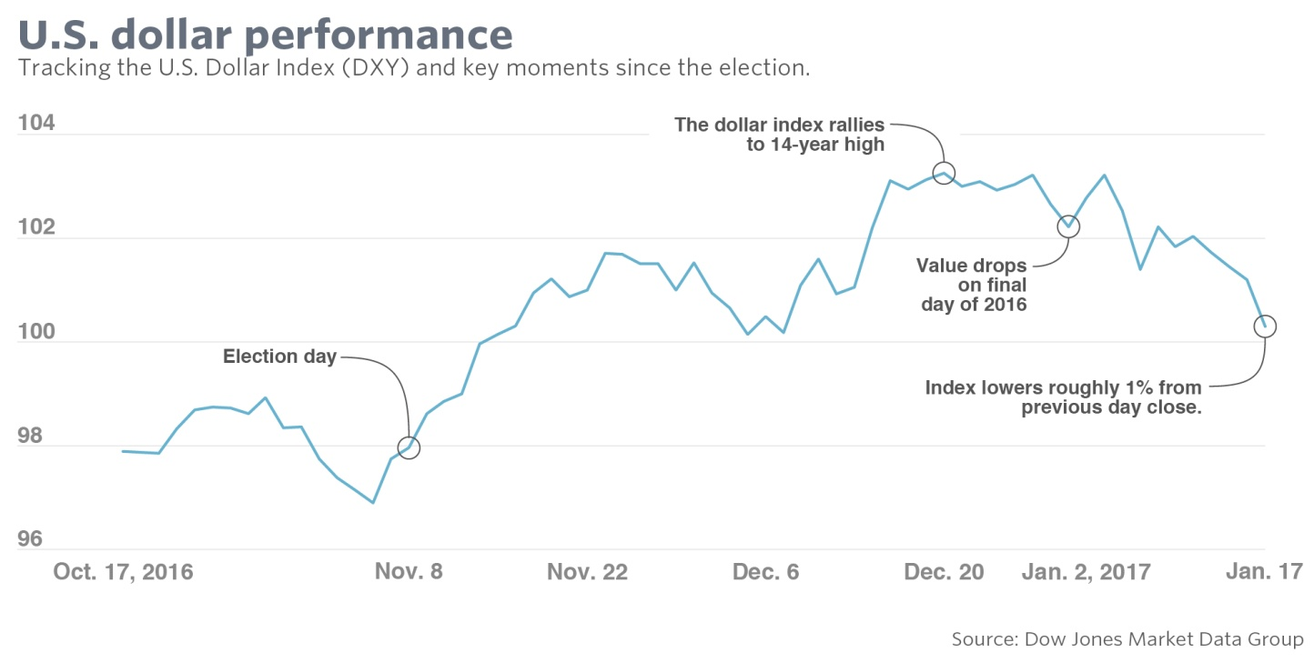
And it isn’t clear that an effort to talk down the buck would be successful. Trump’s calls for fiscal expansion and the repatriation of corporate profits held overseas along with a Fed that is moving to tighten monetary policy could all complicate any attempt to purposely weaken the dollar, noted Steven Barrow, currency and fixed income strategist at Stan

