U.S. Debt Burden: It’s Gotten a Bit Less Bad

Lower interest rates postpone day of reckoning, but entitlements still need long-term solutions
The outlook for the U.S. national debt has actually gotten less dire in recent years, in part due to lower health-care inflation, buying more time for overhauling Social Security and Medicare.
By GREG IP
Updated Feb. 3, 2016 6:51 p.m. ET

Budget watchdogs for years have warned of a looming debt crisis in the U.S. The federal debt, already its highest as a share of the economy since 1950, is poised to rocket higher as retiring baby boomers draw on Medicare and Social Security.
Here’s the surprise: Compared to seven years ago, the long-term budget outlook has gotten better, not worse, thanks to slower health-care inflation and, more important, much lower interest rates.
The hands on the doomsday debt clock have been moved back.
Yes, the debt is still on an unsustainable path. Entitlements still have to be fixed—the sooner, the better. But that need not entail an immediate attack on the debt. So concludes a new study co-written by Doug Elmendorf, who as head of the Congressional Budget Office from 2009 to 2015 was the country’s most influential deficit scold.
Historically, financial crises have wreaked havoc on national budgets, and the U.S. is no exception. As President Barack Obama was rolling out aggressive measures to combat the financial crisis and recession in 2009, his first full budget predicted the federal debt would climb from around 40% of gross domestic product in 2008 to 69% by 2016.
Reality has turned out worse. When Mr. Obama unveils his last budget next week, it will be with the federal debt at 75% of GDP. That’s largely because the economy has grown much more slowly than he predicted back in 2009. Actual deficits have been slightly wider than projected, despite spending caps championed by Republicans in Congress and lower interest rates.
Yet the real problem was never the debts the U.S. incurred at the depths of recession, but those that will pile up in coming decades as an aging population sends the bill for Social Security and Medicare through the roof.
It is on that front that the outlook has changed for the better. In 2009 the CBO predicted that with then-current tax and spending policies continuing, the debt would top 100% of GDP by 2023. While strict apples-to-apples comparisons aren’t possible, by last year, it had moved the date back to 2030. Mr. Elmendorf, now at Harvard University, and his co-author Louise Sheiner, policy director at the Brookings Institution’s Hutchins Center, a think tank, now think that will happen in 2032. (They will present their study at Brookings on Friday.)
One reason for the reprieve is plunging health-care inflation. That’s thanks to the Affordable Care Act’s cuts to Medicare providers, and even more to changed behavior by consumers, employers and private insurers.
The second factor is interest rates. When interest rates exceed the economic growth rate, debt tends to grow faster than the country’s ability to support it. The spread between those two numbers is thus a key determinant of debt risk. Mr. Elmendorf and Ms. Sheiner note that in 2005, the CBO thought rates would run 1.2 percentage points higher than economic growth over coming decades.
In recent years, however, the Federal Reserve, the CBO and most economists have concluded rates are going to be systematically lower, even after the Fed has returned them to normal from near-zero. The CBO now thinks rates will run slightly below the growth rate.
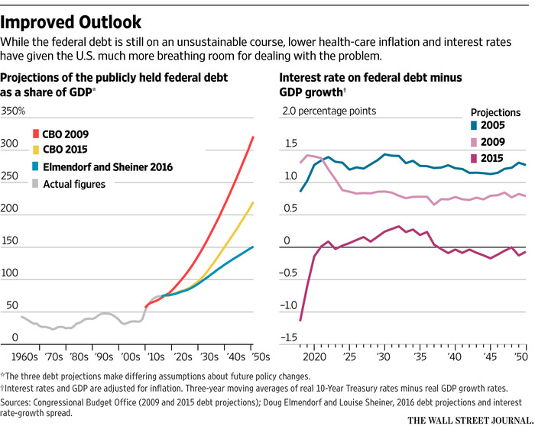
That shift increases the amount of debt the government can comfortably borrow. Whether it should is a different question, the answer to which hinges on why interest rates are low, Mr. Elmendorf and Ms. Sheiner note.
Americans are probably saving more to prepare for the future, and the federal government shouldn’t undo that saving with bigger deficits. On the other hand, foreigners are desperate to own Treasurys, banks need to own them for regulatory reasons, and business investment is unresponsive to cheap credit, all of which justify the federal government borrowing to cut taxes or, as Mr. Elmendorf prefers, invest in education, research and infrastructure.
In addition, higher federal borrowing puts upward pressure on interest rates. That makes it less likely interest rates will have to fall to zero in the next recession, leaving the Fed with no monetary ammunition.
Mr. Elmendorf does worry that feckless politicians will seize on the study as a reason to do nothing about the debt. After all, the study bluntly states that interest rates are unpredictable, the country has to save more to support an aging population, and the sooner it legislates either higher taxes or lower spending, the less convulsive the change. Mr. Elmendorf would enact a long-term deficit fix now, wait another decade before attacking the debt, and use that breathing room to boost federal investment (though his logic also applies to tax cuts).
Nonetheless, the persistence of low interest rates, he says, is something he didn’t expect just a few years ago. “And that really does change things,” he said.

