Brexit’s Hidden Threats—To Europe

Most think of the consequences of a British exit from the EU in terms of the U.K. economy. But what about Europe?
By RICHARD BARLEY
Updated Feb. 19, 2016 5:33 p.m. ET

The U.K. has put itself in the spotlight. After marathon talks, Prime Minister David Cameron has struck a deal on the country’s status in the European Union that paves the way for a referendum on the U.K.’s membership. But for global investors, it is worth thinking as much about the consequences for the continent as for the U.K.
Given the trials of the global financial crisis, it is remarkable that the European project has continued to make progress. The eurozone, which still has the threat of a Greek exithanging over it, has added members. Estonia joined in 2011, Latvia in 2014 and Lithuania in 2015. No member state has ever left the European Union; from its roots as six countries in the European Coal and Steel Community in 1951, it has reached 28 members.
Any exit would be a big deal. The departure of the U.K., which based on 2014 Eurostat data accounts for roughly one-eighth of the EU’s population and one-sixth of its gross domestic product, would be even bigger.
The process alone of “Brexit” may create risks. Europe, already dealing with a migration crisis, the lingering political and economic fallout from the sovereign-debt crisis and a waterlogged banking system, would have to spend a vast amount of time and effort negotiating with the U.K. on the terms of a future relationship. That is without considering the potential for shifts in the balance of power within the EU with a large country departing. For some, a U.K. exit might signal the removal of a brake on the path toward deeper integration. For others it will look like an invitation for more states to make demands of their own based on national grounds.
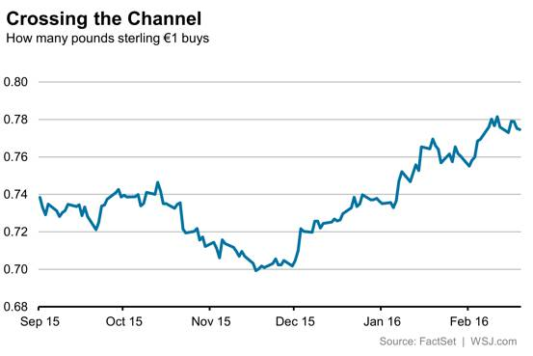
The City of London clearly has a lot at stake in the vote, which may come in June. But that is precisely because the City isn’t just a domestic capital market; it is an international financial center and pre-eminent in Europe. Most significant, London is the home of European bond markets, in particular the corporate-bond market. The infrastructure that makes it easy for Europe’s blue-chip companies to borrow funds in euros is based largely in the City and Canary Wharf.
As such, investors shouldn’t bank on the market turmoil being focused on the U.K. in the run-up to the vote. In that light, the strong run for the euro against sterling—up 5.4% this year and 11% from a low in November—looks somewhat incongruous.
True, some of this rise is because of broader shifts in global markets, including risk aversion and the fading prospect of U.K. rate increases. A U.K. exit could well spur looser policy from the Bank of England, but turmoil in Europe will surely cause further concern at the European Central Bank as well. Perhaps the better play would be to bet on sterling declining further against the dollar.
A vote for Brexit would clearly affect the U.K. most directly. But just like the threat of a Greek exit, don’t assume the rest of Europe can come through the process unscathed.

