Outsider Is Tapped to Lead Adidas

By
ELLEN EMMERENTZE JERVELL
Updated Jan. 18, 2016 4:32 p.m. ET

BERLIN—Battered German sportswear icon Adidas AG is betting that an executive steeped in laundry detergent and computers can help it become cool again in the giant U.S. market.
Adidas said Kasper Rorsted, currently chief executive at Henkel AG, a German maker of cleaning products, adhesives and beauty-care items, would become a board member at Adidas as of August, and CEO in October. Henkel had announced Mr. Rorsted’s resignation earlier in the day.
Adidas’s current CEO, Herbert Hainer, will leave at the end of September, six months before his contract was due to end.
Adidas’s stock closed 6.3% higher on the news, after rising more than​11% during Monday’s trading session, with investors hoping Mr. Rorsted could restore growth at the company.
In his eight years leading Henkel, its share price almost tripled.

MARKET TALK
- “The share price reaction speaks very clearly,” says Union Investment fund manager Ingo Speich after news of a new Adidas CEO propels shares upward. The sportswear maker says Henkel CEO Kasper Rorsted will take its top post as of October, replacing Herbert Hainer, who has faced widespread investor discontent. “We hope ... with this that a long dry spell in Adidas’s profitability comes to an end,” Mr. Speich says. Union Investment, which holds a stake of 1.2% in Adidas, last year pushed for Mr. Hainer to go, saying it had no trust in management. Shares up 7.1% at €89.97.
Under Mr. Hainer’s leadership, the company had lost ground in North America to its biggest rival, Nike Inc., and newcomer Under ArmourInc. Adidas currently holds the No. 3 spot in the U.S. sporting-goods market.
Adidas’s appointment of a financially shrewd consumer-products executive stands in contrast with Nike and Under Armour, whose CEOs have extensive sports-industry experience.
A big uncertainty is whether Mr. Rorsted’s packaged-goods acumen can help Adidas once again set trends and be “cool” among young adults. Nike briefly hired a data-focused former consumer-products executive to its top post, but his two-year tenure is widely considered a failure.
Adidas’s effort to become cool again and regain market share has included moving its global design director from Germany to its U.S. headquarters in Portland, Ore., restructuring its marketing and design departments, and placing more emphasis on U.S. sports marketing.
Adidas in recent years has hired designers from Nike and it’s team-sports chief from Under Armour.

MARKET TALK
- Capital markets valued manager Kasper Rorsted at around €3 billion. The news of his departure from Henkel sent the company’s shares down around 4%, shaving off €1.5 billion in market capitalization. Adidas shares, by contrast, jumped about 8% midday, adding around €1.4 billion in total value. That’s a lot, but there are even better ones. When James McNerney announced he would step down as 3M CEO and move to Boeing, the market valued him at around $6.6 billion. Boeing shares more than doubled during Mr. McNerney’s tenure, but the company also went through a number of crises, including cost overruns, a three-year delay in delivering its Dreamliner jet and the plane’s subsequent three-month grounding after two lithium-ion batteries overheated.
Investors and analysts have praised Mr. Rorsted, a 53-year-old Dane, who is an avid runner. But his career wasn’t always so promising. In 2004, Hewlett-Packard CEOCarly Fiorina fired him as head of Europe, Middle East and Africa for failing to meet his targets.
At Henkel, Mr. Rorsted says he has applied lessons from his time at H-P. He has shaken up the once stodgy company by cutting bureaucracy, shedding 800 noncore brands, overhauling its product assortment and replacing German managers in the U.S. with Americans.
Henkel is now more tightly controlled and compact, said Oru Mohiuddin, senior analyst for beauty care at Euromonitor. Its reaction time to market changes, such as a shift to buying laundry detergents online instead of at stores—has gotten much shorter, she said.
“You can see that their position has become much stronger,” she added. Henkel has been able to outpace competitors including Procter & Gamble Co. in many markets, Ms. Mohiuddin said.
At Henkel, Mr. Rorsted has become known for his constant travels, including monthly trips to the U.S., a market he deemed the most important region for Henkel’s growth.
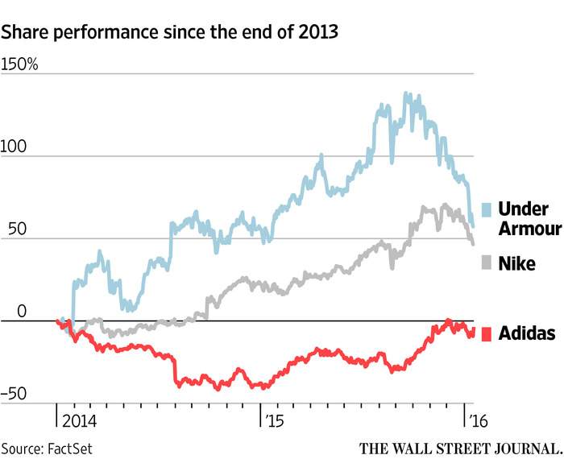ENLARGE
In early 2015, he started a major push into the U.S. market, introducing one of Henkel’s most famous products, the premium-priced Persil laundry detergent, to Wal-Mart Stores Inc.This year, Henkel plans to expand its distribution of Persil to several other major chains, including Kroger and Rite Aid.
In recent years, Henkel acquired numerous U.S. companies, including thermal management firm Bergquist Co. and several professional hair-care brands. Henkel currently holds the No. 8 spot in the U.S. home-care market and the No. 15 spot in beauty care, according to data provided by Euromonitor.
Mr. Rorsted said in a recent interview that the U.S. was “extremely attractive compared to most other markets in the world,” and that he hoped Henkel would increase the U.S. share of its global revenue to 25% from 20% today.
Ms. Mohiuddin, the analyst, said she believed Henkel was headed in the right direction in the U.S., despite still being a small player.
Mr. Rorsted’s selection ends a monthslong search at Adidas that also considered two internal candidates.
Henkel early Monday said its supervisory board and shareholder committee had unanimously agreed to Mr. Rorsted’s request to prematurely terminate his contract as CEO. The company said Hans Van Bylen, a board member overseeing the company’s beauty-care business, would replace him as Henkel CEO on May 1.
“We welcome the appointment of Mr. Rorsted as successor to Mr. Hainer and hope that the long dry spell for Adidas’s profitability will come to an end,” said Union Investment fund manager Ingo Speich. Union Investment has a stake of roughly 1.2% in Adidas, making it one of the company’s top 20 shareholders.
Mr. Hainer, 61 years old, is the longest-serving CEO of a German blue-chip company. In the course of his 14-year tenure, he went from being a lauded executive, posting new profit records annually until 2012, to being pilloried by investors. In 2014 he scrapped Adidas’s financial targets, prompting a fall in its share price of roughly 40%.
Adidas’s share price has since largely recovered.
The weak financial performance was caused by sliding sales at Adidas’s golf business, dwindling market share in North America and currency losses in Russia, one of its most important markets. In late 2014 several investors voiced discontent with the company’s performance. Some pushed for Mr. Hainer’s early departure.
Mr. Hainer held on, insisting he would stay until his contract ran out and that he would turn the company around.
Last March he presented a new five-year strategy that included management changes and more focus on the U.S., where Adidas had been struggling for decades.
Last month, Mr. Hainer said the turnaround was on course. Adidas investors were all satisfied, he said, adding that he expected 2016 to be a record year for the company.
Bernstein analyst Andrew Wood called Mr. Rorsted’s switch to Adidas a surprise.
“Given Rorsted’s success at Henkel, we are sure there was—or would have been—no shortage of offers open to him, so the news that he is to become Adidas CEO is somewhat of a surprise, given Adidas is half the size of Henkel,” Mr. Wood said. He noted that Henkel’s share price had risen to €93 ($101) from €22 in 2008, when Mr. Rorsted presented his first four-year plan.
Neither Kasper Rorsted nor Herbert Hainer was available to comment.
Henkel shares fell 4.1% on Monday.
Adidas declined to comment on Mr. Rorsted’s compensation. Henkel said Mr. Rorsted would receive his fixed salary and “variable remuneration proportionately calculated for his services in the current fiscal year” from the company, but no special compensation.
—Sara Germano contributed to this article.

