Bracing for ‘Brexit’: Traders Get Defensive on British Pound

As U.K. weighs leaving EU, cost soars for options that protect investors from a big move in the pound
By CHRISTOPHER WHITTALL and TOMMY STUBBINGTON
Updated Feb. 18, 2016 7:16 p.m. ET

Demand is spiking for contracts that protect investors from a big move in the British pound this summer—an indication that traders are girding for the aftermath of a referendum on the U.K.’s membership in the European Union.
While wider markets have yet to show a clear reaction to the possibility of a U.K. exit, analysts increasingly talk of its potential as a political risk that could affect a host of assets, from gold to British exporters and high-end London real estate.
The cost of options on the pound, by one measure, has in recent days hit its most extreme level since Europe’s sovereign-debt crisis. Implied volatility on six-month euro-sterling options jumped to just over 12% on Thursday, its highest level since late 2011. That is up from a recent low of 8.4% in mid-December, according to Thomson Reuters data.
Investors are mainly using these options to hedge against a fall by the pound. The relative cost of buying protection against a falling pound, as opposed to the currency rising, is at its highest level since the global financial crisis of 2008, according to Hamish Pepper, a currency strategist at Barclays.
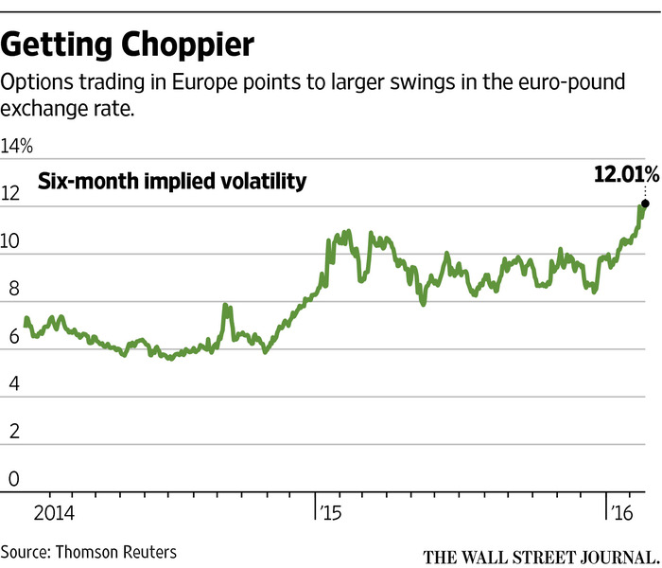
The move comes as U.K. Prime Minister David Cameron seeks to clinch a final dealresetting his country’s relationship with the EU. An agreement this week would pave the way for a vote on Britain’s EU membership in late June, U.K. government officials have said.
“Irrespective of the twists and turns of the debate, uncertainty over the outcome is likely to weigh on U.K. markets for a good few months yet,” said Mike Amey, head of sterling portfolios at Pacific Investment Management Co.
Investors piled into currency options ahead of Scotland’s referendum on its membership of the U.K. in 2014. That referendum hit sterling and caused a wobble in the shares of companies based in Scotland, such as insurer Standard Life PLC. In the end, Scottish voters elected to stay in the U.K., and the pound and stocks bounced back.
‘You’re not seeing a lot of pressure in markets other than on the currency.’
—Charlie Diebel, Aviva Investors
Polls indicate the British population is divided over EU membership. Most investors say the U.K. is likely to stay in the EU, but acknowledge that nervousness over the vote is likely to weigh on markets in coming months.
Pimco puts the chance of a British exit as high as 40%, based on neither option taking a decisive lead in opinion polls.
Uncertainty over whether the U.K. will vote to leave—a move sometimes referred to as a “Brexit”—already has contributed to a slide in the pound this year against other major currencies.
The pound was up 0.5% on the day against the euro in late New York trading Thursday, but it remains down 4.9% against the single currency so far this year.
“Uncertainty is the word that seems to encapsulate everything with respect to Brexit,” said Charlie Diebel, head of rates at Aviva Investors. “You’re not seeing a lot of pressure in markets other than on the currency.”
That is mainly because it isn’t obvious how other asset classes will react following a referendum, investors say. For instance, some investors think an “out” vote would actually benefit U.K. government bonds as the Bank of England would be unlikely to raise interest rates in the near future. Higher interest rates drive up government-bond yields, which rise as prices fall.
For the moment, selling the pound remains the simplest way for investors to express a negative view on the U.K. But as the countdown to the referendum begins, analysts are increasingly looking at what assets will be affected.
Topping most lists is London’s property market. London house prices are among the most expensive in the world, in part due to overseas demand and immigration, and will be susceptible to price falls if Britain leaves the EU.
Gold also may benefit as the potential for a U.K. exit adds to current political and monetary risks that can push money into the haven asset.
If Mr. Cameron fails to reach a deal, “this will definitely lead to higher gold demand,” saidDaniel Briesemann, a commodities analyst at Commerzbank AG.
In equity markets, U.K. companies with significant European activities also could be hit if access to Britain’s biggest trading partner is affected.
For markets, though, it’s not the divorce that matters, said Pimco’s Mr. Amey. It’s the nastiness of the breakup. The aftereffects of “a confrontational separation where the two sides act as if in an unpleasant divorce” could be long-lasting, he said.

