What’s Going On in the Markets? 5 Theories to Explain the Chaos

Fast money, China’s currency and oil prices are among factors influencing markets
A wave of selling slams global markets as a fresh fall in oil prices and a cautious tone from the Federal Reserve fuels anxiety. WSJ's Saumya Vaishampayan discusses several theories about what's causing the market volatility. Photo: Getty
By
SAUMYA VAISHAMPAYAN
Updated Feb. 10, 2016 11:58 p.m. ET

Rising volatility this year in stocks, bonds, currencies and commodities has left investors scrambling to figure out what’s going on.
Market turbulence has further intensified this week, with stocks around the world suffering sharp selloffs.
As investors and analysts search for reasons for the global volatility, what seems plausible one day is quickly disqualified when the market veers in the other direction.
It wasn’t long ago that the plunge in oil prices seemed to be the biggest factor driving down equity indexes. But now the S&P 500 is down more this year than its energy subsector, both declines dwarfed by the plunge in financial shares.
Finding a widely accepted, overarching thesis has proved elusive, leading to the rise of multiple, competing, largely unsatisfactory explanations. Yet analysts and traders keep searching, hoping to devise a road map for the peaks and valleys that lie ahead.
“There’s a confluence of bad news around the world that really shakes investor confidence,” said Brad McMillan, chief investment officer for Commonwealth Financial Network, which oversees about $100 billion. “This volatility is perceived as being very unusual and scary, which is exacerbating the problem.”
So what is the best way to explain market moves? Here are five theories:

Blame the Fast Money
As the Federal Reserve prepared to raise short-term interest rates for much of 2015, investors bet that banks would pocket an expanding difference between what they charge on loans and what they pay on deposits. But financial shares have tumbled this year as investors pivoted to embrace “lower for longer”—a sobering forecast that rates won’t rise much for years. The Bank of Japan shocked an already reeling global financial sector when it cut rates into negative territory on Jan. 29.
The episode highlights both the gloom over the global economy and the whipsaw trading that has developed on major “macro” questions over the past year.
“The fast money moved into banks at the end of 2015 because they anticipated rate hikes, and then the fast money went out,” said Diane Jaffee, a senior portfolio manager at TCW Group Inc.
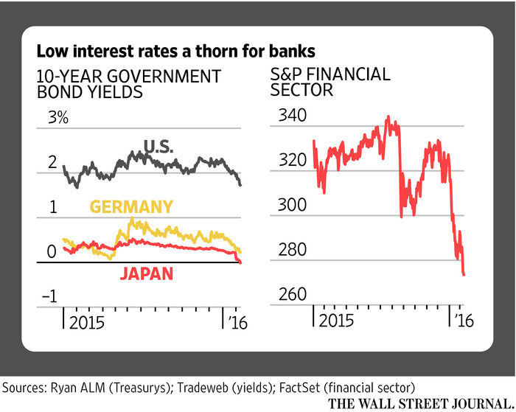ENLARGE

Anxious about the Yuan
Some say the current market turmoil has its roots in China. Many investors believe the country will have no choice but to devalue the yuan, a move that would likely deepen global economic woes by adding to transnational competition for scarce export earnings. Officials say they don’t intend to devalue but some hedge funds are trying to force their hand by making billion-dollar bets against the currency.
Analysts are watching this struggle closely after an August yuan devaluation triggered a global selloff, amid concerns that China—long viewed by Wall Street as miserly with reliable data—is headed for an economic reckoning. Many investors fear recent developments mean “a hard landing,” said Wayne Lin, a portfolio manager at QS Investors.
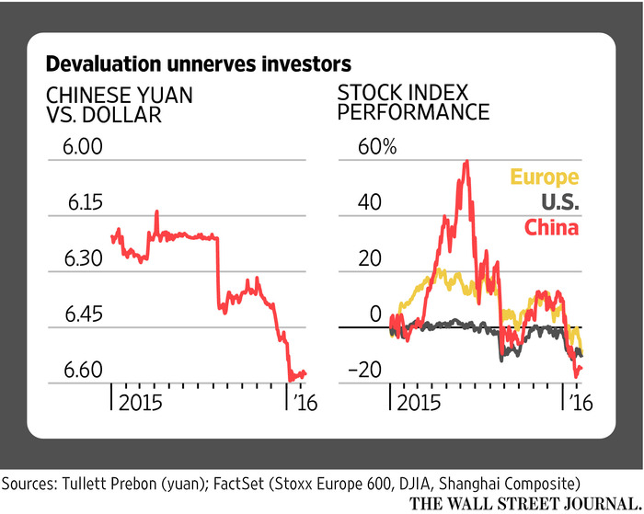ENLARGE

Sovereign-Wealth Funds
Oil-producing countries poured billions into investment funds when crude prices were higher. Now, those funds are liquidating stocks bought in happier times, accelerating the U.S. market selloff, some theorize.
Some of the U.S. stocks with the highest concentration of foreign ownership by oil-rich countries include Nasdaq Inc., Tiffany & Co., AFLAC Inc. and BlackRock Inc., according to Deutsche Bank data.
Of course, data on who is and isn’t actually selling is scarce, and there is some reason to wonder if these funds, however large, could really exert a large effect on U.S. markets.
While J.P. Morgan forecasts that sovereign-wealth funds will be forced to sell $75 billion in stocks around the world this year, the U.S. market recently weighed in at $20.95 trillion.
“Oil prices will be persistently challenged, but I don’t see oil-driven sovereign wealth flows being a mortal threat to U.S. equities or equities in general,” said Ben Mandel, global strategist of multiasset solutions at J.P. Morgan Asset Management.
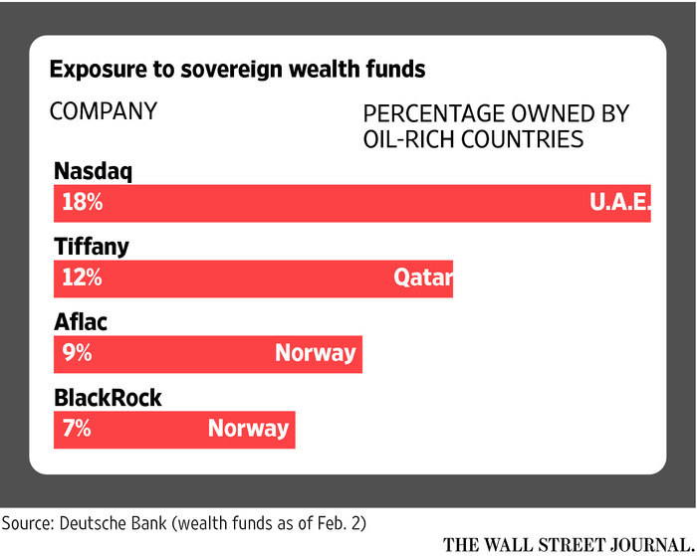ENLARGE

The U.S. Could Get Swamped
Many investors are worried that the U.S., in recent years the strongest-performing economy in the developed world, is about to be dragged down by global forces including the rise of the dollar.
The U.S. manufacturing sector contracted for the fourth straight month in January. Jobs growth, long the bright spot of the economic expansion, slowed last month. Fed officials have signaled concern.
At the same time, unemployment slipped last month and wages rose, and many market indicators that may point to future economic difficulties seem overwrought (consider the decline in bank stocks that has left many major U.S. lenders trading below the stated value of their net assets), accentuating uncertainty.
“The biggest risk that’s really on everybody’s mind is that there’s going to be a sharp slowdown in emerging markets that’s going to spill over into the U.S.,” said David Lefkowitz, senior equity strategist at UBS Wealth Management Americas.
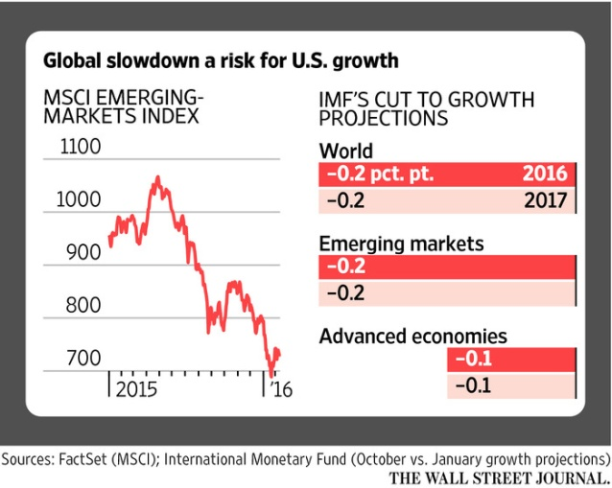ENLARGE

Growth Isn’t Growing
The slump in oil prices since June 2014 has largely been attributed to oversupply, as oil producers around the world continue pumping crude even at depressed prices.
But as benchmark prices dropped below $30 this year, investors started pointing to a slowdown in demand as well.
“If commodities prices as a whole are generally weak, that tells me that generally speaking, global demand is weak,” said Paul Nolte, portfolio manager at Kingsview Asset Management, which manages about $150 million.
