China Trying to Allay Global Concerns About Its Currency Regime
By
LINGLING WEI and

JON HILSENRATH
Updated Jan. 21, 2016 9:37 p.m. ET
DAVOS, Switzerland—Chinese officials are trying to allay growing concerns around the globe about their shifting and often inscrutable foreign-exchange regime, which has been a key cause of financial market turbulence in recent months.
At a World Economic Forum panel here, Fang Xinghai, a senior economic adviser to the Chinese leadership, said the government was committed to a new approach in which it would manage the yuan according to its performance against a basket of global currencies, as opposed to just setting it against the U.S. dollar.
It was the first time officials have said so clearly this was their new regime. Moreover he said the success of the new approach should be measured in the long-run and not by day-to-day shifts in policy.
Christine Lagarde, managing director of the International Monetary Fund, speaking on the same panel, subtly admonished the Chinese leadership, saying officials need to do a better job communicating their exchange-rate approach.
In August, officials allowed the currency to depreciate about 2% against the U.S. dollar and laid out a new strategy to fix it each day based on its performance within a narrow band the previous day. The idea was to give market force more sway in the rate.
Advertisement
In December the central bank signaled through an editorial posted on its website—rather than an official announcement—its intention to move toward navigating the currency against a basket of currencies, even while maintaining a band. In January, the People’s Bank of China allowed the currency to sharply deviate from its previous day’s close. Each was a twist in a policy that hadn’t been fully laid out.
So far, the central bank has never publicly explained its intentions behind each of those adjustments. And market turmoil in recent months has coincided with the hard-to-discern shifts in China’s exchange-rate approach.
“Until there is more certainty over what’s going on in China, it’s better to stay away,”Raymond Nolte, chief investment officer at Skybridge Capital, a New York asset-management firm which oversees more than $13 billion in financial assets, said in an interview on the sidelines of the Davos forum.
On the panel Thursday, Gary Cohn, president and chief operating officer of Goldman Sachs Group Inc., said the combination of “China moving toward a freer market and its inability to communicate freely” generates market volatility.
A shift in China’s foreign-exchange regime is a potentially historic event. China is the world’s second largest economy and for years has sought stability by linking its currency to the currency of the world’s largest economy, the U.S. In the process, it built up foreign-exchange reserves that reached $4 trillion in value, adding to China’s enormous global financial clout.
The link has become less tenable as the dollar has appreciated, lifting the Chinese currency and undermining China’s efforts to boost sagging domestic output.
It is not just investors with money at stake in the new exchange-rate regime. Chinese firms with U.S. dollar borrowing have an incentive to move out of yuan now if the currency is on a path to depreciate.
Many central banks—in places as varied as the United Kingdom, Mexico, Russia and Indonesia—in the past three decades have tried and failed to navigate gradual currency adjustments.
The slowing Chinese economy “might require more readjustment of the currency,” Ray Dalio, founder of Bridgewater Associates, a U.S. hedge fund, said on the panel. “It’s not always easy for governments to maintain their controls over the currency.”
Officials at the U.S. Federal Reserve and other central banks and financial institutions have been struggling to make sense of China’s moves, which affect their own economic prospects. For the Fed, for example, a depreciating yuan puts downward pressure on inflation through cheaper imports at a time when the U.S. is trying to push inflation higher.
“Given the massive transition, there is a communication issue,” Ms. Lagarde said on Thursday. “Better communication certainly serves the transition.
“We should do a better job,” Mr. Fang said on the panel. “We’re learning and doing it. I’m here to communicate.”
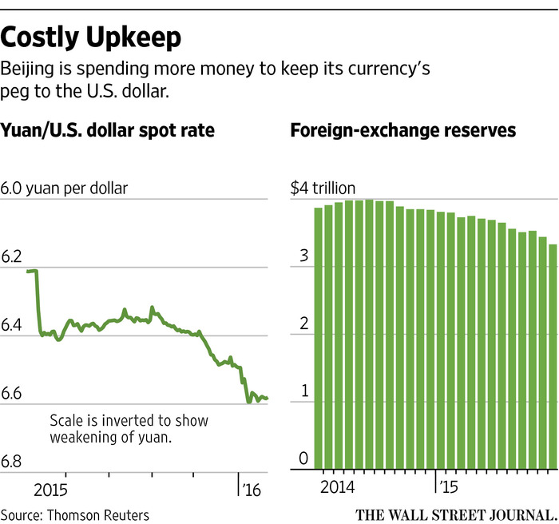ENLARGE
China’s economy and central bank have taken on global relevance but it still has antiquated monetary practices compared with developed economies’ central banks. Monetary policy decisions aren’t made independently by the central bank. Nor does it hold news conferences or release a schedule of meetings or minutes of those meetings or provide public testimony on policy, as the Fed and other central banks do.
It has become increasingly costly to maintain the yuan’s crawling peg to the dollar. In the past two years, the PBOC has burned through $700 billion of foreign-exchange reserves to maintain the yuan’s peg to the ever-strengthening dollar. Those reserves now stand at $3.3 trillion, down from almost $4 trillion in mid-2014.
Maintaining the link has undermined other efforts to support the economy. By intervening in currency markets to keep the peg, the Chinese central bank has bought yuan from Chinese banks, effectively taking money out of China’s financial system even as Beijing tries to make more money available to its businesses and consumers.
A key source of confusion is how the PBOC sets the closely watched reference rate for the yuan each day. The central bank announces the rate—dubbed “fixing”—each morning at 9:15 local time, and the yuan is allowed to move 2% above or below that level in mainland trading.
When the PBOC devalued the yuan in August, it said the central bank would start setting the fixing according to the yuan’s previous close, as a way to give the market more say in its value. Specifically, the dozen or so market makers in China’s foreign-exchange market, including both Chinese and foreign banks, were asked to look at the previous day’s close as a primary factor when deciding what price levels to submit to the central bank.
The PBOC delivered what it had promised in the following months, with the fixing set within an average of 0.02% of its previous close each trading day between late August and December.
After it said it would shift to a basket approach in December, its execution again has been hard to decipher.
In the first week of January, the central bank surprised the market by sharply fixing the yuan weaker than its previous close. That action caused a selloff of everything from the yuan, Chinese stocks, global equities and commodities, as it fanned fears that China’s economy was slowing faster than Beijing had let on and the central bank would engage in big currency devaluation to help revive growth.
Struggling to contain the near-panic selling, the central bank then moved to prop up the yuan by both setting stronger fixings and directly purchasing the yuan and selling dollars in the currency markets. In addition, the central bank has tightened capital controls to prevent money from leaving China and make it more expensive to bet against the Chinese currency.

