Deutsche Bank to Buy Back $5.4 Billion in Debt

Move designed to bolster confidence in German lender’s finances and in value of its securities
By JENNY STRASBURG and CHRISTOPHER WHITTALL
Updated Feb. 12, 2016 1:05 p.m. ET

Deutsche Bank AG said it would buy back $5.4 billion of its debt, in a move designed to bolster investor confidence in the German lender’s finances and in the value of its securities.
The announcement Friday came at the end of a volatile week for Deutsche Bank’s shares and the broader market for bank stocks, particularly in Europe.
Deutsche Bank, which is undergoing a broad restructuring program under new management, has been hit harder than most big peers as investors have worried about the bank’s capital buffers, litigation costs and the extent of its ability to profit amid market turmoil.
Banks’ stock and bond prices have both suffered in the rout. Persistent instability in commodity prices, expectations of further interest-rate drops and other concerns continue to weigh on banks.
Bond-market investors and others said Friday that Deutsche Bank’s debt repurchase could prove a small price to pay relative to the lender’s large balance sheet, if investors and counterparties, including other banks and trading partners, are reassured by the move. But the repurchase might not alleviate deeper concerns about the bank.
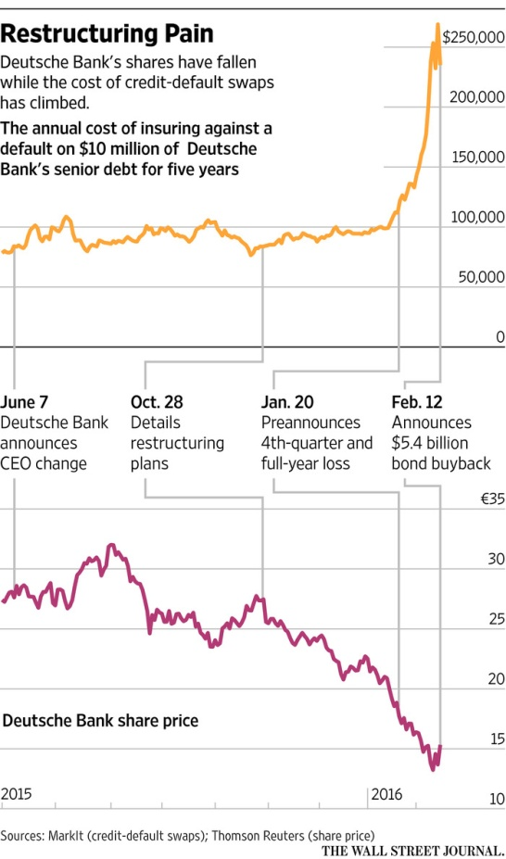
The buyback offer targets senior unsecured debt of as much as €3 billion ($3.4 billion) in euro-denominated securities and $2 billion in U.S. dollar-denominated securities.
Late Thursday, J.P. Morgan Chase & Co. said its chairman and chief executive, James Dimon, had bought 500,000 of J.P. Morgan’s shares, for $26.6 million. The bank’s shares climbed 8.3% on Friday.
Deutsche Bank said its public tender offer was effective Friday for seven days for euro-denominated debt and up to 20 days for U.S. dollar-denominated securities. It targets bonds that mature between May 2017 and January 2026.
The buyback “certainly isn’t a negative for the market,” but “the tender levels don’t look that attractive for investors,” said Tom Ross, a portfolio manager at Henderson Global Investors, who doesn’t hold Deutsche Bank bonds. He said the buyback doesn’t address bigger questions about Deutsche Bank’s capital levels.
The bank said Friday that it had €215 billion in reserves at the end of 2015, as previously disclosed.
Deutsche Bank “is taking advantage of market conditions to repurchase this debt, lowering its debt burden at attractive prices,” said finance chief Marcus Schenck. “By repurchasing this debt below its issue price, the bank realizes a profit.”
However, any profit would be small, because the senior debt involved is trading, on average, barely below face value, Citigroup Inc. analysts said in a note Friday. “Any profit (and corresponding capital gain) will be minimal. Instead the rationale behind this offer is purely to drive sentiment,” they wrote.
Before the announcement, Deutsche Bank’s shares had risen 8% Friday. They finished up 12% on the day. Word of a potential bond buyback had helped stabilize the bank’s shares earlier in the week following a 9.5% fall on Monday.
Shares in the lender have been whipsawed this week amid questions about the bank’s restructuring and ability to pay optional interest payments on its riskiest debt. The stock is down 32% this year.
A commonly watched risk barometer, credit-default swaps reflecting the cost of insuring against default on Deutsche Bank’s senior debt, dropped Friday.
Shortly before the buyback was announced, the annual cost of insuring against a default on $10 million of Deutsche Bank senior debt for five years was $256,000. That cost fell to $235,000 after the buyback announcement, according to data provider Markit.
On Thursday, the swaps rose as high as $286,000 during European trading and finished at $268,000. It last hit those levels in November 2011.
The bond buyback “is just trying to target the [credit-default-swaps] spread. [Swaps are] an indicator for counterparty risk, so risk managers look at it,” said Richard Klijnstra, a fund manager at Kempen Capital Management, who doesn’t own Deutsche Bank bonds.
Some of Deutsche Bank’s debt rose Friday. The price of a €1.5 billion euro-denominated bond included in the tender, which pays a floating interest rate and matures in September 2021, rose nearly 2 euro cents, to €94.335 following the announcement, according to MarketAxess, a trading platform.
Deutsche Bank said the bond buyback wouldn’t affect its ability to pay interest on its riskiest debt, called contingent convertible bonds. They are formally called additional Tier 1 debt.
The bank this week issued a rare statement reassuring the market it had sufficient funds to pay interest on that riskier debt. In a letter to employees, co-Chief Executive John Cryan said Deutsche Bank is “absolutely rock-solid.”
On Friday, Germany’s finance minister said he wasn’t concerned about the financial health of Deutsche Bank. “Deutsche Bank has sufficient capital,” Wolfgang Schäuble told journalists in Brussels. “Deutsche Bank is a strong bank,” he said.

