Europe’s Lower-Rated Debt Moves Higher on Amundi’s List

Asset manager thinks slender yields on highly rated European corporate bonds don’t offer enough protection against a market selloff
By CHRISTOPHER WHITTALL
Jan. 17, 2016 5:30 a.m. ET
Europe’s largest asset manager is adopting an unusual strategy to shield its corporate-bond funds from the volatility roiling financial markets: buying riskier debt.
Paris-based Amundi, with €952 billion ($1.04 trillion) in assets under management, is concerned that the slender yields on highly rated European corporate bonds, as well as the narrow spread to haven government bonds, don’t offer investors enough protection against a market selloff. Even a minor jump in bond yields, which rise as prices fall, can leave bondholders nursing hefty losses.
Moving into lower-rated debt has its own downside, including a greater risk of default. The strategy highlights the dilemma facing bond investors in Europe, where the central bank’s money printing has pushed yields down to rock-bottom levels.
“We are concerned,” said Marie-Anne Allier, head of euro aggregate fixed income at Amundi. “When you have very low yield and low spread, you have absolutely no cushion against volatility.”
The risks were highlighted by a sharp slump in German government-bond prices last spring. The yield on the 10-year bond jumped from close to zero in April to 1% about two months later. By June 10, investors who before the selloff began had been sitting on a return of 4.5% for the year to date were then facing a loss of 2.2%, according to Barclays bond indexes.
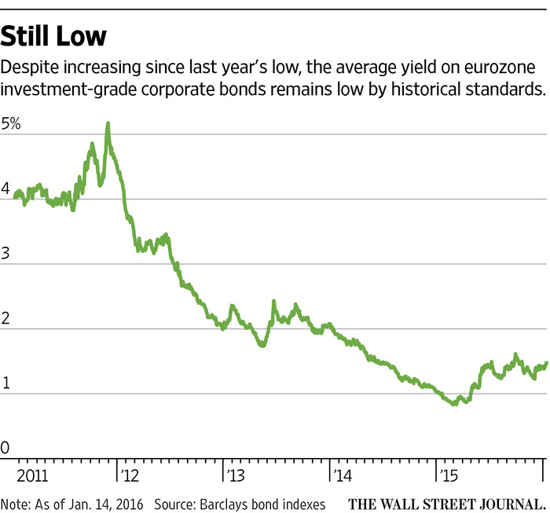ENLARGE
Investors in high-grade eurozone corporate bonds lost 0.6% last year, compared to a positive return of 8.4% in 2014, according to Barclays. European high-yield bonds returned nearly 3%.
Advertisement
Among the securities Amundi is buying are junior bonds issued by banks, which can be made to suffer losses if a bank’s capital levels fall below certain levels, and so-called corporate hybrid securities. (Interest payments on hybrids typically can be deferred, and they are subordinate to traditional debt in the event of a default.
Those sorts of securities tend to have a higher yield for a reason: They present a greater risk of default. Ms. Allier said she believes European corporate defaults will remain low as the European Central Bank keeps its foot on the easing pedal.
The approach contrasts with Amundi’s actions in the U.S., where the firm has been selling riskier debt and moving into investment-grade bonds, Ms. Allier said. The U.S. junk-bond market has suffered from its large exposure to the energy sector as oil prices have collapsed. The U.S. is also further along in the credit cycle than Europe, a period when corporate defaults tend to pick up.
The average yield on five-year U.S. investment-grade debt was 3% as of Friday, according to Barclays, down slightly from the start of the year.
By contrast, the average yield on similar eurozone investment-grade bonds was 1.5%, according to Barclays, up from 1.4% at the start of the year.
Riskier European debt has also suffered this year, but Ms. Allier said the higher yield offers more protection than investment-grade debt.
European banks’ contingent capital securities, a form of banks’ junior debt commonly referred to as CoCos, offer a yield of 6.6%, according to Barclays.
“We have tried to concentrate…on the risky part of the market,” said Ms. Allier. “We prefer to be protected.”
Amundi was formed six years ago by Crédit Agricole SA and Société Générale SA. Roughly half of its assets under management are invested in fixed income.
Investment-grade bond yields in Europe have risen since last spring, but remain low by historical standards. The European Central Bank’s package of stimulus measures has pushed down bond yields across the market, leaving around €2.5 trillion of government debt with negative yields, according to Lombard Odier Investment Managers.

