Inflation Is Now at the Fed’s Service

Services are pushing overall prices higher, but with no pickup in goods prices, some companies could be left in the lurch
By JUSTIN LAHART
Feb. 19, 2016 12:36 p.m. ET

Inflation is showing some encouraging signs of life. But not everywhere.
The Labor Department on Friday said that consumer prices were flat in January from a month earlier, putting them up 1.4% from a year ago. The closely watched core measure, which excludes food and energy, rose 0.3% and was up 2.2% on the year. This marked its best annual gain since June 2012.
That gain doesn’t count as mission accomplished for the Federal Reserve on its 2% inflation target. The core reading on the inflation measure it watches was likely up 1.6% in January, according to Bank of America Merrill Lynch calculations. And the dollar’s gains against other currencies over the past half-year have yet to be fully reflected in consumer prices.
Still, there has been a clear pickup in inflation for items less affected by the dollar’s strength, a sign the U.S. job market’s strength is starting to get reflected in prices. Core services prices, which run the gamut from child care to funeral expenses, were up 3% on the year. That was the strongest advance since 2008. Meanwhile, core goods prices, which are far more exposed to currency movements and global economic developments, were down 0.1% from a year earlier.
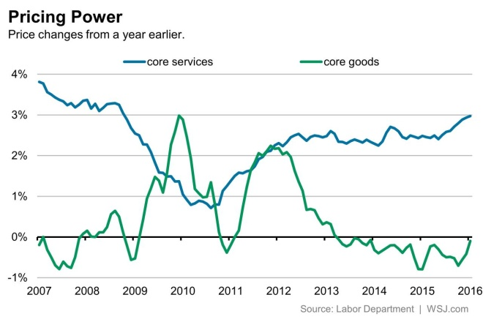ENLARGE
For the Fed, which views the dollar’s effect on consumer prices as ultimately temporary, services-price gains are a comforting sign. With a March move on interest rates still highly unlikely, Friday’s inflation report strengthens the case for Fed policy makers to tighten at their June meeting.
The fly in the ointment is for companies in the business of selling imported goods or making goods that face import competition. Friday’s report points to more pain ahead for them.
These companies have to pay for services themselves and need to compete with service-providing companies for employees. But the prices of the goods they sell are under pressure. And while lower wholesale-goods prices are providing them with some cost savings, given the intensity of the competition they face, it is hard not to pass on lower costs.
So profit margins are in for further squeezes. This will hit many public companies particularly hard because they are more focused on goods versus services than the U.S. economy at large.
Worse, if services inflation keeps picking up, making the Fed feel more comfortable about tightening, the dollar could see another bout of strength. That could make the squeeze even more intense.

