Why Winning the Powerball Jackpot Is Harder Than Ever

Worse odds yield a bigger grand prize, generating publicity and inspiring more people to buy tickets. Lottery officials want it that way.
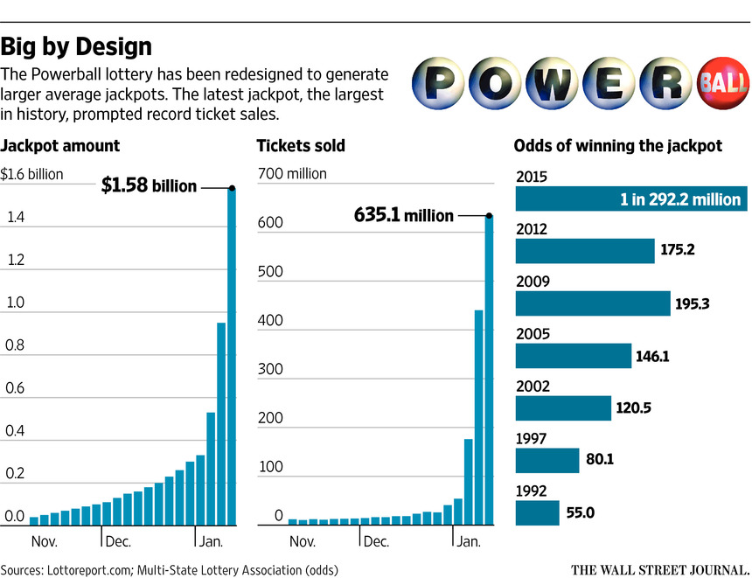ENLARGE
By
JO CRAVEN MCGINTY
Jan. 15, 2016 10:10 a.m. ET
There’s something Powerball losers should know: It’s harder than ever to win the jackpot.
This isn’t a coincidence, or a sign of your everlasting bad luck. It’s by design.
Since its 1992 launch, the Powerball lottery has been reformulated half a dozen times to alter the chances of winning. In most cases, the tweaks have reduced the odds of collecting the grand prize. The most recent change occurred in October, when the odds of winning decreased to 1 in 292 million from 1 in 175 million.
The strategy by lottery officials takes advantage of the psychology that drives the Powerball frenzy: Worse odds make it more likely that it will take longer for someone to win the prize—and the longer it takes, the more time the jackpot has to swell with cash.
Giant jackpots, in turn, inspire additional ticket sales, and generating revenue is the goal of the Multi-State Lottery Association, which administers the game for 44 states, Washington, D.C., the U.S. Virgin Islands and Puerto Rico.
This past week’s $1.58 billion jackpot sent hordes scurrying to buy a chance to win the prize. The winning number—4-8-19-27-34 with a Powerball of 10—was revealed on Wednesday. More than 635 million tickets were sold for the drawing, including three with the winning number.
Although no one could predict exactly how large the jackpot would grow, the change that contributed to its size didn’t happen by chance. The current odds are the longest in Powerball history, and the jackpot was the largest on record.
Here’s how the game works—for and against players.
Every Wednesday and Saturday at 10:59 p.m. Eastern time, the lottery draws five white balls from one drum and one red ball from a second drum. Winning tickets match the numbers of all five white balls in any order plus the number of the single red ball.
The lottery association tinkers with the odds of winning by adjusting the number of balls in each drum. Most recently, the association added 10 white balls, bringing the total to 69, and subtracted nine red balls, reducing the total to 26.
Adding white balls creates many more possible combinations of numbers, making it more difficult to pick the winning set. Meanwhile, subtracting red balls makes it easier to choose the correct number from the smaller pool of options.
Together, those changes made it harder to win the lottery’s grand prize—but easier, according to the lottery association, to win other prizes.
It’s true that the odds for winning all $4 prizes and some $7 prizes have improved. In fact, over the years, Powerball has consistently made it easier to win $4 prizes while almost always making it harder to claim larger winnings, ranging from $100 to $1 million, as well as the grand prize.
And that is the lottery’s strategy: It tempts players with the promise of an eye-popping jackpot while doling out small prizes to whet their appetites.
“They purposely design the game so you keep buying and buying and buying and do not win,” said Dawn Nettles, the founder of lottoreport.com, a website that tracks the lottery. “It’s a gamble of course, and it is in their favor.”
The lottery association didn’t respond to requests for an interview, but in printed material it acknowledges using the tactic for both Powerball and Mega Millions lotteries: “Both games have been redesigned through the years to continue to generate larger average jackpots while still offering players several other ways to win.”
Currently, the odds of winning a Powerball prize of any size are about 1 in 25. In comparison, when Powerball started, the matrix included 45 white balls and 45 red balls. Then, the odds of winning any prize were about 1 in 35, and the odds of winning the grand prize were about 1 in 55 million.
“Going from 45 white balls up to 69 gets a massive increase in the odds,” said Alan Tucker,a mathematician at Stony Brook University in New York and author of “Applied Combinatorics.” “That’s going to hurt you.”
By last Saturday, when more than 440 million Powerball tickets had been sold and no one had won the jackpot, some players speculated that the drawing was fixed. After all, if the odds of winning were 1 in 292 million, how could there be no winner with that many tickets sold?
“We’re looking at the probability of not getting the specific winning collection,” Mr. Tucker said. “The probability that you’ll lose is astronomically greater than the probability that you’ll win. So the probability of lots and lots of people losing is pretty good.”
If 440 million tickets were sold, the probability of no one winning would have been about 22.2%, according to Merrill Liechty, a statistician at Drexel University LeBow College of Business in Pennsylvania.
After Wednesday’s win, the jackpot was reset to the starting minimum of $40 million, but with the tougher odds in place, it could overflow again.
“If 100 million people were betting, there would be a 29% chance someone would win,” Mr. Tucker said. “The chances of winning are directly proportional to the odds of losing. So things are likely to build up fast in the future.”
And that is how the players get played.
Write to Jo Craven McGinty atJo.McGinty@wsj.com

