Fed Raises Interest Rates for Third Time Since Financial Crisis
By BINYAMIN APPELBAUMMARCH 15, 2017

The Federal Reserve delivered the widely expected increase in its benchmark interest rate on Wednesday, and said the domestic economy remained on a path of slow and steady growth.
The decision raises the Fed’s benchmark rate to a range between 0.75 percent and 1 percent.
In a statement after a two-day meeting of its policy-making committee, the Fed said that the United States economy continued to chug along, expanding at a “moderate pace.” Employers are hiring, consumers are spending and businesses — the laggards in recent months — are starting to spend a little more, too.
The Fed also highlighted a recent increase in inflation after a long period of sluggishness. Prices are now rising at roughly the 2 percent annual pace that the Fed regards as optimal. The Fed, which had made faster inflation a central objective, said on Wednesday that it was now focused on stabilizing inflation.
It is the first time in recent years that the Fed’s forecasts have moved in the direction of tightening, a change in tune that parallels the Fed’s confident tone and its decision to raise rates on Wednesday.
There was one dissent. Neel Kashkari, president of the Federal Reserve Bank of Minneapolis, voted against raising interest rates. The Fed’s statement did not provide a reason for Mr. Kashkari’s vote.

GRAPHIC

Why the Fed Raised Rates for the Third Time
The Federal Reserve is raising interest rates for the third time since the financial crisis after being at near zero.
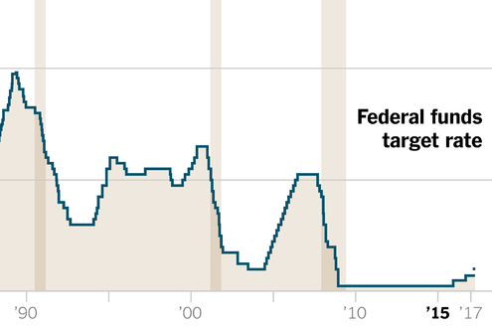
OPEN GRAPHIC

The Fed’s assessment of economic conditions remained quite measured. There was no sign of the ebullient optimism President Trump had shown in recent comments about the economy.
Even though the Fed had clearly telegraphed the timing of the increase, stock markets in the United States rose after the announcement. The Nasdaq index was up 0.74 percent while the Dow Jones index rose 0.54 percent.
A new round of economic projections from the Fed’s senior officials was nearly unchanged from the last round of projections in December. The Fed continues to forecast a Goldilocks economy, with the unemployment rate remaining at 4.5 percent and inflation around 2 percent for the next three years.
An increased number of Fed officials are expecting to raise rates at least twice more this year. Only three of the 17 officials who submitted forecasts now expect the central bank to move more slowly. There was a similar coalescing around tighter policy for the following two years, although the median prediction of a 3 percent funds rate by the end of 2019 remained unchanged.
The rate hike will increase the upward pressure on interest rates that consumers pay, but the immediate effect is likely to be modest. People with credit card debt are likely to see an immediate increase of about a quarter percentage point in their interest rates. The effect on longer-term loans is less direct, but the average rate on a 30-year mortgage rose by half a percentage point over the last year.
The nation’s largest borrower, the federal government, will also feel the pinch of higher rates. Federal interest payments, measured as a share of the economy, are expected to double over the next decade, according to the Congressional Budget Office.
Savers are unlikely to benefit immediately. Banks tend to raise interest rates on loans more quickly than they raise rates on deposits. That was certainly the pattern after the Fed last raised rates, in December. Last week, the average rate on a six-month certificate of deposit was 0.14 percent. Last year at this time: 0.13 percent.
Wednesday’s decision quickens the Fed’s march toward higher rates. The Fed raised rates for the first time since the financial crisis in December 2015. It waited a full year before the second hike. The third comes just three months later.
One reason for that is that economic growth remains slow. The economy expanded by just 1.6 percent in 2016, and there is little sign of an acceleration during the first quarter. But the Fed has concluded that the economy is growing at something close to its maximum sustainable pace.
The Fed, charged with maximizing employment and moderating inflation, is close to achieving both goals. The unemployment rate fell to 4.7 percent in February, a level consistent with the normal churn of people moving among jobs.
Inflation is finally starting a comeback, and moderate as it is, that’s not a bad thing. The Fed’s preferred measure rose 1.9 percent over the 12 months ending in January, close to the Fed’s 2 percent annual target.
The Fed’s policy-making committee next meets on May 2 and 3.

