Financial Statements Analysis
Term Project

DRUGSTORE INDUSTRY ANALYSIS
Walgreens (WBA), CVS (CVS), Rite-Aid (RAD)

Industry and Company Profile Description:
The United States Drugstore Industry is fueled specifically by three different factors. The first of which can be credited to the aging population of baby boomers who rely on the convenience and services of drugstores. Other leading factors that the drug store industry rely on include increasing awareness of health issues, and medical advancement. Drug stores are among the many industries that have benefited greatly from the increase of technology in the medical field. This allows drugstores to continue developing products that change and improve with technological advances in the medical field. By doing this, customers can rely on drugstores’ up-to-date product base and find products at ease.

The success and profitability of the drug store industry is also largely tied to the companies’ pharmaceutical services, more specifically the companies’ supplier relationships as well as their access to medical insurance groups. The companies that have access to more medical insurance groups and stronger supplier relationships are typically more profitable. Because of this, the industry is typically dominated by larger companies due to economies of scale, but smaller companies can still play their part by offering convenient and strategic locations. Some companies within this industry include Walgreens, Rite-Aid, and CVS, which will be analyzed and further discussed within the next paragraphs. Some other companies that affect this industry due to similar products and pharmaceutical sales include Walmart, Costco, and several other retail/grocery stores that offer pharmaceutical services to customers.

- Walgreens:
Walgreens has achieved the status of the world’s number one drugstore. The company operates more than 8,300 stores spread across the 50 states, the Virgin Islands, and Puerto Rico. Although Walgreens offers many products and services from general retail to the photo printing services, pharmaceutical sales make up over two-thirds of the company’s sales. By offering drive-thru pharmacy and clinic services in convenient and global locations, Walgreens has been able to dominate the drug store industry in pharmaceutical sales. As well as this, Walgreens acquired Alliance Boots, creating the Walgreens Boots Alliance, which is the first global pharmacy-led, health and wellbeing enterprise (“Walgreen Co.”). Walgreens Boots Alliance is a market leader in Europe, and owns stores in Mexico and China as well. To expand their services further, on September 19, 2017, Walgreens agreed to purchase 1,936 stores of one of their competitors, Rite Aid. These store purchases are expected to begin in October, and be completed by Spring of 2018 (“Walgreens Boots…”). Walgreens gains a competitive position in the industry by being a global company that has strong ties and partnerships with companies such as Amerisourcebergen, a subsidiary of Alliance Boots. These partnerships allow Walgreens to provide competitive price management and customer earnings programs.

- CVS:
While Walgreens holds the number one position for the industry due to their global status, CVS takes the number one position for being the largest pharmacy health care provider in the United States. CVS offers over 9,600 retail drug stores within the United States, in addition to stores operated inside Target stores. The company also operates a prescription management company called Caremark Pharmacy Services and offers MinuteClinics inside about 1,000 of the CVS owned stores. CVS also owns Omnicare, a nursing home pharmacy. While Walgreens tends to expand with a global customer oriented mindset, CVS focuses more on gaining PBMs, currently servicing ninety million PBM plan members (Taylor). Despite the company’s focus on insurance aspects, they have began to globalize, opening stores in Puerto Rico and Brazil. CVS is very much a growing company that has many outlets to expand from. (“Company…”)

- Rite-Aid:
Rite-Aid was founded in 1962 and ranks a distant third behind the companies mentioned above, Walgreens and CVS. Rite-Aid has 4600 stores that span across thirty states, where approximately sixty percent of those stores are freestanding, and half offer drive-thru pharmacy services. One of Rite-Aid’s unique characteristics in the industry is their product configuration, which carries over 3,500 Rite-Aid brand private-label products. Despite this, sixty percent of the company’s sales are from pharmaceutical sales. The company’s pharmacy also consists of EnvisionRX, which provides a range of pharmacy benefits. As of recently, Rite-Aid will sell nearly half of their stores to the industry leader, Walgreens Boots Alliance.

Financial Statement Data Analysis:
(All numbers in thousands, statements attached in Appendix)

- Walgreens:
Overall, Walgreens’ financial statements look healthy. The total assets nearly doubled from 2014-2015 due to increased net receivables and “other current assets.” As well as this, the goodwill, intangible assets, and “other assets” accounts also increased. As expected, the total liabilities had the same reaction as the total assets, nearly doubling from 2014 to 2015. The gross profit and total revenues of the company are steadily increasing, and the net income of the company almost doubled to $4,220,000 from 2014 to 2015, but decreased to $4,173,000 during the 2016 fiscal year.

- CVS:
CVS has performed fairly consistently over the past three years, increasing most accounts from 2015 to 2016. Current assets and liabilities appear to be steady from 2015 to 2016, and the retained earnings and gross profit are increasing each year. From 2015 to 2015, the net income increased dramatically, building it up to $5,317,000 for the 2016 fiscal year.

- Rite-Aid:
Compared to Walgreens and CVS, Rite-Aid’s financial statements appear to be struggling. Although they greatly increased accounts such as goodwill and intangible assets, the company’s retained earnings is consistently in the deep negatives. Looking towards the optimistic side, the company’s common stock, total revenue, and gross profit are slowly increasing; and the net income experienced a dramatic increase in 2015.

Ratio Analysis:

Ratios in a snapshot:
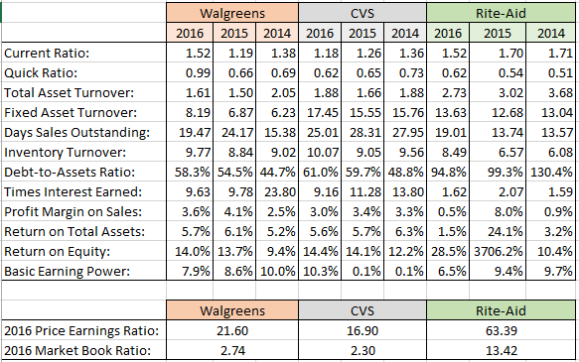

The table above shows a convenient breakdown of all the ratios for the three companies selected within the drugstore industry. By showing the final product in a table like so, the companies can be easily compared to one another.

At a quick glance, the companies above all seem pretty similar. However, a closer view at the ratios shows the differences between the companies, as can be seen especially in Rite-Aid’s debt to assets ratio. The extremely high ratio that Rite-Aid shows here is a solid indicator that Rite-Aid does not have enough assets to cover even a quarter of its debt. The comparison from 2014 to 2016 shows that they have improved their ratio, but it should still be of concern to the company. Despite Rite-Aid’s debt to assets ratio being extremely high, the company’s current ratio actually exceeds that of its competitors, and comes closest to meeting the industry average of 1.7. This indicates that Rite-Aid has significantly more current assets than long term assets. In addition to Rite-Aid’s debt-to-asset ratio being much higher than its competitors, its return on equity for 2015 is unreasonably high, at 3706.2%. This is due to the company’s spike in net income available paired with their normal amount of common equity

By looking at the numbers above, it can be seen that CVS and Walgreens are fairly close in all of their numbers, as they are each other’s largest competitors. Rite-Aid lags a bit in keeping up with the larger companies, but exceeds its competitors in days sales outstanding. I found this to be interesting because Rite-Aid has significantly less locations than CVS and Walgreens. This could indicate that Rite-Aid orders only enough inventory to meet their current needs.

A noticeable difference between Walgreens and CVS can be noted in BEP ratio for 2014 and 2015. Walgreens had a much higher earning power than CVS during these two years because CVS had a massive amount of assets compared to their earnings before interest and taxes. During these two years, CVS greatly increased their amount of long-term assets, which later pays off based on their 2016 BEP ratio.

Trend and Comparative Analysis:
The industry average for the Price Earnings ratio in 2016 was 22.53 for consumer services, and the sector average for food and drug retailers was 17.60. Walgreens met the sector average for 2016, but failed to meet industry, and CVS did not meet either. There are other ratios in which the industry leaders did not meet expectations. This is due to a mild cold and flu season for the 2016 year that affected the expected amount of sales for the year, both pharmaceutical and over-the-counter. On the opposite side of the spectrum, Rite-Aid’s P/E ratio was incredibly high which is due to their extremely low EPS of .02. The M/B ratio follows the same patterns as above, with the sector average being 2.5 and the industry average 5.3.

- Liquidity: Current Ratio Analysis and Comparison
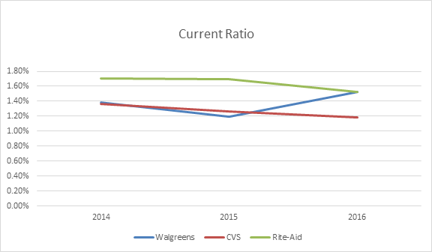
The above chart shows that Rite-Aid consistently has the highest current ratio, meaning at this moment in time they had the best proportion of current assets to back up their current liabilities. The chart also shows that CVS is fairly consistent over the past three years, whereas Walgreens experiences some fluctuation. When comparing the current ratio to the quick ratio, the results differ highly from above. Rite-Aid consistently has the lowest quick ratio of the three companies, which signifies the majority of their current assets is most likely made up of inventory. In the case that Rite-Aid had to liquidate immediately and pay off all their current liabilities, they would struggle the most of the three companies.

- Asset Management: Total Asset Turnover Ratio
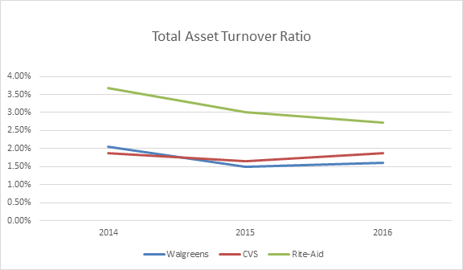
The above chart shows that Rite-Aid is best handling their assets of the three companies. By looking at this chart and the other asset management ratios, it can be seen that Walgreens and CVS are typically in close competition with each other, while all three companies remain pretty consistent in their asset management.

- Debt Management: Debt-to-Assets ratio
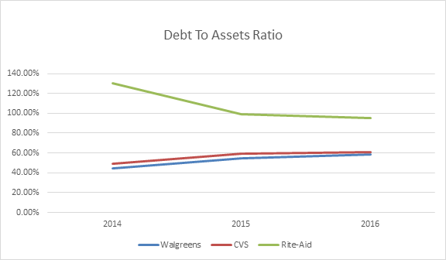
The debt-to-assets comparison of the three companies shows a large problem in the financial statements of Rite-Aid. Walgreens and CVS are, as usual, very close in relation to each other and remain fairly consistent from year to year. Rite-Aid, on the other hand, has a debt-to-asset ratio that could be fatal for the company, and is proving so through Walgreen’s acquisition of 1,936 of their stores. Rite-Aid’s asset management ratios looked healthy, signifying that once they have the assets they are selling them at a proper price range to generate sales. However, the ratio shown above being so high may signify that their means of achieving these assets are not appropriate for the company’s current financial status. As of 2016, the company has significantly more total debt than they do assets, which does not look good for the company.

- Profitability: Basic Earning Power

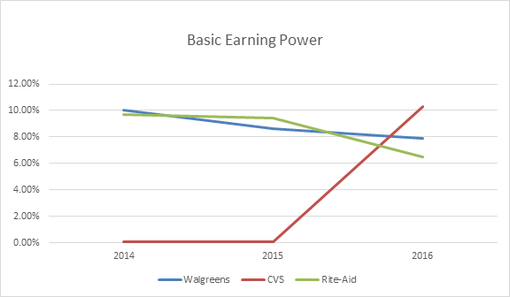

This chart looks significantly different from the other ones. This time around, Walgreens and Rite-Aid have a fairly consistent ratio, where CVS experiences a dramatic increase during 2016. As mentioned previously, CVS greatly increased their amount of long-term assets during 2014 and 2015, which later pays off based in their 2016 BEP ratio.

Recommendations:
From the financial statements and the ratios, Walgreens and CVS appear to be generally healthy companies. They are both consistent from year to year, with a few exceptions such as CVS’s BEP ratio. Rite-Aid is not as consistent, and needs to focus heavily on debt management and control. As far as remaining competitive with one another, each company has their own niche that they seem to specialize in. To compensate for the different ways that each company is growing, CVS should focus on globalizing and stronger customer appeal and Walgreens should look into the PBM route that CVS has taken. Rite-Aid, in addition to improving debt management, needs to find something else to set them apart from these bigger companies, or it will soon be taken over completely. The findings prove that the industry is a growing field for American consumers that has a strong future as long as they continue to progress technologically and geographically.

APPENDIX
(Financial Statements, Sources)
WALGREENS: Balance Sheet
All numbers in thousands
Period Ending 8/31/2016 8/31/2015 8/31/2014
Current Assets
Cash And Cash Equivalents 9,807,000 3,000,000 2,646,000
Short Term Investments - - -
Net Receivables 6,260,000 6,849,000 3,218,000
Inventory 8,956,000 8,678,000 6,076,000
Other Current Assets 860,000 1,130,000 302,000
Total Current Assets 25,883,000 19,657,000 12,242,000
Long Term Investments 6,174,000 1,242,000 7,336,000
Property Plant and Equipment 14,335,000 15,068,000 12,257,000
Goodwill 15,527,000 16,372,000 2,359,000
Intangible Assets 10,302,000 12,351,000 1,180,000
Accumulated Amortization - - -
Other Assets 467,000 4,092,000 1,876,000
Deferred Long Term Asset Charges - - -
Total Assets 72,688,000 68,782,000 37,250,000
Current Liabilities
Accounts Payable 16,690,000 15,489,000 8,121,000
Short/Current Long Term Debt 323,000 1,068,000 774,000
Other Current Liabilities - - -
Total Current Liabilities 17,013,000 16,557,000 8,895,000
Long Term Debt 18,705,000 13,315,000 3,716,000
Other Liabilities 4,045,000 4,072,000 2,942,000
Deferred Long Term Liability Charges 2,644,000 3,538,000 1,080,000
Minority Interest 401,000 439,000 104,000
Negative Goodwill - - -
Total Liabilities 42,407,000 37,482,000 16,633,000
Stockholders' Equity
Misc. Stocks Options Warrants - - -
Redeemable Preferred Stock - - -
Preferred Stock - - -
Common Stock 12,000 12,000 80,000
Retained Earnings 27,684,000 25,089,000 22,327,000
Treasury Stock -4,934,000 -3,977,000 -3,197,000
Capital Surplus 10,111,000 9,953,000 1,172,000
Other Stockholder Equity -2,993,000 -216,000 131,000
Total Stockholder Equity 29,880,000 30,861,000 20,513,000

(Retrieved from Yahoo Finance)

WALGREENS: Income Statement
All numbers in thousands
Revenue 8/31/2016 8/31/2015 8/31/2014
Total Revenue 117,351,000 103,444,000 76,392,000
Cost of Revenue 87,477,000 76,691,000 54,823,000
Gross Profit 29,874,000 26,753,000 21,569,000
Operating Expenses
Research Development - - -
Selling General and Administrative 23,873,000 22,085,000 17,375,000
Non Recurring - - -
Others - - -
Total Operating Expenses - - -
Operating Income or Loss 6,001,000 4,668,000 4,194,000
Income from Continuing Operations
Total Other Income/Expenses Net -261,000 1,248,000 -481,000
Earnings Before Interest and Taxes 5,740,000 5,916,000 3,713,000
Interest Expense 596,000 605,000 156,000
Income Before Tax 5,144,000 5,311,000 3,557,000
Income Tax Expense 953,000 1,032,000 1,526,000
Minority Interest 401,000 439,000 104,000
Net Income From Continuing Ops 4,173,000 4,220,000 1,932,000
Non-recurring Events
Discontinued Operations - - -
Extraordinary Items - - -
Effect Of Accounting Changes - - -
Other Items - - -
Net Income
Net Income 4,173,000 4,220,000 1,932,000
Preferred Stock And Other Adjustments - - -
Net Income Applicable To Common
Shares 4,173,000 4,220,000 1,932,000

(Retrieved from Yahoo Finance)

CVS: Balance Sheet
All numbers in thousands
Period Ending 12/31/2016 12/31/2015 12/31/2014
Current Assets
Cash And Cash Equivalents 3,371,000 2,459,000 2,481,000
Short Term Investments 87,000 88,000 34,000
Net Receivables 12,164,000 11,888,000 10,672,000
Inventory 14,760,000 14,001,000 11,930,000
Other Current Assets 660,000 722,000 866,000
Total Current Assets 31,042,000 29,158,000 25,983,000
Long Term Investments - - -
Property Plant and Equipment 10,175,000 9,855,000 8,843,000
Goodwill 38,249,000 38,106,000 28,142,000
Intangible Assets 13,511,000 13,878,000 9,774,000
Accumulated Amortization - - -
Other Assets 1,485,000 1,440,000 1,445,000
Deferred Long Term Asset Charges - - -
Total Assets 94,462,000 92,437,000 74,187,000
Current Liabilities
Accounts Payable 14,883,000 14,319,000 12,363,000
Short/Current Long Term Debt 11,367,000 8,850,000 6,664,000
Other Current Liabilities - - -
Total Current Liabilities 26,250,000 23,169,000 19,027,000
Long Term Debt 25,615,000 26,267,000 11,630,000
Other Liabilities 1,549,000 1,542,000 1,531,000
Deferred Long Term Liability Charges 4,214,000 4,217,000 4,036,000
Minority Interest 4,000 7,000 5,000
Negative Goodwill - - -
Total Liabilities 57,632,000 55,202,000 36,229,000
Stockholders' Equity
Misc. Stocks Options Warrants - 39,000 -
Redeemable Preferred Stock - - -
Preferred Stock - - -
Common Stock 17,000 17,000 17,000
Retained Earnings 38,983,000 35,506,000 31,849,000
Treasury Stock -33,452,000 -28,886,000 -24,078,000
Capital Surplus 31,618,000 30,948,000 30,418,000
Other Stockholder Equity -336,000 -389,000 -248,000
Total Stockholder Equity 36,830,000 37,196,000 37,958,000

(Retrieved from Yahoo Finance)
CVS: Income Statement
All numbers in thousands
Revenue 12/31/2016 12/31/2015 12/31/2014
Total Revenue 177,526,000 153,290,000 139,367,000
Cost of Revenue 148,669,000 126,762,000 114,000,000
Gross Profit 28,857,000 26,528,000 25,367,000
Operating Expenses
Research Development - - -
Selling General and Administrative - - -
Non Recurring - - -
Others - - -
Total Operating Expenses - - -
Operating Income or Loss 10,338,000 9,454,000 8,799,000
Income from Continuing Operations
Total Other Income/Expenses Net -643,000 -643,000 -521,000
Earnings Before Interest and Taxes 9,695,000 9,454,000 8,278,000
Interest Expense 1,058,000 838,000 600,000
Income Before Tax 8,637,000 8,616,000 7,678,000
Income Tax Expense 3,317,000 3,386,000 3,033,000
Minority Interest 4,000 7,000 5,000
Net Income From Continuing Ops 5,320,000 5,230,000 4,645,000
Non-recurring Events
Discontinued Operations -1,000 9,000 -1,000
Extraordinary Items - - -
Effect Of Accounting Changes - - -
Other Items
- - -
Net Income
Net Income 5,317,000 5,237,000 4,644,000
Preferred Stock And Other Adjustments - - -
Net Income Applicable To Common Shares 5,317,000 5,237,000 4,644,000

(Retrieved from Yahoo Finance)
RITE-AID: Balance Sheet
All numbers in thousands
Period Ending 2/27/2016 2/28/2015 3/1/2014
Current Assets
Cash And Cash Equivalents 124,471 115,899 146,406
Short Term Investments - - -
Net Receivables 1,601,008 998,727 949,062
Inventory 2,697,104 2,882,980 2,993,948
Other Current Assets 128,144 224,152 195,709
Total Current Assets 4,550,727 4,221,758 4,285,125
Long Term Investments - - -
Property Plant and Equipment 2,255,398 2,091,369 1,957,329
Goodwill 1,713,475 76,124 -
Intangible Assets 1,004,379 421,480 431,227
Accumulated Amortization - - -
Other Assets 213,890 200,345 271,190
Deferred Long Term Asset Charges 1,539,141 1,766,349 -
Total Assets 11,277,010 8,777,425 6,944,871
Current Liabilities
Accounts Payable 2,970,047 2,384,624 2,458,278
Short/Current Long Term Debt 26,848 100,376 49,174
Other Current Liabilities - - -
Total Current Liabilities 2,996,895 2,485,000 2,507,452
Long Term Debt 6,967,288 5,458,740 5,632,798
Other Liabilities 731,399 776,629 843,152
Deferred Long Term Liability Charges - - -
Minority Interest - - -
Negative Goodwill - - -
Total Liabilities 10,695,582 8,720,369 9,058,573
Stockholders' Equity
Misc. Stocks Options Warrants - - -
Redeemable Preferred Stock - - -
Preferred Stock - - -
Common Stock 1,047,754 988,558 971,331 Retained Earnings -5,241,210 -5,406,675 -7,515,848
Treasury Stock - - -
Capital Surplus 4,822,665 4,521,023 4,468,149
Other Stockholder Equity -47,781 -45,850 -37,334
Total Stockholder Equity 581,428 57,056 (2,113,702)

(Retrieved from Yahoo Finance)
RITE-AID: INCOME STATEMENT
All numbers in thousands
Revenue 2/27/2016 2/28/2015 3/1/2014
Total Revenue 30,736,657 26,528,377 25,526,413
Cost of Revenue 22,910,402 18,951,645 18,202,679
Gross Profit 7,826,255 7,576,732 7,323,734
Operating Expenses
Research Development - - -
Selling General and Administrative 7,013,346 6,695,642 6,561,162
Non Recurring 48,423 41,945 41,304
Others - - -
Total Operating Expenses - - -
Operating Income or Loss 764,486 839,145 721,268
Income from Continuing Operations
Total Other Income/Expenses Net -36,508 -14,713 46,459
Earnings Before Interest and Taxes 727,978 824,432 674,809
Interest Expense 449,574 397,612 424,591
Income Before Tax 278,404 426,820 250,218
Income Tax Expense 112,939 -1,682,353 804
Minority Interest - - -
Net Income From Continuing Ops 132,260 2,090,661 186,971
Non-recurring Events
Discontinued Operations - - -
Extraordinary Items - - -
Effect Of Accounting Changes - - -
Other Items - - -
Net Income
Net Income 165,465 2,109,173 249,414
Preferred Stock And Other Adjustments - - -
Net Income Applicable To Common Shares 165,465 2,114,629 220,872

(Retrieved from Yahoo Finance)
Sources

“Company Information, Facts & Figures.” CVS Health, CVS Health , 2017, cvshealth.com/about/facts-and-company-information.

Taylor, Chris. “CVS Vs. Walgreens: The Best Drugstore Stock to Own Now.” CVS Vs. Walgreens: The Best Drugstore Stock to Own Now, Fortune, 20 Apr. 2016, fortune.com/2016/04/20/cvs-walgreens-drugstore-stocks/.

“Walgreens Boots Alliance Secures Regulatory Clearance for Purchase of Stores and Related Assets from Rite Aid.” Walgreens Boots Alliance. Walgreens Boots Alliance, 2017, www.walgreensbootsalliance.com.

“Walgreen Co.” D&B Hoover, Dun & Bradstreet Inc, 2017, www.hoovers.com.

“Yahoo Finance - Business Finance, Stock Market, Quotes, News.” Yahoo! Finance, Yahoo!, 2017, finance.yahoo.com/.

